A Dental Pantomime for schoolchildren in Vanuatu
April 14 to 21 2016 RAWCS Project *24/2012-13
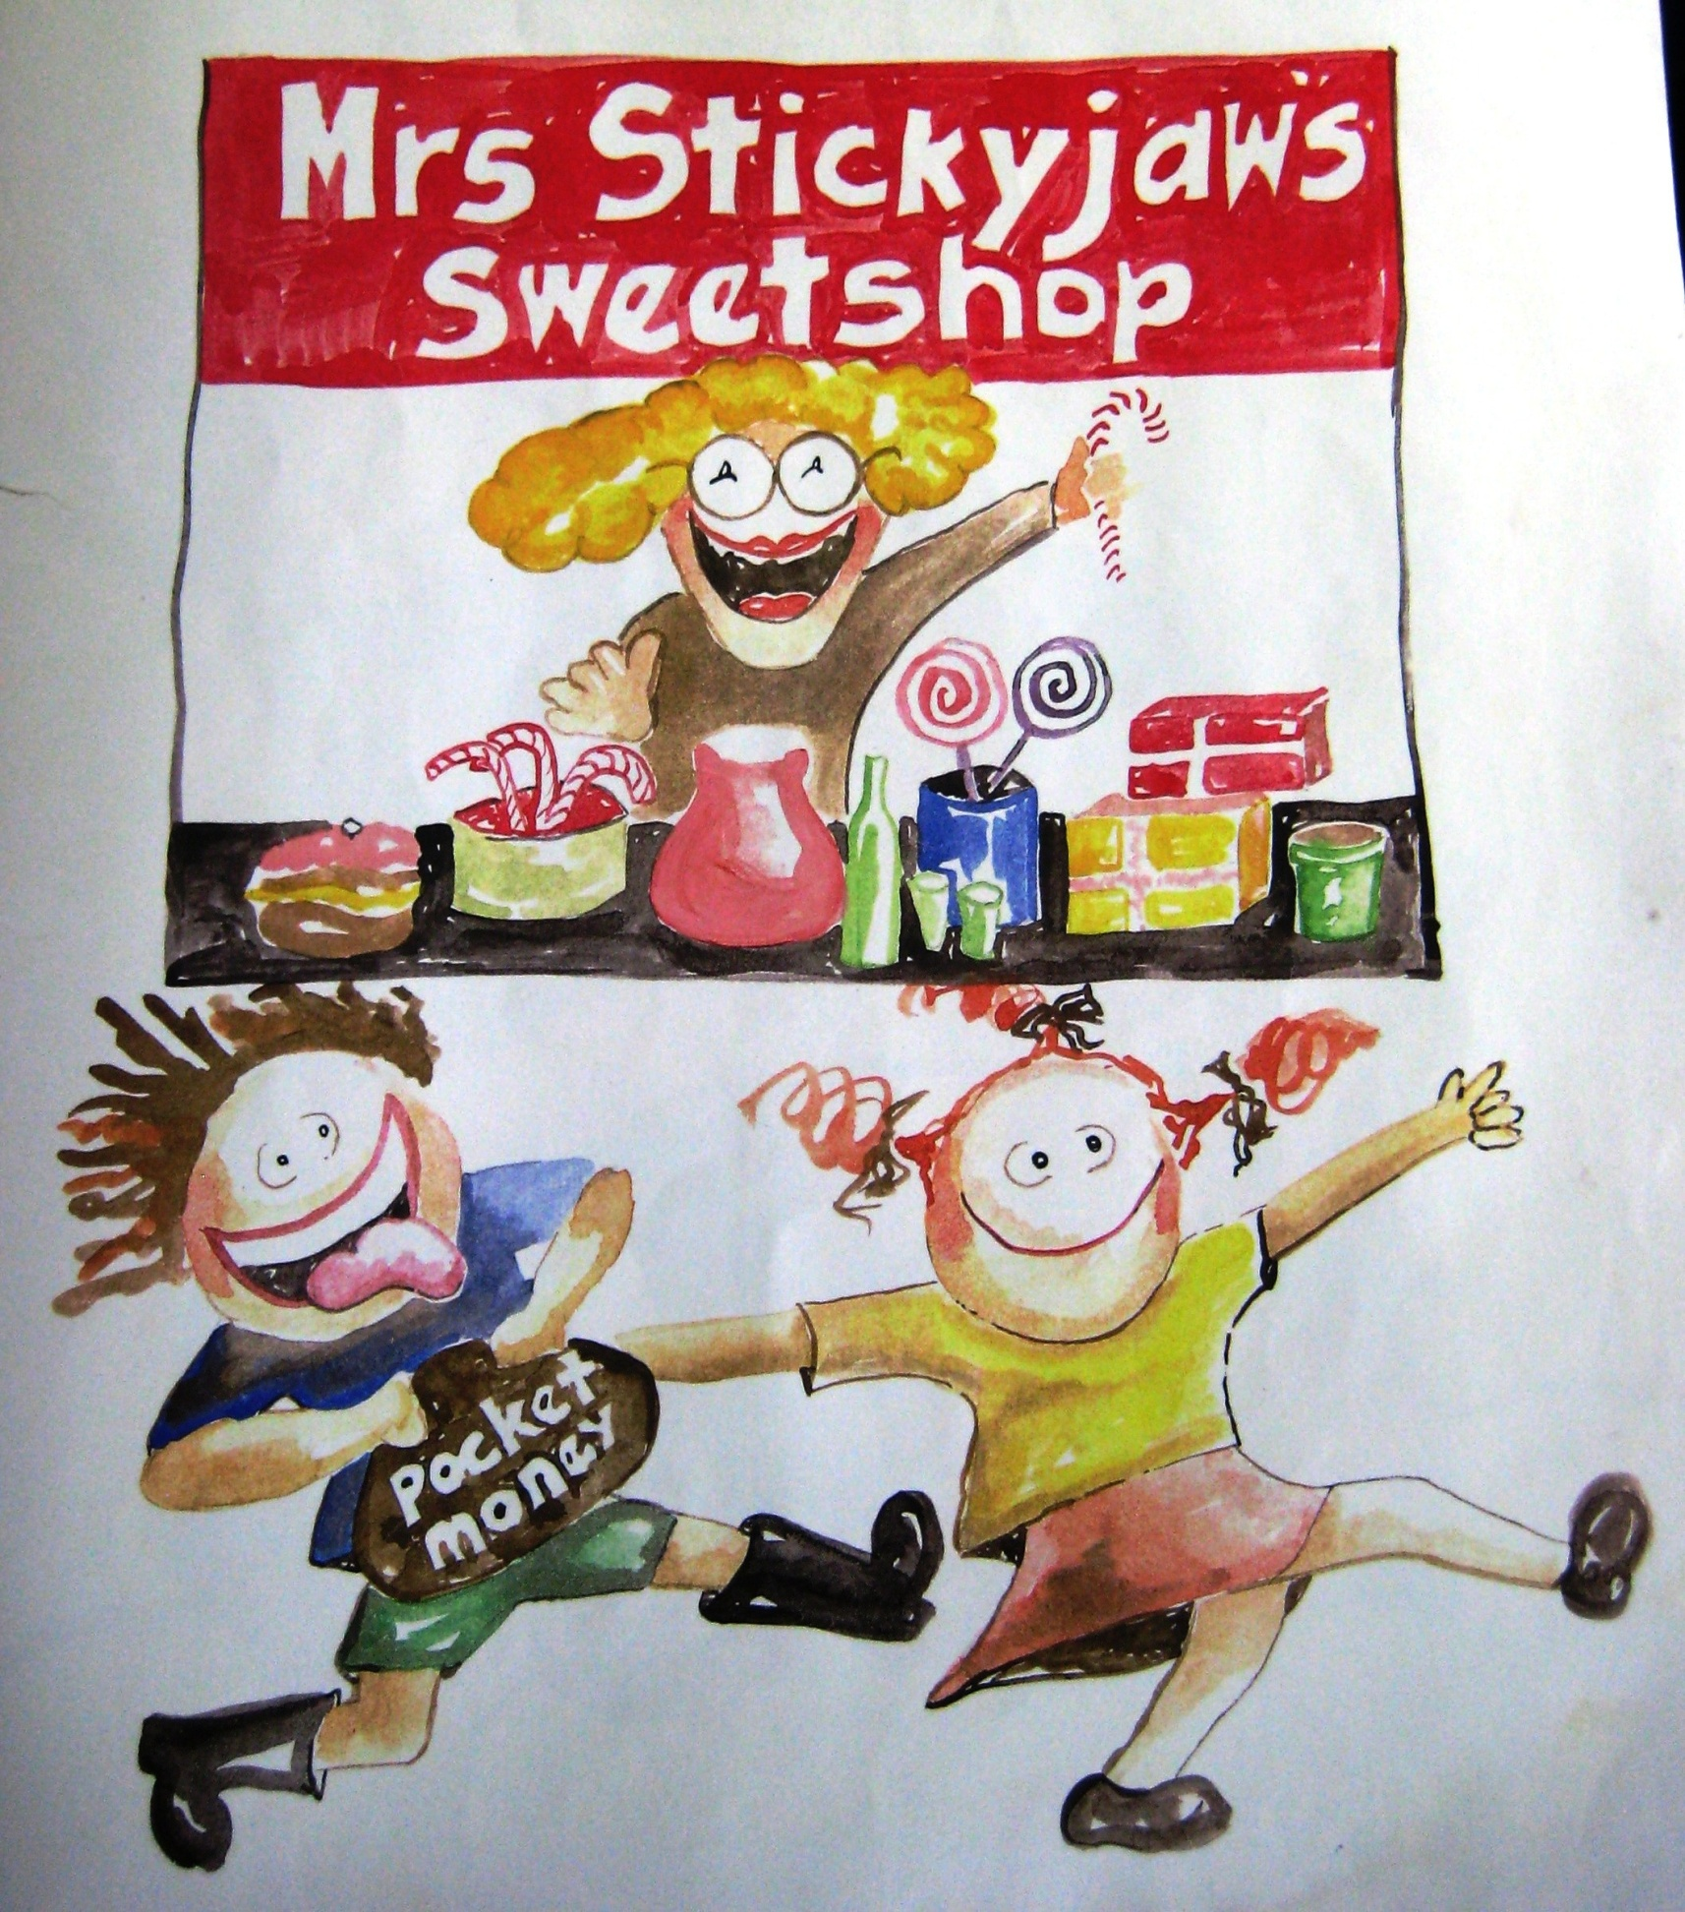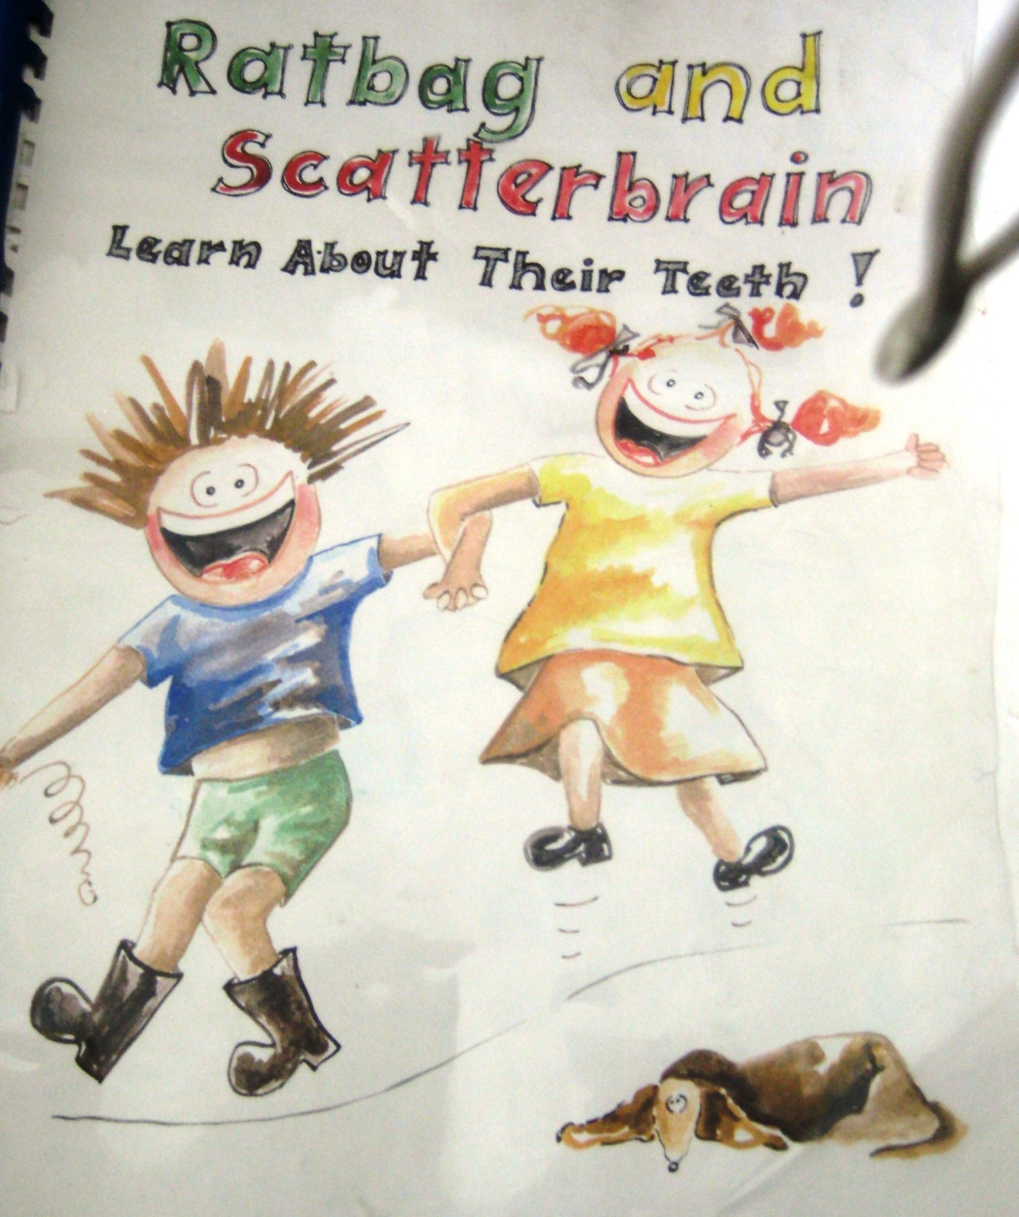
Taken from an article by Katie Lester and scripted by Jamie Brown
A cast of 6 (4 dentists, 2 nurses) and with local Ni-Van involvement
Cast; David Goldsmith / Hannah Watson, Rami Kuar, Scott and Robyn Sherwell, John Hazledine
Toothbrushing instruction and free samples of toothpaste and toothbrushes to be given to all children in the schools
