What is RAWCS ?
The RAWCS vision;
“To support Australian Rotarians and Rotary Clubs in assisting disadvantaged communities and individuals with humanitarian aid projects.”

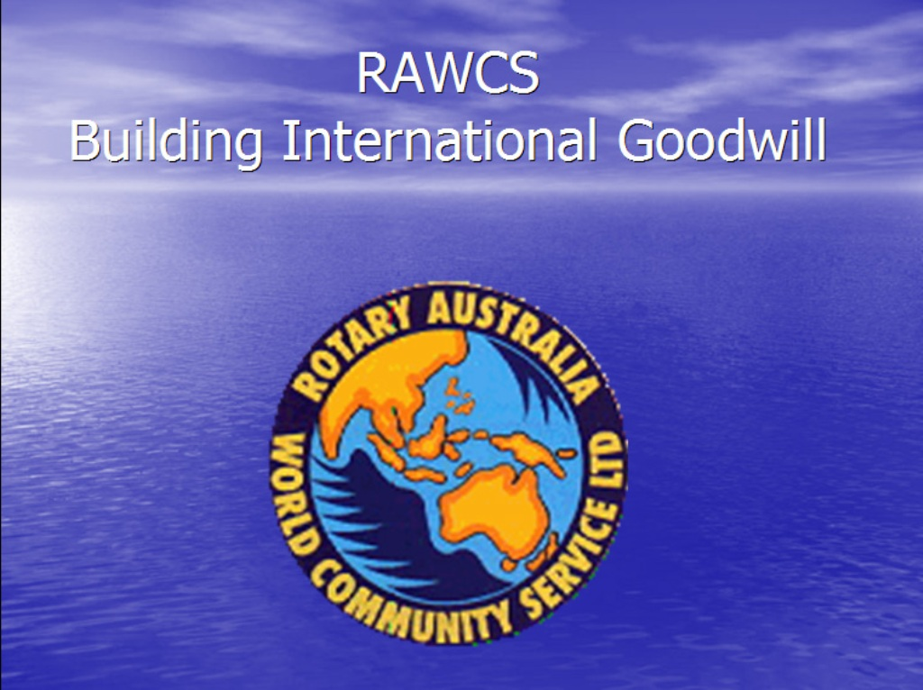

Traditionally RAWCS has been the Australian arm of Rotary International that assists Rotary Clubs with the development and management of International projects. As a result of its recent reorganisation into a National Rotary body RAWCS now offers more diverse opportunities for service projects here in Australia and overseas
As a result RAWCS is now the largest and fastest growing arm of Rotary in Australia.
RAWCS consists of several committees integrated together within the same organization

- PROJECT VOLUNTEERS
- DONATIONS IN KIND (DIK)
- ROTARIANS AGAINST MALARIA (RAM)
- SAFE WATER AND SANITATION SAVES LIVES (SSWSL)
- ROTARY AUSTRALIA BENEVOLENT SOCIETY
- ROTARY AUSTRALIA DISASTER FUND

RAWCS Projects are registered for three different purposes:

RAOAF – Rotary Australia Overseas Aid Fund is an Overseas Aid Fund to provide sustainable development aid in developing countries as identified by the Department of Foreign Affairs or short term relief for disasters.
RABS – Rotary Australia Benevolent Society is a Public Benevolent Fund to register projects within Australia to enable Rotary Clubs and District to provide assistance to people in need within their local or wider community.
DCDF – Developed Countries Disaster Fund is a Public Benevolent Fund to respond with cash donations to disasters that occur in developed countries. It is administered by a committee within Australia and a committee from a Rotary Club or District in the country where the disaster occurs.
ALL RAWCS projects must be sponsored by an Australian Rotary Club or District and wherever possible endorsed or partnered with a Rotary Club or District overseas. The only exception are RABS projects that are local and are sponsored and administered by the same Rotary Club or District.
RAWCS has seen unprecedented growth over the past 5 years

Why is RAWCS growing so fast? What has changed?
- Because RAWCS has arranged its structure to be fully compliant with Australian Government departments e.g AusAid / DFat / ACNC /ATO etc.
- RAWCS has changed from being a regionally based organisation to a National organisation with a full time office and paid secretary
- This ensures good governance and accountability for all its Rotary projects
- it has Designated Gift Recipient (DGO) status with the Australian Tax Office (note - Rotary Foundation does not)
- It offers a convenient and secure web based financial system for Rotarians and the public to make tax deductible donations
- Running costs not funded by Rotarians but from corporate and public donations (e.g. Rotary Foundation charges 5% to10% on all donations)
- Its web page contains all the information needed to source information from similar projects and / or countries to share expertise and avoid duplication
- Web page gives examples of projects in all 6 Rotary areas of focus
- Lists 462 current RAWCS international projects in 27 countries with their host and sponsor clubs and aims and objectives and contact information
- Experienced support, advice and training is available if needed
- Support is also available to enhance projects via DIK, SSWSL, Disaster Aid Australia etc.
- With RABS this now extends these advantages to projects within Australia
- CHECK OUT THE WEB PAGE www.rawcs.org.au

Project Volunteers
Is your club looking for an International Project?

All registered projects are listed on the RAWCS website www.rawcs.org.au
There are currently well over 450 open projects listed country by country and also by the 6 Rotary International areas of focus and with a search facility
Web site has all the downloadable forms and information needed to set up a RAWCS project – District chairs will guide you through the process if needed
Once registered, donations to any project can be made via credit card or direct debit and a tax deductible receipt is automatically generated.
This is a quick and easy way for the general public (and Rotarians) to make tax deductible donations to Rotary projects and the funds are immediately available for the project to use.
There is no levy on RAWCS donations from Rotarians or Rotary clubs – Trusts and public donations incur just 3% to cover RAWCS admin. costs (RF charges 5% to 10%)
For Rotary Club Treasurers this saves much administration work
These funds are audited and bank statements are reconciled on a daily basis.

Finances and project reports are forwarded to the Australian Government (Dfat/AusAID) so that Rotarians’ activities are recognised
This is also a convenient way for PAFs (Private Ancillary Funds) to help to fund Rotary projects

This is NEW!
Rotary Australia Benevolent Society (RABS)

This now allows clubs to quickly set up their own projects with tax deductibility and good financial governance for a Community Service project that arouses compassion in the community.
Great potential for clubs to use in fundraising for a local project

RABS Rotary Australia Benevolent Society

The ACNC Act requires that all Benevolent Society projects must address one of the following criteria that arouse the compassion of your community: i.e.
Poverty Sickness Suffering Distress Misfortune Disability Destitution Helplessness
The main requirement for RABS projects is that they provide direct relief to people in need. If the clients are disadvantaged, the relief should target that disadvantage, i.e. a place to sleep for the homeless, food and money for those in poverty, counselling and support of those in distress.
The relief provided must only be for people. Your project must also show that it works for a section of the community that clearly needs help, in other words 'people in need'.
'Public' refers to who your project, works for. The benefit can be for a section of the community (as long as it is needy) and does not have to be for the benefit of the community as a whole.
RABS has determined that our activities are predominately (at least 60%) the provision of direct relief. The RABS project approval process will carefully review activities to determine whether it is direct or indirect relief. Even if activities are direct, the clients must be suffering so as to arouse compassion in the community in order to make direct relief ‘benevolent relief’ and therefore come within RABS public benevolent institution requirements.

Contact person for RABS
PDG Lew Pretorius D9830 Email: lewp@precons.com
P.O.Box 214 Kings Meadows Tas 7249 Phone: H 6344 6183 B 6344 2686 Mob: 0438 131669

Some Examples of RABS projects
RAWCS is not just International – it is also Community Service

The first RABS project was to buy a motorised wheelchair for an orphan by RC Kingston – now seen daily on the streets of Kingston
Sharon Chan RABS appeal raised $1.2million in 3 weeks - featured on Channel 9 TV
Read the story - http://www.dailymail.co.uk/news/article-3185827/Watch-incredible-moment-widowed-mother-38-weeks-pregnant-told-800-000-donations-raised-support-family-including-son-syndrome-fighting-leukaemia.html
A tree fell on a car and caused the occupant to become a paraplegic - $60,000 raised to buy a wheelchair accessible car
A Melbourne rail commuter raised $31,000 for Syrian refugees in a day using RABS
Rachel Moore Family trust appeal (60 Minutes) – domestic violence
http://www.9jumpin.com.au/show/60minutes/stories/2015/september/5-little-heroes/
Helen Bertocci & Daughters (14 y o & 18 months) Trust Fund - Husband and father, Roger, was killed when he stepped in to break up a domestic dispute between neighbours - resulted in a RABS TV appeal
See http://aca.ninemsn.com.au/article/8970390/family-of-local-hero-share-his-legacy

What is D.I.K.? (Donations in Kind)

Another arm of RAWCS that is experiencing rapid growth with local depots at Geelong, Ballarat and West Footscray

- DIK is a recycling operation that specializes in reusable goods and is run by volunteers. Goods that organisations and the public no longer require are gathered and sent to people in genuine need for free
- DIK often gets first choice of goods because of the way it has structured its business
- It’s said to be Rotary’s biggest Australian Vocational project
- 98 containers were shipped to Third World countries last year from this Region
- Over the past 14 years every $1 invested in freight has resulted in $16 in goods shipped !!
- Rent at D9780 depots is free – at West Footscray it has to fund $50,000 annually from 5 other Districts
- Goods are available for any club project and whilst most go overseas, some material is available for local projects (NB Community & Youth committees)- all is needed is Board approval and a Project Wish list
- All Rotarians and clubs welcome to join in this work – more volunteers are needed!
- Club visits to the depots welcome – & expect to be pleasantly surprised!
- DIK Geelong depot Osbourne House, Swinburne St., North Geelong , next door to the Geelong Maritime Museum. Opening hours every Tues & Wed 9.00 am to 12 noon Melways 442 A8 Tel 0412 256 878
- DIK Ballarat Airport is open on the first Saturday morning of each month Tel 03 5335 9468

What is RAM?
Is it successful? YES - very !!
Incidence of Malaria has been reduced significantly in PNG and Solomon Islands. Over 9 million nets supplied to PNG by RAM
Adopt A Village project by clubs is very successful

Over 9 M nets supplied to PNG by RAM

In Solomon Islands

Where do we operate?
Papua New Guinea
Solomon Islands
Timor Leste
Vanuatu

ROTARIANS AGAINST MALARIA
Our Partners are
WHO
Bill and Melinda Gates Foundation
Australian Defence Force
Walter and Eliza Hall Institute

For further details on Malaria contact the National RAM Secretary in Melbourne
Virginia Turner vm.turner@bigpond.com

What is SSWSL?
Safe Water and Sanitation Saves Lives
WASRAG and START WITH WATER (a USA Rotary program)
Add clean water – reduce deaths by 5%
Add sanitation – improves to 35%
Add soap improves to 49%
Studies show that 96% of water projects in Africa fail within 4 years unless they incorporate sanitation
Advice is available from Rotarians experienced in water projects
e.g. Which Is the most suitable and reliable system for a particular area and how to source the equipment needed
See Rotary 3156 Wins v6 ppt. - This is a useful PowerPoint resource from Rotary International
Well worth looking into for those Rotarians proposing to be involved in water projects
Rotarian Bill Chapman has valuable experience in water and sewerage projects and is able to offer expert advice

DCDF – Developed Countries Disaster Fund
DCDF – Developed Countries Disaster Fund is a Public Benevolent Fund to respond with cash donations to disasters that occur in developed countries. It is administered by a committee within Australia and a committee from a Rotary Club or District in the country where the disaster occurs.
e.g. Cyclone Pam in Vanuatu and Nepal Earthquake appeals

Private Ancillary Funds (PAFs)
What are PAFs and how can they help with funding?
Private Ancillary Funds are trusts set up by companies to offer philanthropic projects through their Foundations. They are not allowed by law to undertake their own projects or make grants to individuals. They must donate their profits to a Deductible Gift Recipient and/or Tax Concession Charity.
They are strictly controlled by by law and have to distribute a percentage
of their profits annually. It is estimated there is $100 Billion in these funds in Australia
- RAWCS offers a convenient way for PAFs (Private Ancillary Funds) to channel these funds through Rotary
Because of its trusted brand, Rotary is seen to be an ideal organization to facilitate this process
The Rotary Foundation cannot facilitate this (RF does not have DGR status with the ATO) but RAWCS can and does (e.g. Cotton-On Foundation and RC Geelong)
RAWCS has set up a simple and trusted way for these PAFs to distribute their funds because its DGR status with the ATO RAWCS offers these companies the tax deductibility they require as part of their constitution.

R.A.W.C.S. Rotary Australia World Community Service
This is Rotary Australia’s World Community Service - there is only one other Rotary WCS in the World (New Zealand)
RAWCS has changed from being a regionally based organisation to a National organisation with a full time office and staff. This has come about due to the enormous expansion in its activities over the past 5 years
RAWCS offers a convenient and secure web based financial system for Rotarians and the public to make tax deductible donations and help with fundraising
With the introduction of RABS income is expected to more than double by 2019 to $70million
RAWCS is the largest and fastest growing arm of Rotary in Australia today; By contrast RF is stagnating

Complete details on the above and all forms, manuals etc. are available on the one website - www.rawcs.org.au
This site is continually updated

Local contact is ; Rtn David Goldsmith
D9780 RAWCS Chair
Rotary Club of Ballarat West
dgold@netconnect.com.au
03 5341 3451
January 2016
RAWCS nationally
2009 – 2014
$9 million
$33 million (latest figure ~ $40M)
With the introduction of RABS this is expected to more than double by 2019 to $70million

Value of RAWCS projects (not cash) as reported to DFAT
Southern Region
-> 2014
$3.2 Million $9.4 million
DISTRICTS 9780/ 9790/ 9800/ 9810/ 9820/ 9830

