Converting a shipping container into a new Dental Prosthetics Laboratory for Vanuatu
Rotary Club of Ballarat West
There is an identified need for such a facility in Port Vila with local support from Grassroots Vanuatu Rotary Club, Novodental private practice and the Presbyterian Church of Vanuatu (PCV). A free denture (and optical) service will be provided to Ni-Van people where dentures are completely unaffordable for the vast majority of the population
RAWCS Project 43/2014-15
August 2015

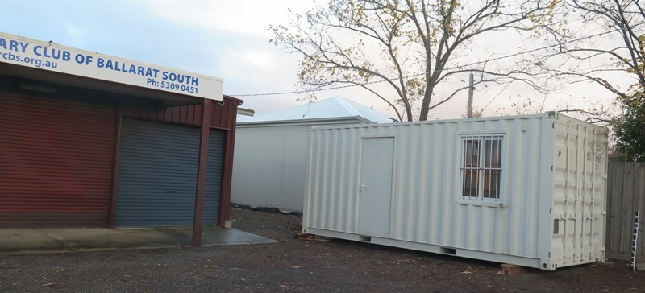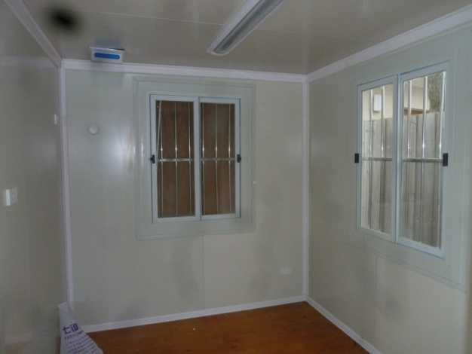
Project started off with this shipping container - RC Ballarat South generously allowed us the use of their facilities
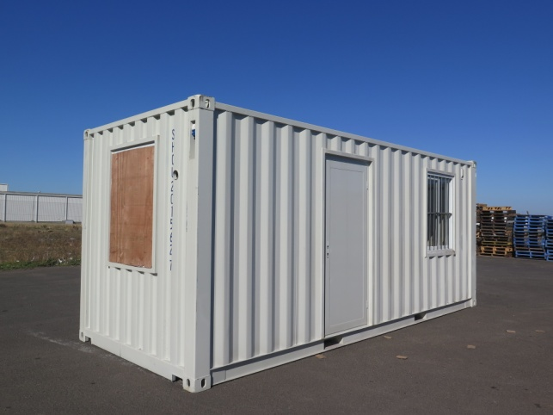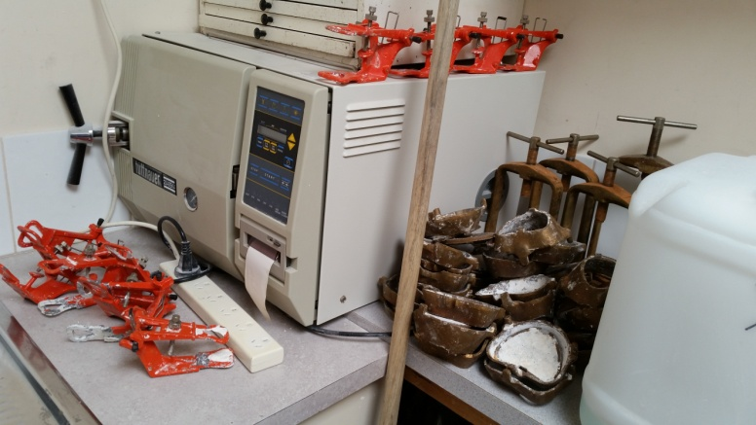
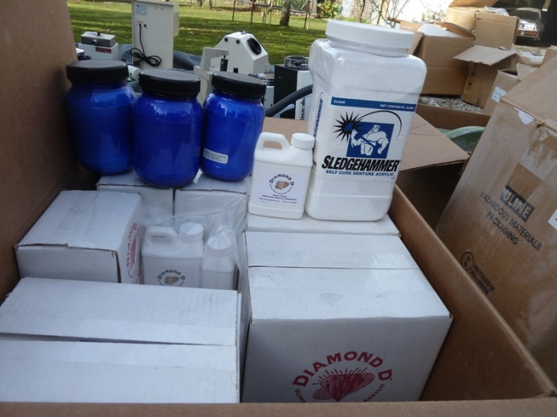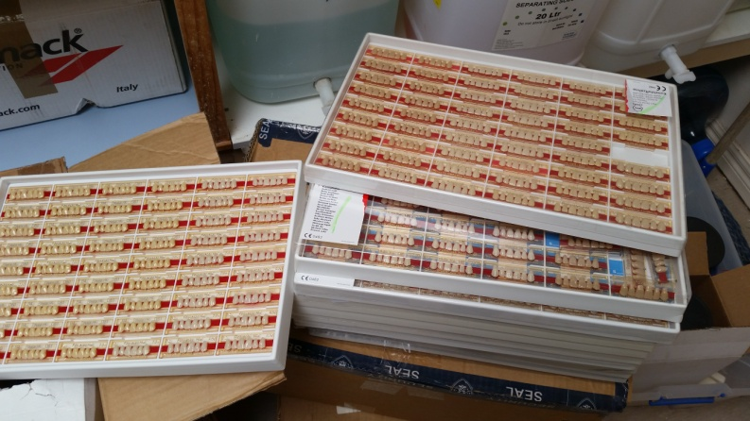
Large supply of acrylic and teeth sufficient to make several hundred new full and partial dentures
Much of the cabinetry and many of the fittings were recycled from the decommissioning of the Ballarat Health Services Dental clinics in 2015. Fitting out of the Lab. was done by volunteer Rotarians from the Ballarat West Rotary Club (particularly Daryl Elford and Paul Trevenen) and electrical work by Damian and plumbing by Terry Illingworth. Invaluable help and planning expertise and many equipment and consumables donations were provided by Ballarat Prosthetist Bill Davies. His son Ryan, also a dental Prosthetist will accompany the Lab. to Port Vila in April 2016.

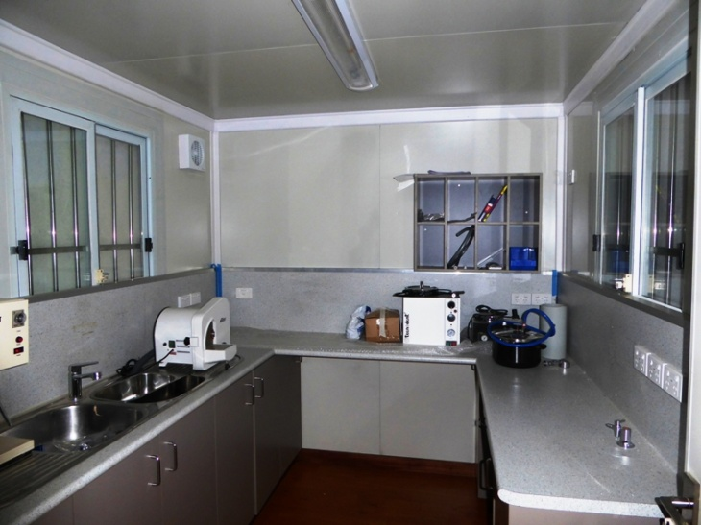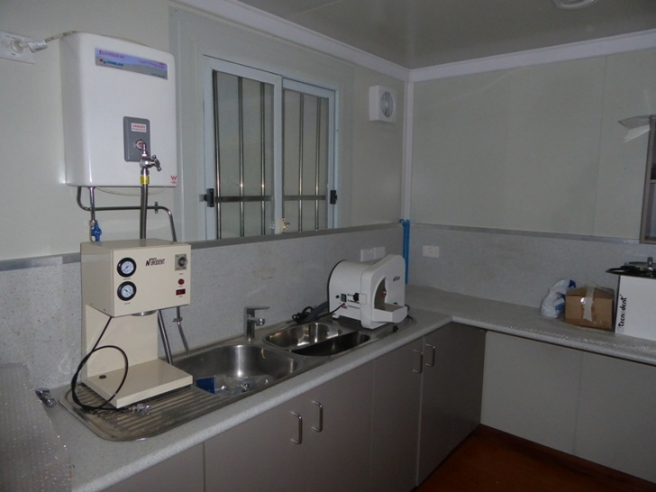
February 2016 .
Built on site in Ballarat this modified Shipping container comes with

- heat and sound insulation, fluorescent lighting
- 4 security windows with flywires and lockable doors,
- fitted cabinetry, flooring, ceiling , partitioning and overhead cupboards,
- separate air-conditioning for both rooms
- ventilation and power points for gas, compressed air and water,
- plumbing and rewired electrical installations all conforming to Australian safety specifications.
- Overhead and under bench Cabinetry in both rooms
- custom fitted bench tops,
- dental chair,
- stainless steel double drainer with strainer
- porcelain sink with modern taps
- soap and sanitizer dispensers,
- boiling water unit,
- autoclave
- metalwork ventilation and exhaust outlets etc. all installed professionally
- Gas piping, fittings and taps
- Hundreds of hours of volunteer skilled tradesmen work

Note; not all of the equipment in the Lab. is shown in these photos as some items are boxed up ready for transportation but everything needed for a modern Lab. is included, almost all of which is new equipment, stock and instrumentation

Equipment includes
- autoclave,
- vacuum plaster mixing unit
- vibrator to cast impressions
- 3 pressure curing pots for heat/ cold cure acrylic and repairs (all connected to compressor by quick release couplings and electrically powered),
- mouthguard and vacuum forming machine,
- two new brushless handpieces with drills, cutting and polishing tips,
- dual motor vacuum polishing unit with replaceable /pumice dust disposal bags,
- plaster trap with external connection to sewerage,
- air compressor in sound insulated box with external ventilation
- compressed air mallet and chisels
- complete set of new dental extraction instruments , local anaesthetic syringes, dental mirrors,
- diamond wheel model trimmer
- flasks and clamps for processing
- Ley surveyor
- electric wax softening unit for bite registrations
- gas taps and quick release air connections in all benchtops,
- pliers, spatulas, carvers,
- articulators, clamps for processing metal flasks
- lockable mobile cabinetry
- electric hot plate for boiling out flasks
- portable LED working light

Donated supplies include
- denture teeth and acrylic sufficient to make many 100s of dentures ,
- hundreds of metal and plastic impression trays,
- duplicating silicones, pumice
- impression materials, modelling wax, wax rope, SS wire, preformed clasps and cribs
- denture wax, denture boxes and denture cleaning brushes,
- 2000+ tubes of toothpaste,
- disinfectant, hand sanitizers
- 120 kg of plaster and model stone
PCV have a fully serviced site prepared ready to accept the container close to their existing dental clinic.
>>>>>>>>>>
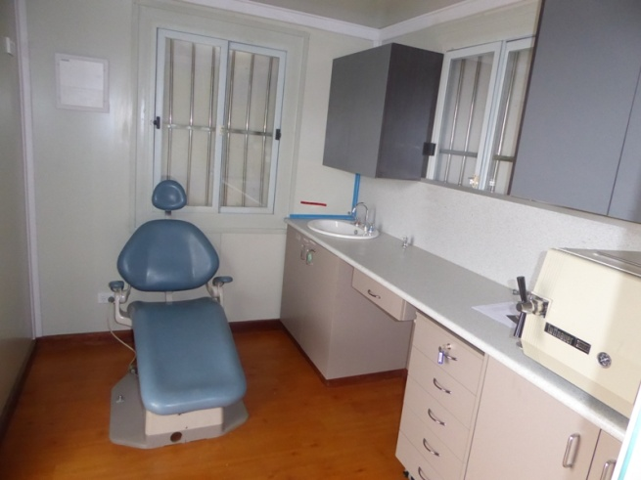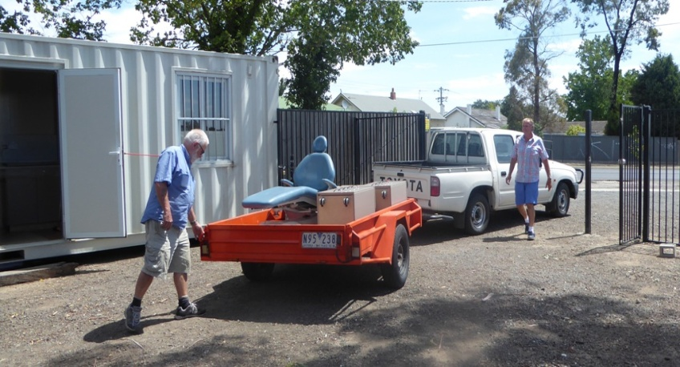
Completion date Feb. 22. 2016 then to ship to Vanuatu via Rotary DIK
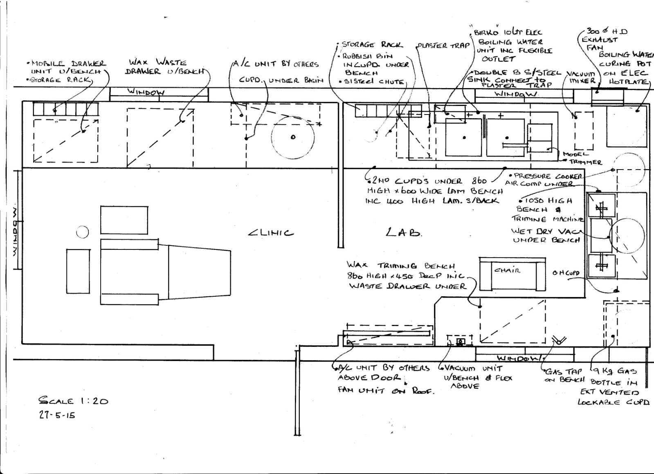
Original Lab. Container plan (to scale) - since added to and modified

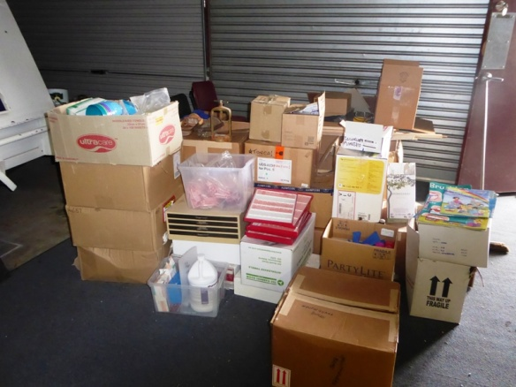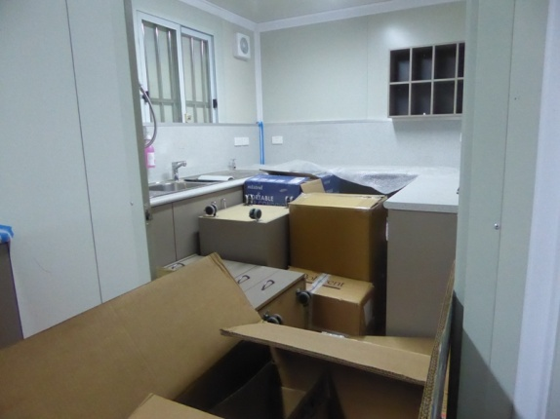
Some of the supplies and consumables to go into the Lab.

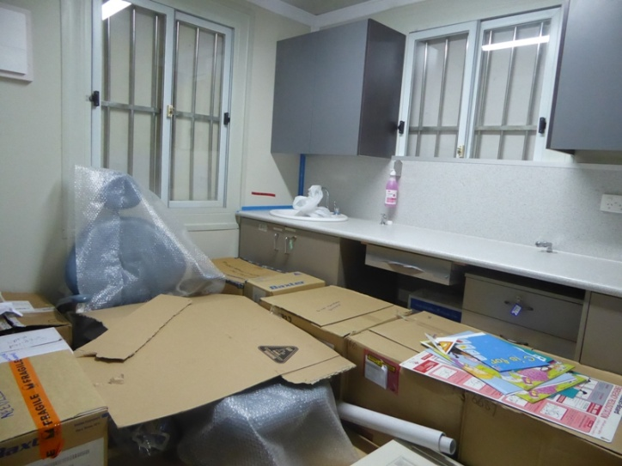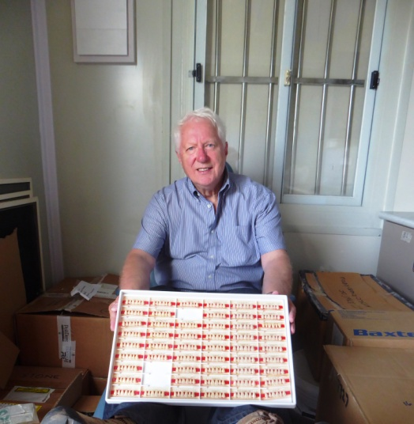
All packed and ready to go 22/2/2016
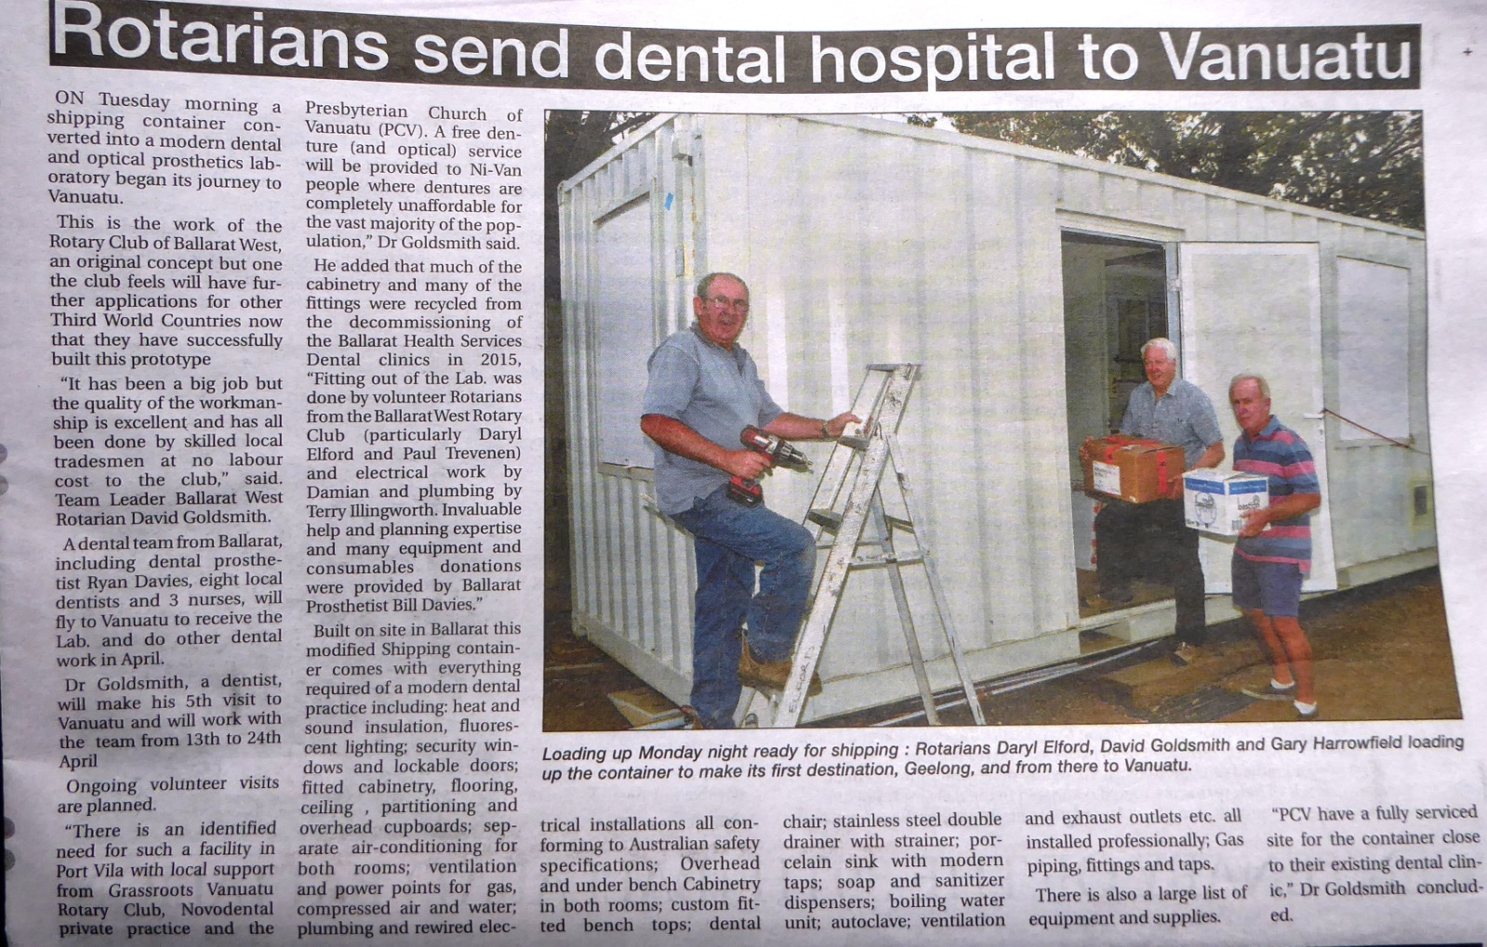

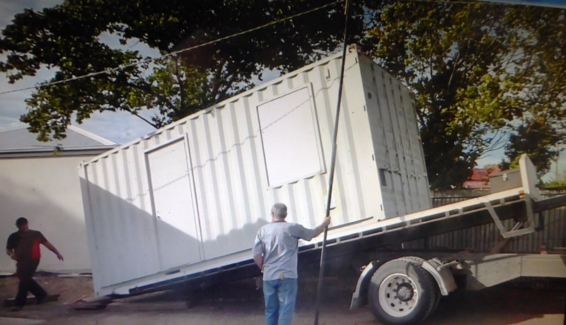

P.S. Pictures of the Rotary Mobile Dental Van in use in Vanuatu since 2013 Vanuatu RAWCS project 24/2012-13
This is fully equipped and used in the villages on the island of Efate to provide a mobile dental service that is not otherwise able to be delivered to the people of Vanuatu outside of Port Vila.

The new Lab. will add to and extend the scope of this ongoing RAWCS project

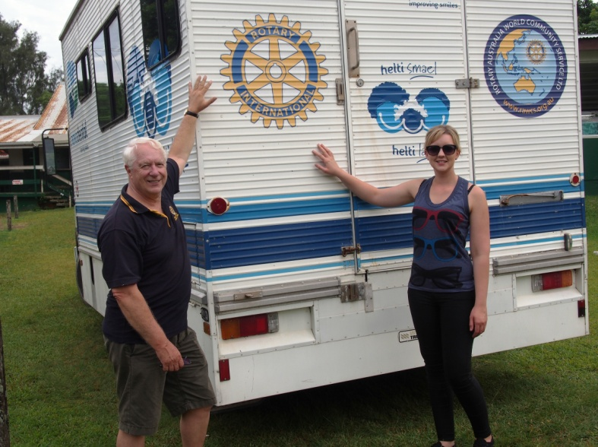
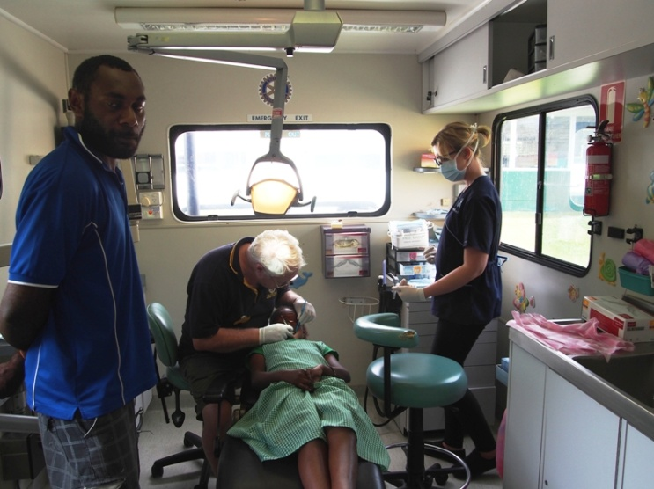
March 2014 working at Port Vila Central School
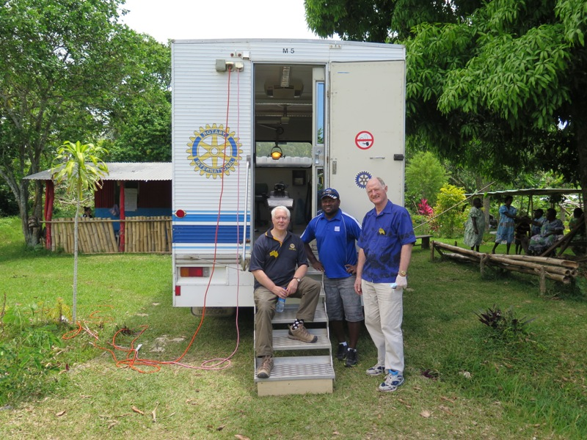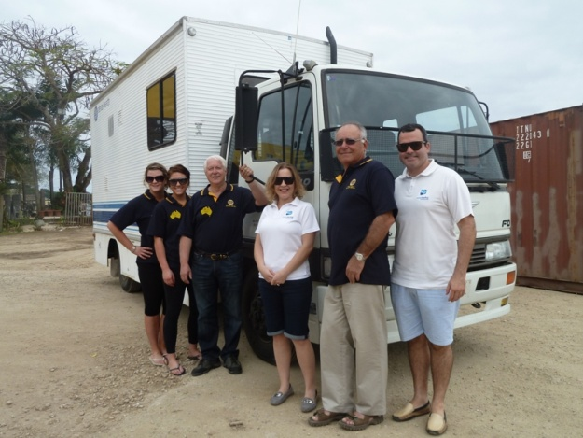
Below; August 2013 – handing over the dental van
October 2014 working in a Village on Efate
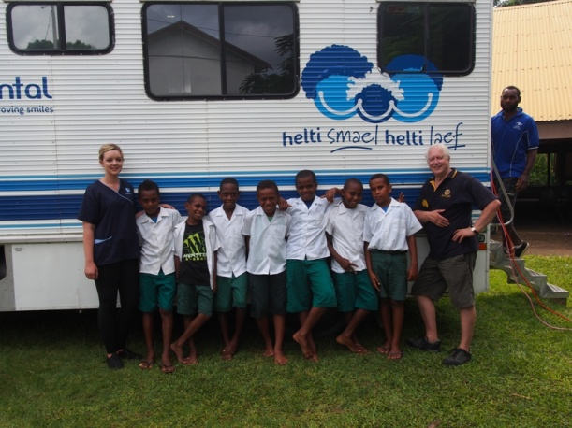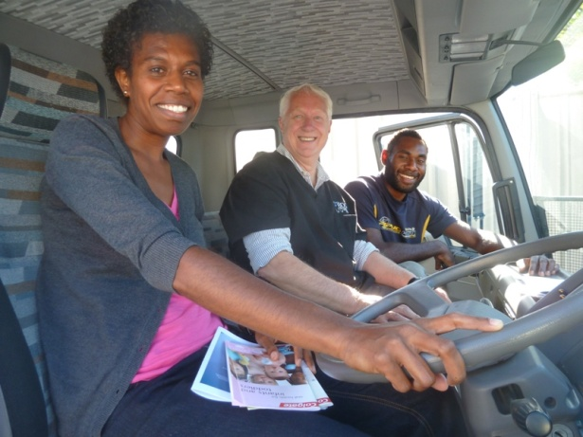
March 2014 Ni- Vanuatu PCV dental health workers Morinda & Bob in the Van
Dr. David Goldsmith B.D.S., L.D.S.R.C.S., F.I.C.D., F.A.D.I.
ROTARY CLUB OF BALLARAT WEST
c/o Ballarat Dental Group, 11 Lyons Street North, Ballarat 3350, Australia
dgold@netconnect.com.au

