List of Dental donations available for Solomon Islands. December 2015
3 dental chair /units (1 x Midmark, 2 x Adec,) FORK LIFT IS AVAILABLE TO MOVE THEM
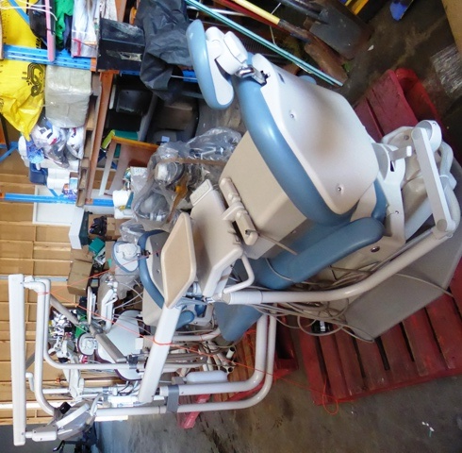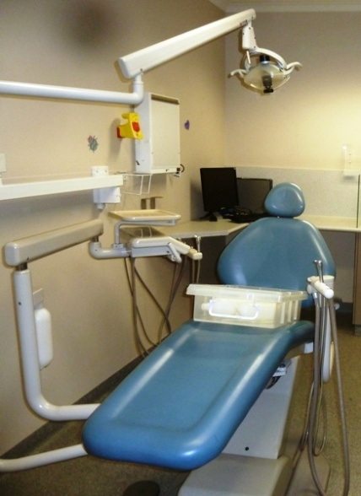
Adec chairs 1600 X 1000 X 750 WEIGHT 800KG - ON PALETTES

4 dental stools 1000 x 40 x50 Weight 25kg each
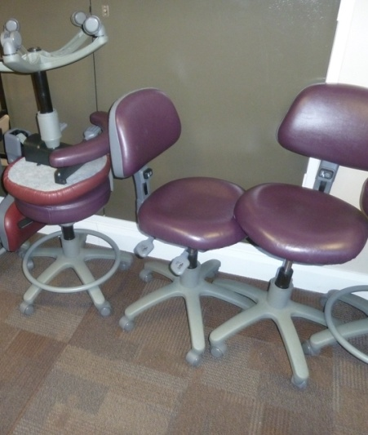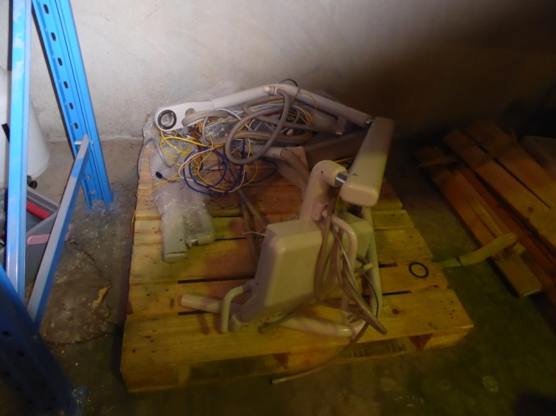
Spare parts for the Adec chairs weight 200 kg
4 mobile cabinets 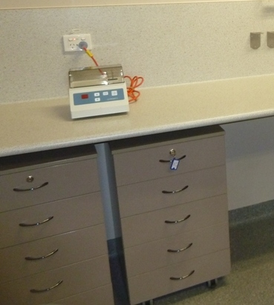 500 X 500 X 800 80KG. EACH
1 Cattani Central Suction Unit (ability to cater for up to 8 surgeries)
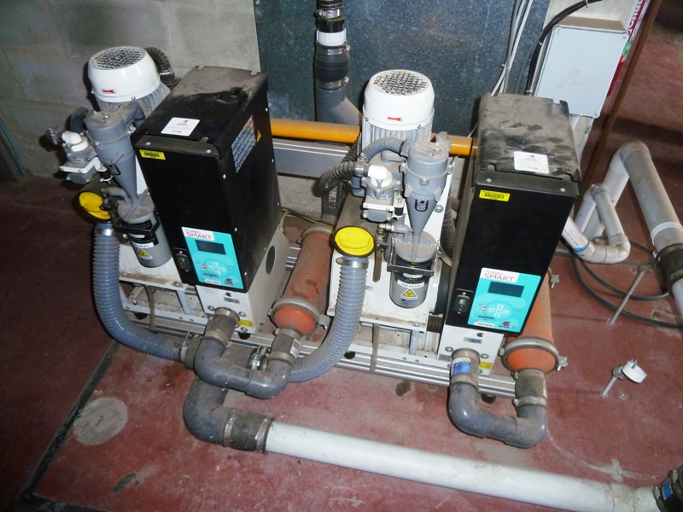 1000 X 800h WEIGHT 500 KG
Cattani Oil Free Air Compressor (ability to cater for up to 8 surgeries)
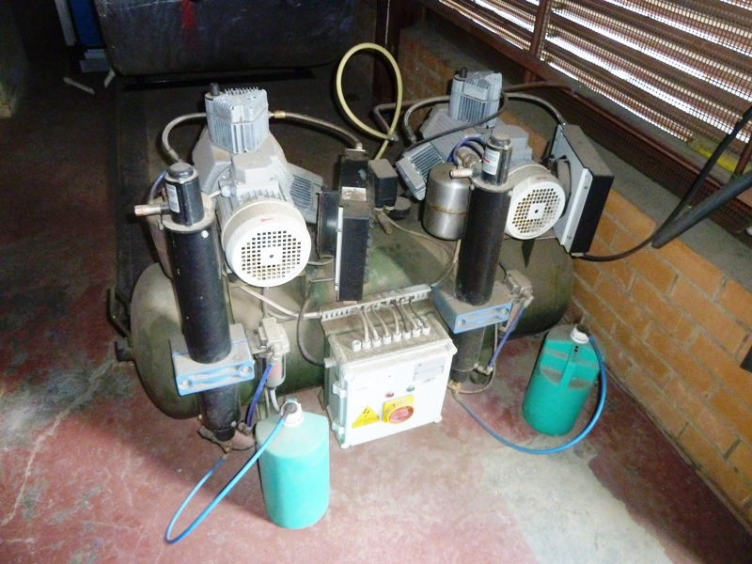 1000 X 800h WEIGHT 500 KG
4 Dental X-ray Units and wall mounted timers (2 x Belray, 2 x Progeny)
500 X 500 X 100 TOTAL WEIGHT 300KG ON A PALETTE
4 x-ray machines - IMPORTANT - timers for two of the units are inside one of the cabinets
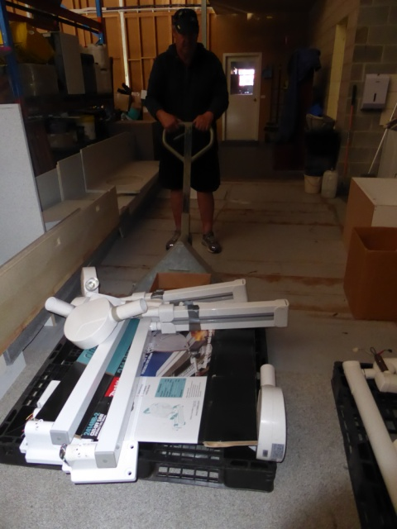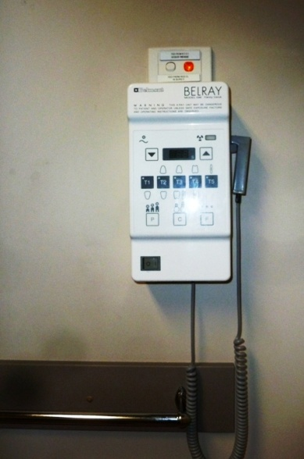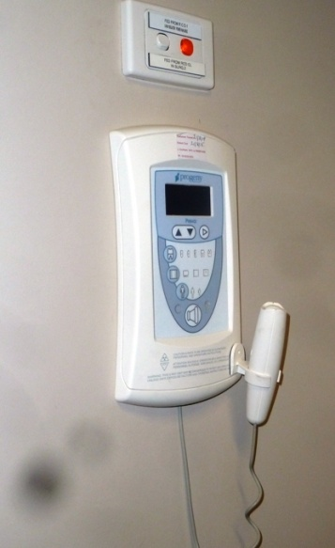
3 Amalgamator mixing machines 20 x 20 x 20 weight 5kg each
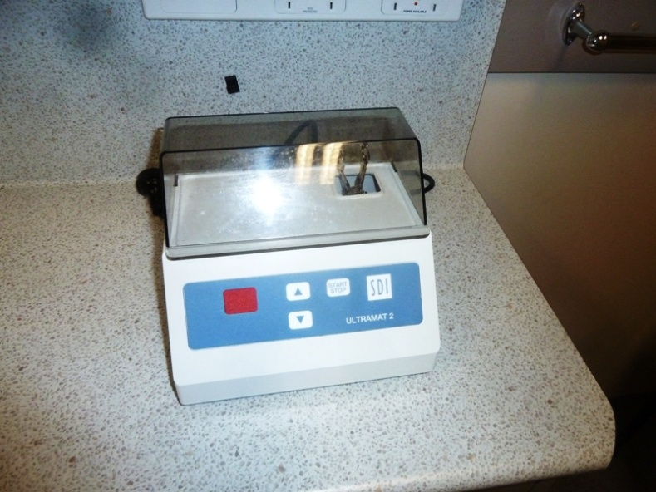
2 Midmark Dental Autoclaves with printers and drying cycles
Weight 35 kg each
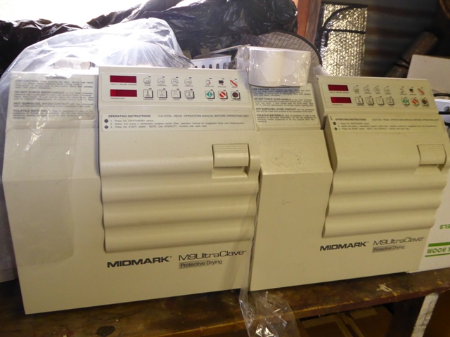
+ Assorted Dental supplies and materials, especially dental prosthetics
4 Cupboards 600 x 600 x 800 Weight 50 kg each
Stainless Steel and Porcelain sinks, inside
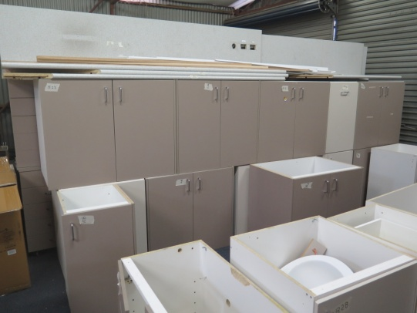
Please contact me at dgold@netconnect.com.au if you would like further information
David Goldsmith
Tel. 03 5341 3451 / 0488 688 700

