Donations for Tonga 2016

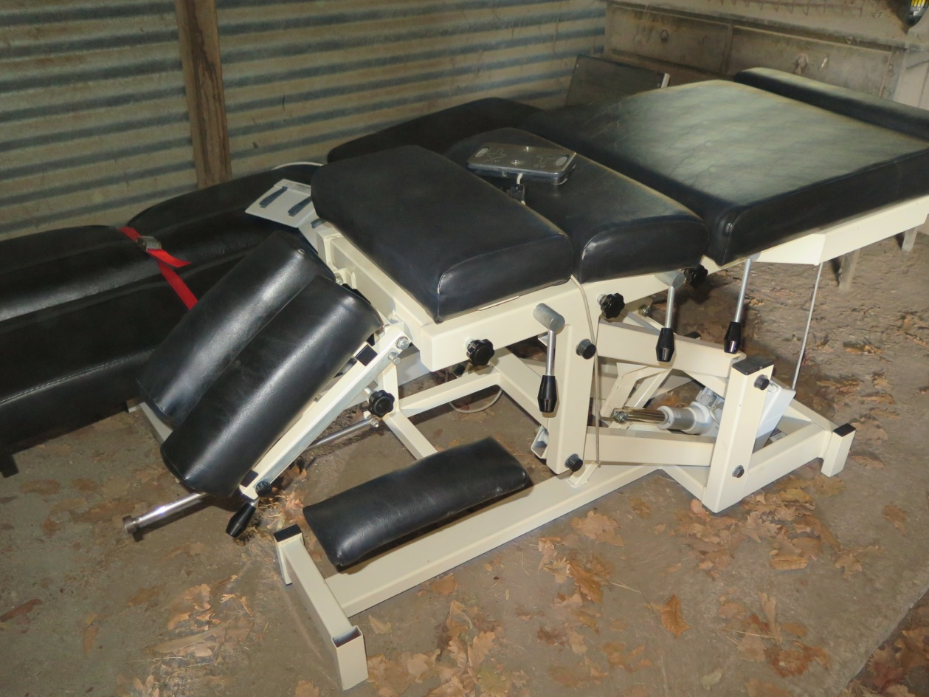
\Chiropractic chair for Nuku'alofa Hospital

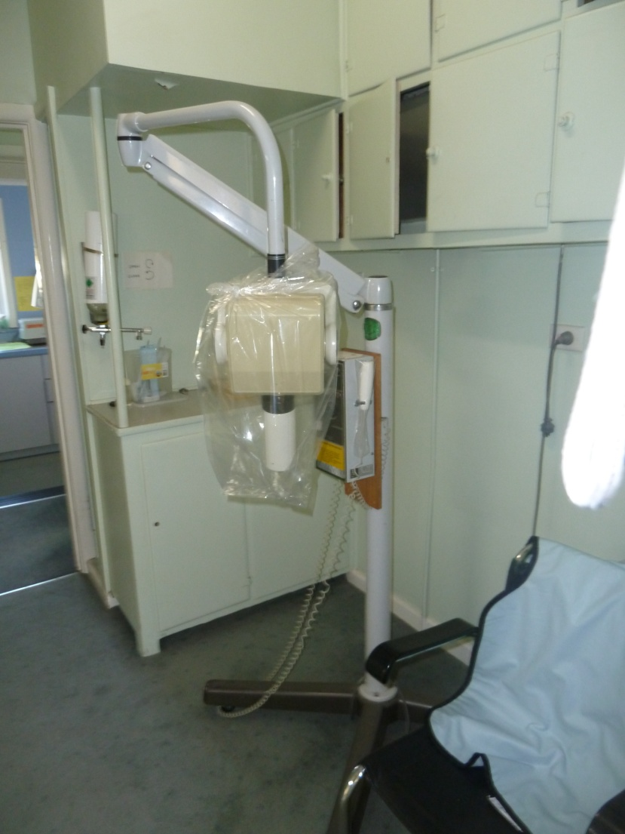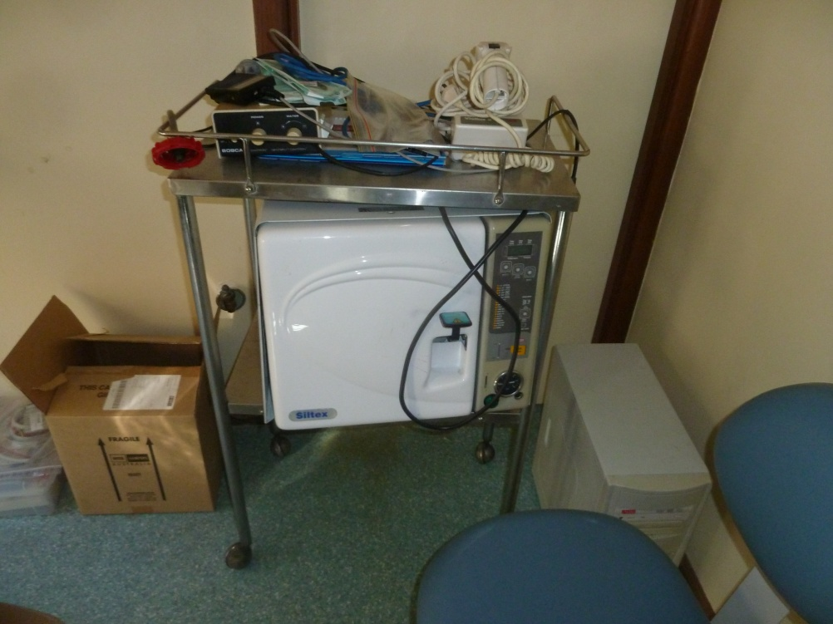
Dental chair, portable X-ray machine, autoclave, curing light etc. for Ha'afeva or Nomuka islands, Ha'apai Tonga

