Dental donations sent to Port Vila Dental Hospital from RC Ballarat West
Trailer provided by Paul Trevenen and Paul helped to pack the trailer with goods stored at the Rotary Club of Ballarat South Shed
More equipment added from Dick Parry’s store

Taken to Geelong DIK on October 27th. by Daryl Elford and David Goldsmith from Ballarat West Rotary Club

Everything packed into the DIK container for Vanuatu which sailed 23/11/15 ETA Port Vila December 5th. to add to the BHS Medical Suction Unit and a considerable amount of Hospital / Medical items from the DIK stores

Shipping charges paid for by the Vanuatu Ministry of Health with a MOU arranged by John Oswald

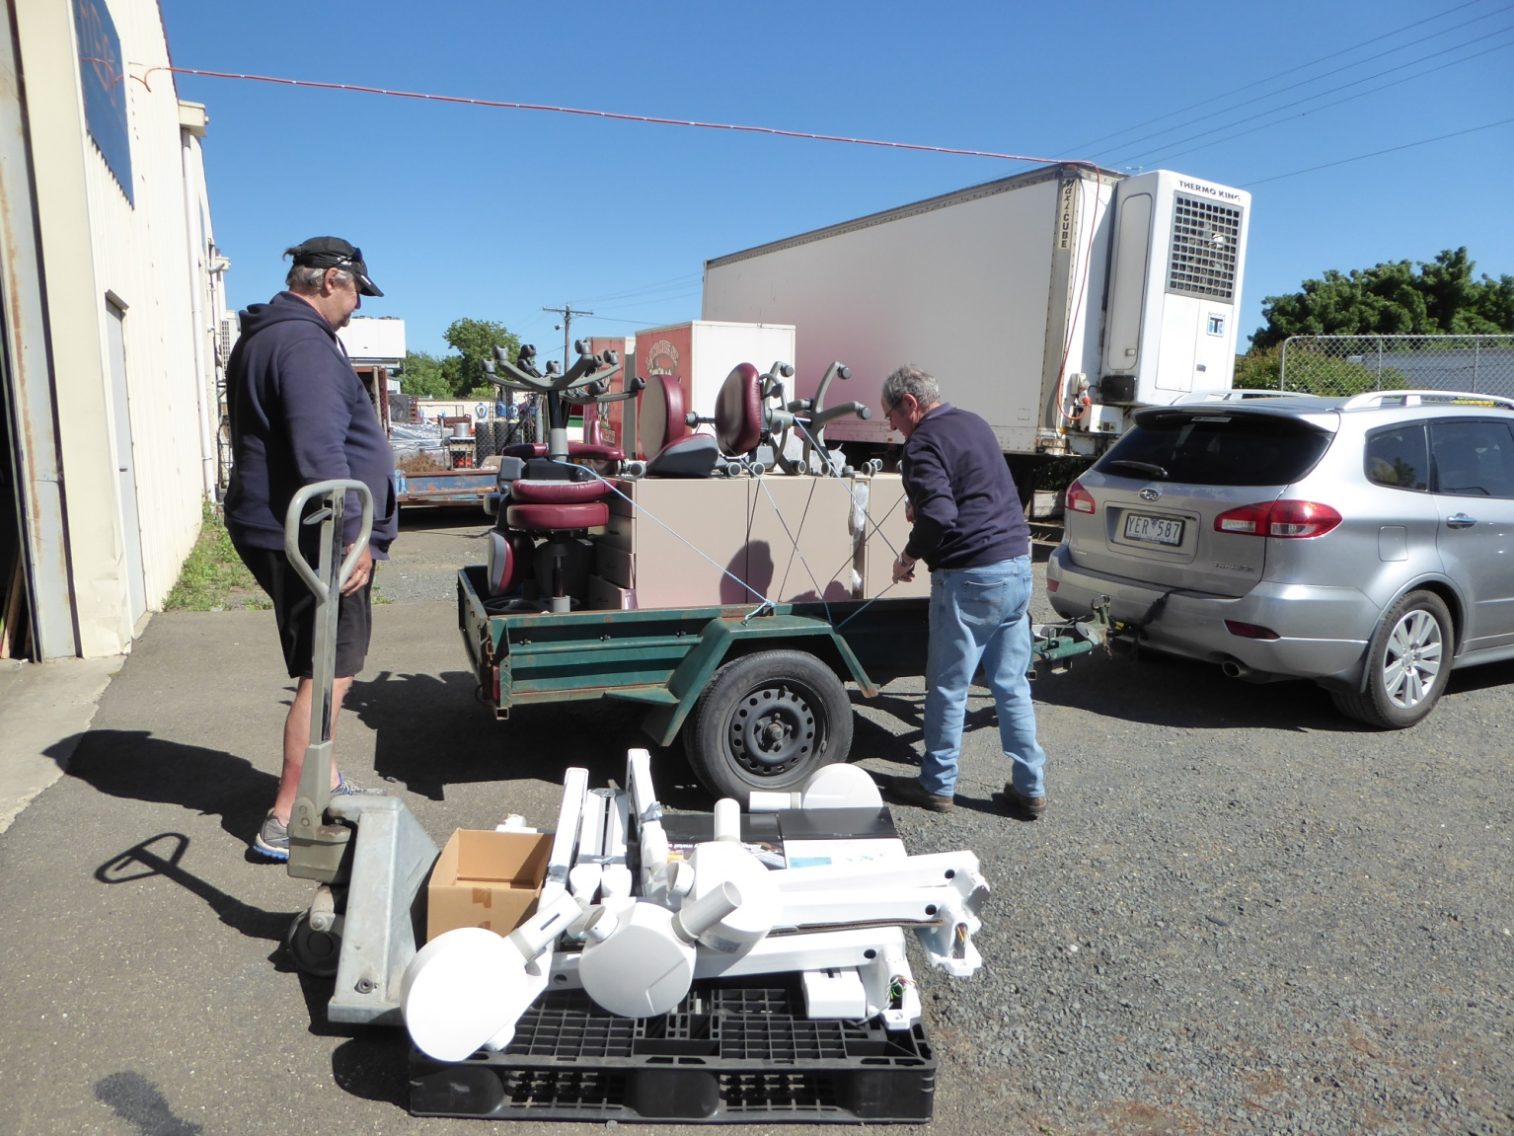

Dental Clinic Items
4 x Belray dental X-ray units (arms +timers separate)
6 dental stools (3 dentist, 3 dental nurse chairs with arms)
6 mobile dental cabinets (with lockable drawers)
3 oval porcelain sinks with taps
3 dental amalgamators
3 sets of towel rails, coat hanger boards and door protectors together with backing boards
4 x soap holders
1 clock
2 paper towel holders
2 X-ray viewing boxes
2 safety scalpel blade removers
~3 Dental Formica benchtops with rounded ends

Dental Lab. Items
Cold Cure 1lb.acrylic powder/liquid 8oz x 2
Heat cure acrylic 1 lb. powder/liquid 8 oz. X 2
Approx. 500 sets of denture teeth
Vacuum Plaster mixer
2 x Clamps, 6 x Flasks, 8 x Articulators
Mouthguard machine
Model trimmer
(also a die trimmer available if needed)
2 x Bench grinder/polishing motors
Sandblaster
Duplicating Silicone (12 bottles)
Pressure pot for denture repairs
Electric wax heater for bite registrations
Large number of assorted metal impression trays (?80)
Assorted dental supplies, antiseptics etc.

Estimated total value ~$60,000
a Medical Suction Unit for Port Vila Hospital
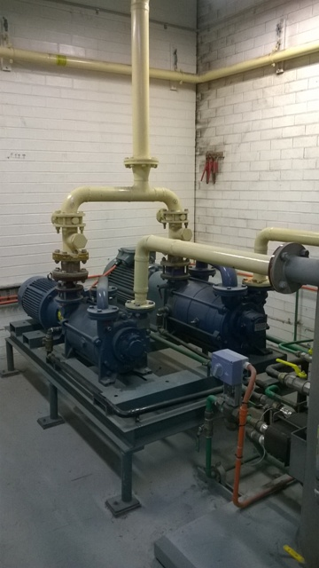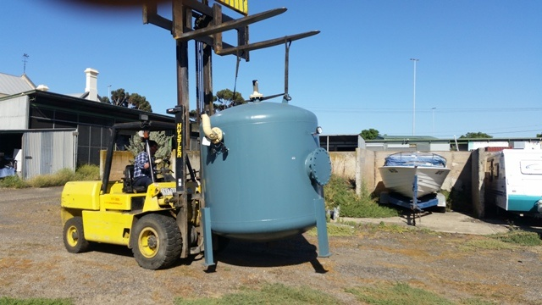
Plus, from DIK Rotary stores - 14 pairs of crutches, 109 bags of hospital linen, 26 boxes of face masks, one autoclave, 3 mobile dental cabinets, 12 shower chairs, 24 walking frames, 23boxes of hospital crockery, 75 boxes of medical equipment

David Goldsmith
Ballarat

