FOUR-WAYCONTEST
April 6, 2024
TIMELINE: 2023-2024

December 2023: Contacts should be made to high school. Club competitions should be completed.
Names of local club winners must be submitted to Elwood Walker
or Sandra Lang

March 1, 2024: Club competitions completed

March 15, 2024: Names of District Club winners submitted to Elwood Walker or Sandi Lang

If your Club is not participating this year, we would appreciate it if your Club would contact one of us as soon as possible with that information. It will save us from contacting your Club. We want all the contestants to be listed in the program, but each year someone shows up that we were not expecting. It is the Club's responsibility to be sure that their contestant is registered.

April 6. 2024: District Competition at Fairways at Arrowhead
Location: Arrowhead Golf Club
Place: 1500 Rogwin Circle, SW North Canton, OH 44720 Time: 9:00 AM-1:00 PM

Note: Contestants should arrive between 8:30 AM and 8:45 AM the day of the contest for registration and position assignment.

At registration, please submit a copy of the speech and the permission slip signed by the
school principal.
For more information, contact:
Elwood Walker:
301 Custer Orangeville Road (PO Box 88)
Brookfield, OH 44403
Home Phone: 330-619-5174
Cell Phone: 330-718-6210
E-Mail: emwkmw4446@gmail.com

Sandra Lang:
2924 Cloverhurst Street, NE
Canton, Ohio 44721
Phone: 330-432-4706
E-Mail: sk_lang@hotmail.com
ROTARY FOUR WAY TEST SPEECH GUIDELINES

Frequently Asked Questions:

What is the most important thing for students and teachers to remember about the 4Way competition?

Prove the relationship between the 4 Way parameters and the topic.
Is it the truth?
Is it fair to all concerned?
Will it build goodwill and better friendships? Will it be beneficial to all concerned?

The major theme should be something that the student is passionate about and should demonstrate the relevance to today's needs in the community. Some past winning topics have been recycling, communication barriers, moral conduct, and discrimination.

What are the judging parameters?
Speeches are judged on the following areas:

Content: Originality of topic, organization, clarity, clear relationship to the 4-Way Test, use of supporting examples.

Delivery: Poise, enunciation, bodily expression, use of voice, ability to impress audience.

Time: All speeches should be no longer than 7 minutes and no shorter than 4 minutes. 3 points should be deducted from the score for every minute under 4 and over 7 minutes in length. There is a 30 second grace period with no penalty, however, the teacher may want an administrator and/or a Rotary member to judge. In most cases, it is beneficial for the class to do the judging because it can be used as a teaching tool.

What does the student need to bring with them to the competition?
When a student is selected to participate in the District Competition, the permission signed by the principal must be emailed or mailed to one of the District 4 Way Chairs. If this cannot be arranged before the District Competition, the slip can be presented at the time of participation when the copy of the speech is also presented.

Who can participate in the competition?
Any student in Grades 9-12. The students can be a part of an English, Speech or Communications class and should be sponsored by either the school or the local Rotary Club.

When should the local competitions take place?
A timeline sheet is sent to all Rotary clubs in November. Local competitions should be held either at a regularly scheduled Rotary meeting in early March or at a special designated time in March before the District Competition held in late March or early April.

What kind of prizes are awarded?
Each Rotary should decide what kind of awards the contestants should receive.
Suggested prizes are gift cards and monetary prizes for the top 3 winning positions. When ONE local Rotary club winner is sent to the District Competition, the representative could win between $50 to $300 for 1st- 4th place.

Are there any tips for Rotary club competitions?
- If Speech or English classes write and perform the speech as a project for the entire class, the class can use the provided judging sheet to decide who will be sent to the local Rotary club.
- The speaker does not need to stand behind a podium. In fact, if the speaker steps away from the podium and moves only from center to one side, to another side, back to center, the speeches appear more interesting. However, “wandering” is distracting. If movement is used, make sure that the move is made on a specific point.

- Note cards can be utilized but speeches are better received without notes. Props are not allowed.
- Each Rotary club can decide if several competitors (suggested 6—8 max) should be used as a program at a regular Rotary meeting or if a special meeting should be set up for the participants, their parents and Rotary member.

- If there is a competition held at the Rotary meeting, three members should judge the participants. When the judges leave the room to tally votes, have the participants discuss their plans for the future, etc. Invite the teacher whose students used this as a project and let the teacher discuss what is taught in the class.

- Prizes should be awarded to the participants at the time of presentation. There can only be one local winner sent to the District competition.

- To acquire more school participation, the Local 4-Way Rotary coordinator should contact the superintendent or the principal with a phone call followed by a letter.

WHY THE 4-WAY TEST?

The 4-Way Test consists of 4 short questions, 24 words, which can make a difference in our lives. It reads:
Is it the truth?
Is it fair to all concerned?
Will it build goodwill and better friendships?
Will it be beneficial to all concerned?

The 4-Way Test encourages us to examine our patterns of choosing, evaluating, and acting. It is an objective guide which we can use in deciding how to best to respond in any given situation.
There is a great difference between winning success end being a success. Many people have the first without the second. Just as important as winning the respect of others is to enjoy self-respect.
The 4-Way Test helps us as we go about choosing and acquiring our desired prizes, to keep our inner eye open to what we are becoming, not just the prizes we strive to acquire. These 4 questions can stimulate meaningful growth-inspiring answers for the person who will test his or her thoughts, words, and actions by thein.
The 4-Way Test does not provide answers but encourages creative and effective solutions in problem solving situations. “You sow a thought, you reap an act. You sow an act, you reap a habit. You sow a habit, you reap a character. You sow a character; you reap a destiny." It all starts with how we think.
The 4-Way Test carries us out beyond the self into the lives and concerns of other people. It deals with human relationships We may be making remarkable progress technologically, but we still get bogged down at times in this area of human relationships. It is a critical problem when we consider that even without entire computers, etc., nothing can be accomplished in this world, except through people-ourselves and others working, playing, communicating with each other.
The 4-Way Test recognizes that the welfare of each individual is linked with the welfare of all of us. Used, it can create an attitude and atmosphere in which people can better relate, share, and implement ideas.
The 4-Way Test does work when applied in people's lives and has been proven all over the world. Today, the 4-Way Test is translated into the languages of more than a hundred countries. It sits on the desks of more than 500,000 business and professional leaders in America alone; is on the walls of schools, libraries, factories, and business offices around the world.

The author of the Four Way Test, Herbert J. Taylor, was the 50th president of Rotary International (1954-55). The four questions which comprise this test came to him as an answer to prayer. Today the test is known and practiced worldwide.

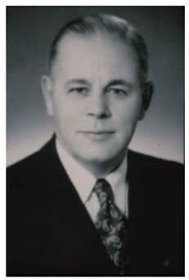
Following his discharge from the Navy after World War I, Herb Taylor went home to Chicago, married the young woman who was waiting for hm, then started his business career in Pauls Valley, Oklahoma, located in District 5770. During his 4 1/2 years there, he became a Rotarian and a strong advocate of community service. Back in Chicago he moved rapidly up the ladder with Jewel Tea Company. In 1930, while executive vice president of the company, he was asked by a bank representative. to Spend half his working time helping another company avoid bankruptcy, and at the same time help save 250 jobs during the peak of the depression.
It was agreed that the failing company, Club Aluminum, could contract 1/2 his time. He soon discovered the company was immersed in lawsuits and $400,000 in debt. No one else thought it was a wise move but, feeling confident that this was the plan for his life, he resigned his $33,000 a year job, borrowed $6,100 on his Jewel Tea stock, and wound up as President of Club Aluminum in 1932. His new salary was $6,000 per year. Herb knew if
the employees of his new company were to think right, they would do right, so his priority was to set ethical business standards. What was needed was some sort of “yardstick"; an easily remembered guide. After searching unsuccessfully through books, he did what he usually did with his problems...he leaned on his desk, rested head on hands, and prayed. After a few moments he reached for paper and pencil and wrote the 24 words which are so well known to Rotarians:
Is it the truth? Is it fair for all concerned? Will it build goodwill and better friendships? Will it be beneficial to all concerned?

The first business across his desk that day was a tear sheet of some advertising where the product was billed “fee greatest cookware in the world'. Knowing this could not be proved, he gave instructions to eliminate all superlative advertising, and to use only facts. After two months, he called in his four department heads: A Catholic, A Christian Scientist, A Jew, and a Presbyterian, and asked if there was anything in the Four Way test that was contrary to their religious or moral beliefs. After scrutiny they approved it and agreed to use it.
All employees were then encouraged to use the Test. The test was printed on the back of all business cards. Salesmen were encouraged to say something like °of course I can't live up to it perfectly, but I'd appreciate your help. Whenever you find I am not living up to it, let me know and I'll try my best to change”. Instead of persuading a dealer to take more than he needed, the salesmen would determine what the dealer could reasonably sell, then provide tips and materials to help the sales. Renewed confidence became evident in the dealers and, as this feeling was passed on to customers, sales began to climb steadily.
One day the sales manager bounded in, breathlessly announcing a possible order for 50,000 utensils...but there was a hitch. The potential customer intended to sell the products at cut rate prices. Obviously, the proposition didn't meet the Four Way Test standard, as it wouldn't be fair to the regular dealers. It was a difficult decision, but the order was rejected.
By using the Four Way Test, goodwill was built with both dealers and consumers. Employees tried to make certain they never spoke of a competitor’s product unless they had something good to say. This resulted in a growth in esteem for the entire industry, and more sales for all.
The debt of $400,000 was paid off in five years and, during the next 16 years, the company's net worth climbed to $1,750,000, with over $1 million in stock dividends distributed.
In 1942, after Herbert Taylor recited the Four Way Test and spoke of its origin in a speech to a Rotary club in California, a man in the audience asked if he might writ+ it down and use it. Several others in the audience also copied it. Then, a member of the Board of Directors of Rotary International asked if the Test might be used to promote Rotary's objective of high ethical standards. Finally, during Taylor's term as R.I. President in 1954, the copyright for the Four Way Test was presented to Rotary International.

The Japanese were the first to use the Four Way Test in high schools. At a civic club meeting one member said to the president, “I have a community service project to recommend. Let us put a big box at the entrance to the railroad station. As you know, rain showers often come quickly. Let us put some umbrellas in the box and a sign above: Borrow an umbrella and please return this umbrella when you are through with it”. A second man said, "Who will furnish all the umbrellas, because no one will return them?" A third man said, “We have used the Four Way Test in our schools for two years and saw a definite improvement in the moral and ethical standards of our young people. Why not put the Four Way Test on the umbrellas?” So, they did. Right on the inside of the big parchment and bamboo umbrellas, the Four Way Test was printed for the borrower to see. At the end of the test was added, “Please return this umbrella to the place where you got it". Later, the civic club sent Mr. Taylor one of the umbrellas with the comment that not a single umbrella had been lost.
One city, Daytona Beach, Florida, used the Four Way Test in a city-wide plan. Posters were displayed. Radio, TV, and newspapers boosted the idea. At the end of one-year, juvenile delinquency had been reduced over 20%. The divorce rate was down, and bank earnings and business transactions increased compared to other communities. The plan included putting Four Way Test stickers on car wind shieIds with the question, ”How does your driving check with the Four Way Test?” Everybody agreed the test questions made sense except the one, “Is it the truth?”. The answer, of course, was "That's to be used when a traffic officer stops you!” Injuries from accidents dropped nearly 20% during the year. Herb Taylor insisted there is a lot of good in everybody, but too often we look only for the bad. The Four Way Test encourages the good in person who uses it. It helps people to think right and to think things through before they speak or act.
The four Way Test started in an office in the days of the Great Depression as the result of a prayer for help to preserve the jobs of 250 people. Through Rotary International, it spread around the world. lt has influenced thoughts, words, and actions of countless people, and through them, even government and world events.
It is a test for all time and for all people. Try using it on the next decision you face.

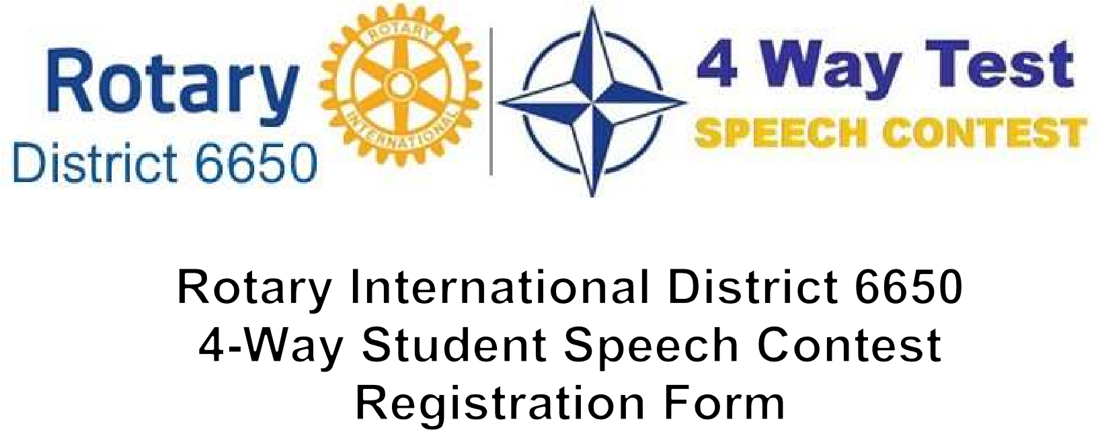

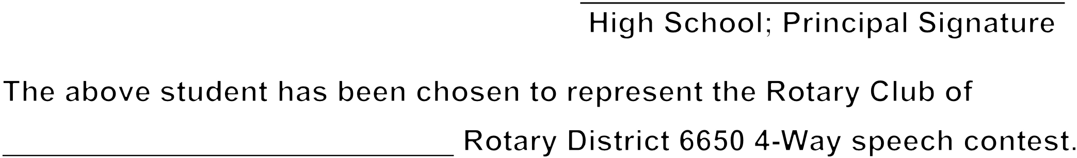

FOUR WAY TEST SPEECH COMPETITION
JUDGE’S FORM

Speaker #

Points: 1 2 3 4 5
CONTENT:

Originality of Topic

Organization

Claríty

Clear Relationship to the 4 Way Test

Use of Supporting Examples

DELIVERY:
Points: 1 2 3 4 5
Poise

Enunciation

Bodily Expression

Use of Voice

Ability to Impress Audience

Rank: _____________________Points:_____________________TOTAL : ______________________ 2 points should be deducted from the score for every minute under 4 and over 7 minutes in length. There is a 30 second grace period with no penalty.

JUDGE : _______________________________ Point Rating:
1 - Poor, 2— Average, 3 - Good, 4— Superior, 5 - Excellent

