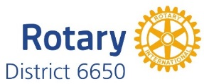

2016-2017 District Award Winners

Roland Luhman – Community
- Warren – Slice of the Valley Pizza Challenge
- Wooster – Al Van Wie/Wooster Rotary Classic

Robert Manchester – Vocational
- Canton – Junior Achievement Career Connections Project

Bryce Kendall – Club
- Poland – A Night at the Races

Jack Maxwell – Bulletin
- Salem
- Youngstown

Jack Vogel – Public Relations
- Struthers
- Salem

