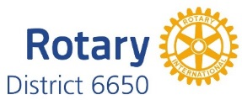

2018-19 District Award Winners:

Roland Luhman – Community
- Canton – Health Screen and Wellness Fair
- Youngstown – Wick Park Pavilion Restoration

Bill Elliott- International

- Plain Twp. & Salem – STEM Learning Center in India (focus on Literacy)

Bryce Kendall – Club
- Youngstown – Inaugural Beerfest
- Youngstown – YoRo Cash Raffle

Jack Maxwell – Bulletin
- Minerva

Jack Vogel – Public Relations
- Youngstown – Women in Rotary Social Medical Presentation
- Cortland – 2018-19 Theme Promotion

Emmet Riley - Literacy
- No Submissions

Robert Manchester – Vocational
- No Submissions

Special Achievement Recognition
- Boardman – Oktoberfest – Outstanding Community Event

