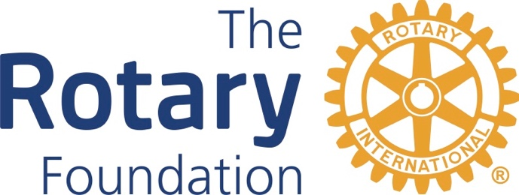

Meeting Notes

DRFC – Zoom Meeting
March 6, 2023
4 pm

District Grants Status – Kristi Halvorson reported that we started the year with $66,578 for district grants. We have dispersed $58,212 for 18 grants. $572 is being returned by Sierra Vista. We had administrative expenses of $1300 for the ClubRunner Grants Module and for Adobe Acrobat. That leaves $7,104 for this year. She has received 2 final reports and is working on getting the remaining reports.
Global Grants Status and Reporting – Diane Ventura-Goodyear reported that the SaddleBrooke project for water fountains at a school in Nogales is nearly finished, after 8 years.

Endowment Fund, Major Gifts – Linda Stratton reported that we are exceeding our goals in this area. She said we have 2 new Major Donors as of January. She said there also is a potential for a major gift, perhaps Arch Klumph level. She said it might be helpful to have a Zoom meeting with club foundation chairs to help determine what their needs are and how the District can support them.
PolioPlus Status – Michael Drake reported that in 2022 there were 22 cases of type 1 wild polio virus, 20 in Pakistan, 2 in Afghanistan. There was an outbreak in Mozambique. There also are continuing cases of vaccine-derived polio. These come from the oral vaccine, which uses an attenuated live virus The injections use dead polio virus, but they are more difficult to administer. This year to date, there are no cases of wild polio virus and 4 cases of vaccine-derived polio. In terms of fund raising, we have raised $74,000 for PolioPlus. He did not know if that included funds from The Ride To End Polio. In 2022, local Rotarian donations increased 20%. The Indoor ride raised $100,000, not including the Gates Foundation match. Michael said the PolioPlus Society is apparently going to be made an official Foundation program. He plans to continue promoting this society to increase contributions to this program.
Fund Raising Status – Bob Grady reported that by the end of February, we had raised $228,000 for the Annual Fund. Oro Valley currently leads the district in per capita donations. He said he plans to work with assistant governors to increase the contributions by the end of the Rotary year.

