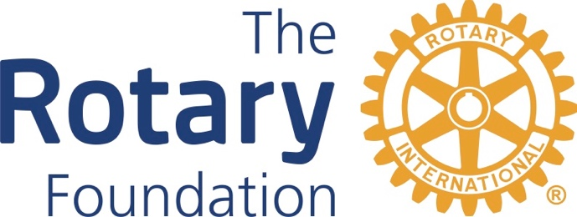

Meeting Notes
DRFC – Zoom Meeting
September 17, 2022
8:00 am

Global Grants Status and Reporting – Diane reported that the SaddleBrooke project in Nogales is progressing. Some of the tanks have been installed. SaddleBrooke is still waiting for the return of the money impounded by the bank in Mexico. Michael reported that Tucson Verde’s project in Mexico has been approved.
District Grants Status – Teree said the district grant has been approve by The Rotary Foundation and the clubs should get their checks soon. We will be having a second round of district grants soon.
Endowment Fund, Major Gifts – Linda said she is continuing to put articles in The Glance, and that there will be a session relating to this at the District Conference. Linda said she is planning to put together a small committee to plan events.
PolioPlus Status – Michael said the clubs have given $6700 so far to PolioPlus. We will have an increase in this amount when the El Tour is held. He said we will have a World Polio Day program on 10/22. The new case of polio in NY is concerning.
Fund Raising Status – Teree said we ended the last Rotary year with $202 per capita in giving to the Annual Fund. Gary said he would prepare something on the annual fund giving to send to all Rotarians.
Video Project – Gary said he wants to do a video on ways to give. It was decided that Gary, Diane and Teree would get together to decide content for the video.
Stewardship – Chad said most clubs have not submitted their MOUs. Diane said the clubs are finding it difficult to provide signed MOUs. Diane suggested that we allow clubs to do typed signatures. Chad said he doesn’t think that is sufficient, when we are giving the clubs thousands of dollars. There was a discussion of using DocuSign, but it appears to be too pricey.
Foundation Day Event – Teree said we should have a Foundation event this year. Because there are so few people at the meeting, she would send a separate inquiry to the DRFC to get ideas about what we might do. Chad suggested that we do Foundation podcasts that people can listen to on their own schedule. Chad said we need to target clubs that do not participate in grants.
Arizona-Mexico Global Grant Exchange – Oct. 27-31 in Zacatlan, Puebla, Mexico. The committee authorized Michael to allocate $25,000 to projects during the event.

