BOOKS FOR KINDERS

The Rotary Club of Sahuarita's Service Project for the District Conference was to display the work the Club is doing reading and distributing one book, ("What a Seed Needs to Know" by Grandpa Gardener) in the Sahuarita Unified School District #30.
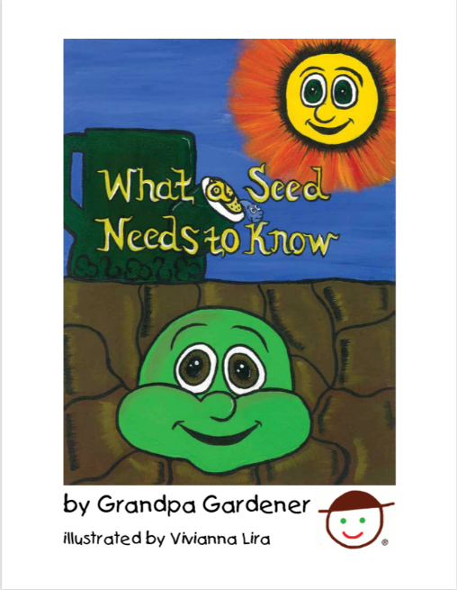

The author and publisher of the book is a Club member and can create custom runs of this book with personalization inside the front cover, with the Rotary logo and text as desired.

We applied for, and received, a District Grant to print and distribute 422 copies of this book. DG Anita was presented with 10 copies of this book, personalized "This book is a gift of District 5500 Governor Anita McDonald."
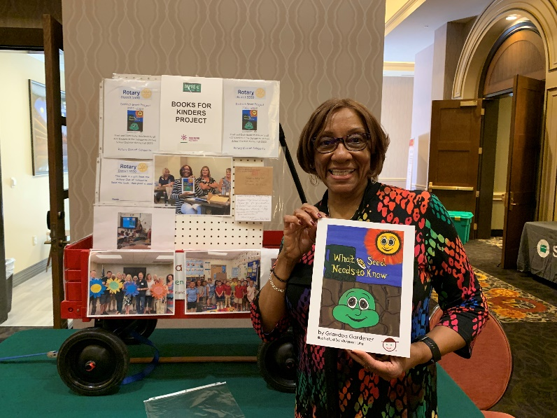
The club members read to our first school, Wrightson Ridge, on August 8th and distributed the books, now personalized "This book is a gift of the Rotary Club of Sahuarita. Read the book, then plant a seed!" The club members, teachers and students had a wonderful time.

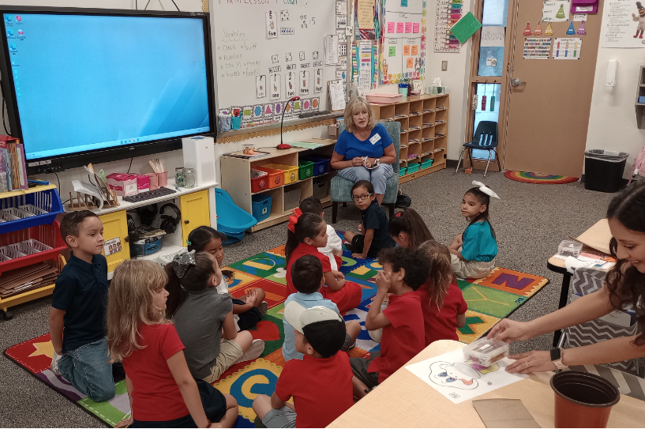

We went back to the School on August 20th to receive customized Thank You's from each of the four classes: custom flowers and each Kinder made a petal for their class flower. That evening these Thank You's were presented to the club and a photo was taken.
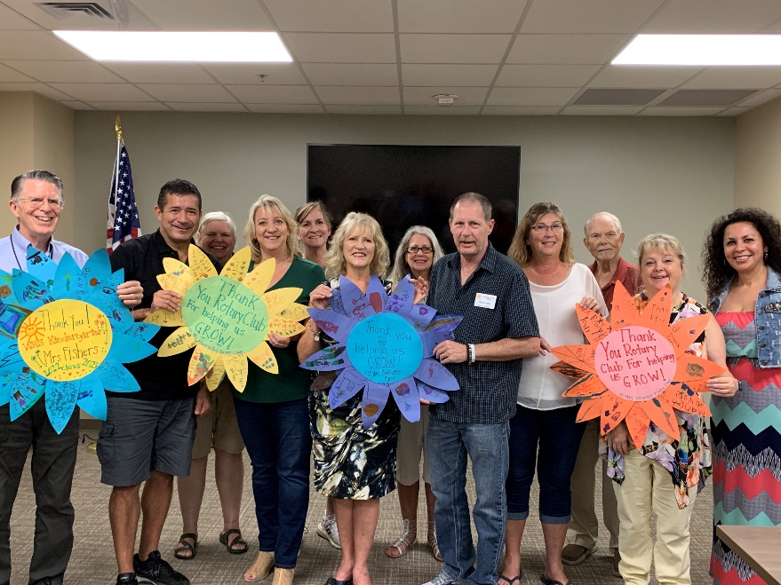

Our service project table at the District Conference was a series of photos of Club members reading to the students, receiving the thank you's, displayed in a little red wagon.
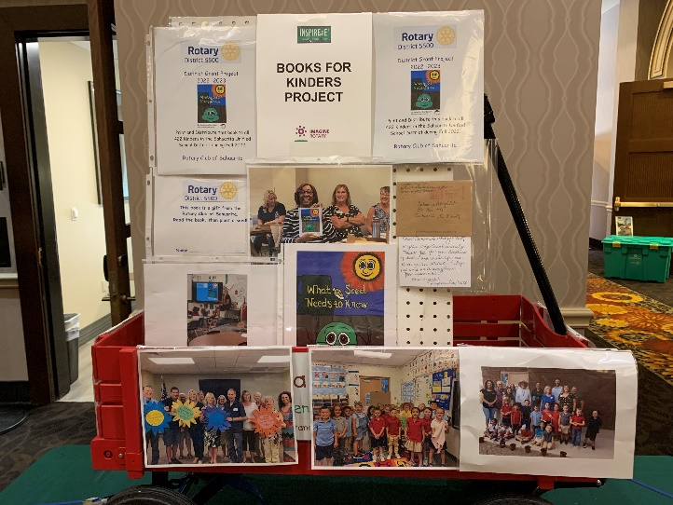

For more information:

Randy Van Nostrand
Chair, Foundation Committee
Rotary Club of Sahuarita
wrvn3md@aol.com

