DISTRICT 5500 SERVICE PROJECTS

Five Corridor I-19 Rotary Clubs and District 5500 fund Cleft Palate Surgeries for Children

Rotary Clubs banded together to fund Children’s cleft palate surgeries for children who would never have the resources for the procedure. Our Rotary Clubs from Valle Verde, Green Valley Rio Rico, Tubac and Nogales pooled together the funds. This collaboration of St. Andrew’s Children’s Clinic, Children’s Surgery International and Hospital CIMA for a cleft palate clinic. Families traveled by bus as long as 30 hours for this life changing surgery for their child. The project was held from Sept. 24-28 in Hermosillo, Sonora Mexico.

Rotary Clubs along the I-19 Corridor contributed $8,000 to this project. Combined with a $6,000 grant from Rotary D5500 we were able to help 60 children.
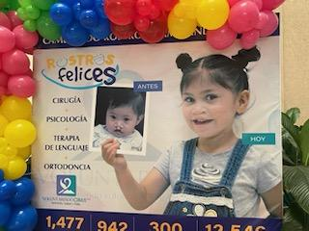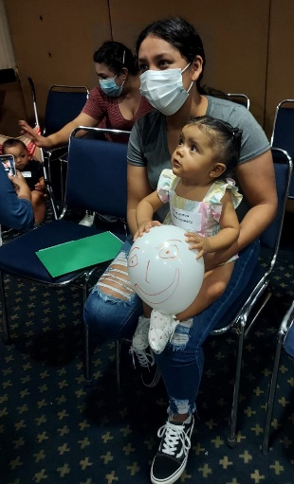
Over 60 surgeries performed over four days by a team of CSI surgeons from all over the country. Surgeons from MA, OH, NV MN and CA have volunteered their services year after year. Surgical support personnel from both CSI volunteers and Hermosillo Hospital CIMA personnel. This multi-faceted, multi-day clinic operated like a “well oiled machine” under the overall leadership of Laura Romero. Romero’s mother began St. Andrew’s Children’s Clinic over 50 years ago when she could not find medical care for her son with cerebral palsy. Visitors heard nothing but praises for Laura and her staff coordinators, Diana Ward and Yadelle Valdez. Physicians, hospital personnel, volunteers and patient families praised the operation of the clinic.

Hospital and Clinic volunteers assisted with screening patients, COVID testing, completing all paperwork, translating for physicians and families and photographing patients. In addition to providing funding, Rotary volunteers entertained the children awaiting surgery to help distract them from their fears. Kelley Rivers, a Tubac Rotarian performed magic tricks and juggling act, delivered gifts and coloring books. Bud Eckhart, a Tubac Rotarian, danced for the patients and families in a turkey costume.
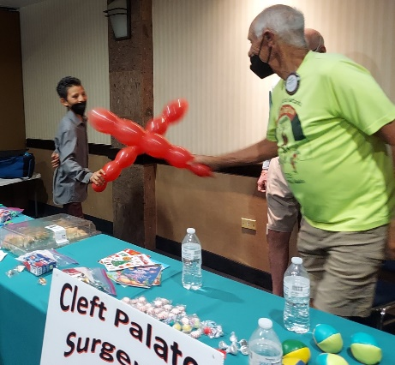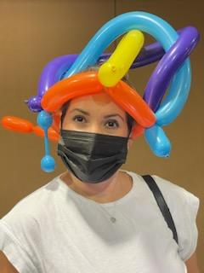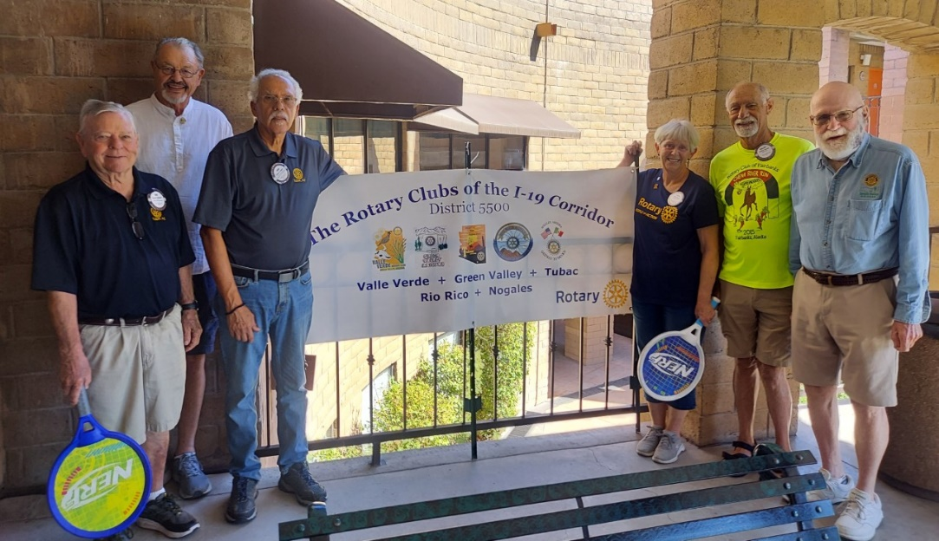

Contacts for additional information or interviews:

Laura Romero, cell 520.470.7138. Laura’s email is laumaria@hotmail.com to verify all aspects of the clinic mission and sharing of patient details and photos.

Cathy Angel, cell 360.477.7827, email cathyangel46@gmail.com regarding Rotary participation in the clinic.

Bruce Monro, cell 520.850.4406, email bruce-tubacaz@outlook.com regarding Rotary financial contributions to this clinic.

Partners in Cleft Palate Project:
St. Andrew’s Children’s Clinic, Laura Romero Director and Tubac Rotarian
Children’s Surgery International , New Brighton MN
Hospital CIMA Hermosillo
Rotary Clubs of the I-19 Corridor in District 5500: Valley Verde, Green Valley, Tubac Rio Rico and Nogales.

Rotary Volunteers:
Bud Eckhart, Tubac Rotary
Cathy Angel, Tubac Rotary
Kelley Rivers, Tubac Rotary
Jose Lopez, Tubac Rotary
Tim Dugan, Valley Verde Rotary
Richard George, Rio Rico Rotary

Press Release submitted by Jenny Didas, Tubac Rotarian, didas@msn.com and cell is 520.561.0823. Many photos are available which Laura Romero can provide as well as Jenny Didas.

