What is Rotary Local?
The Rotary LOCAL Program helps educators in the Tucson area by providing items and services to be used in learning. In many cases, our network of local business partners provides the necessary resources to help achieve project goals. If you're a business leader who wants to strengthen community through education, consider partnering with Rotary LOCAL.
If you're an educator, tell us what you need. We believe that you can identify your needs better than we can. Be creative, and tell us how we can help you build a stronger community through education. Visit www.rotarylocal.org for more information.
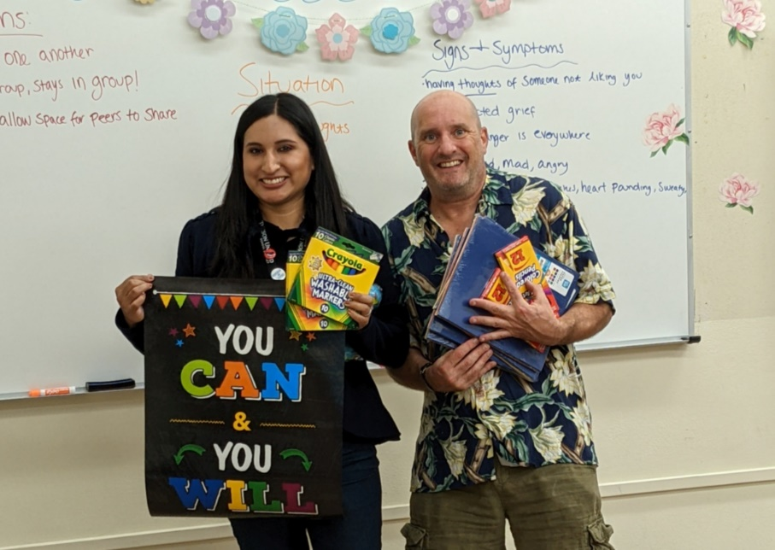
Palo Verde High School Social Worker Andrea Vazquez Mata runs support groups to help students develop positive coping skills, increase self-esteem, work on their goals, and regulate their emotions. She requested help decorating their Titan Support Group Room with motivational posters, stress balls, and other decorative items. The Rincon Rotary was excited to support this initiative through our Rotary LOCAL program, whose mission is to help improve the local community through educational outreach. Rotary LOCAL can provide manpower, resources from local business partners, or in some cases, direct financial support to teachers who apply for assistance.

