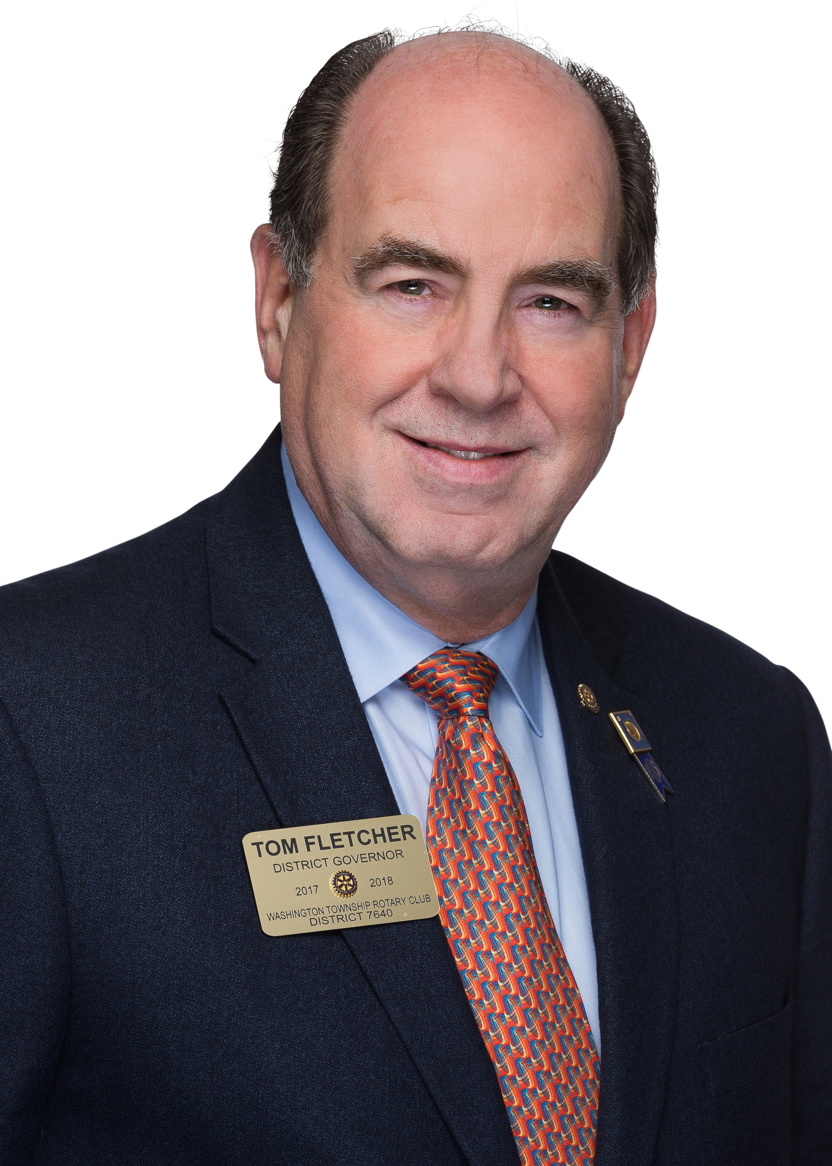
Thomas J. Fletcher
District 7640
District Governor 2017-18

Tom first joined Rotary in 1978 when he became a member of the Middlesex NJ Rotary Club. He had to leave Rotary after he was transferred into a new assignment that required extensive travel.

In 2007 Tom joined the Washington Township Rotary Club and became President in 2012-2013. Tom was an Assistant Governor for District 7640 for 2013-2014. Tom was selected as the District 7640’s Governor for 2017 - 2018.

Tom and Michele participated in a Clean Water Project in Panama in October 2016. Their team installed 200 water filtration systems in four different villages in Panama.

Tom has completed RLI courses; Parts I, II, III, the Graduate Course and is now an RLI Facilitator.

Tom is very active in his community and has served as the President of the Chamber of Commerce for 2012 – 2013. He also served on the Washington Scholarship Foundations and was President in 2010 - 2011. Tom served as Vice Chairman of the Mayor’s Economic Task Force.

Tom retired from a successful career in banking and now has his own printing franchise.

Tom lives with his wife Michele (My Bride of +34 Years) in Washington Township.

