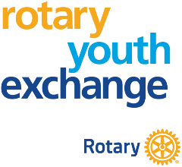 | Stephanie Denning, District 5440 STEP Chair  Cowboy Country Rotary Youth Exchange  2341 Plain View Rd  Cheyenne, WY 82009  307-421-2553 (cell)  District5440.STEP@gmail.com | 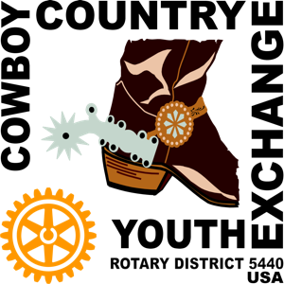

What You (and Your Parents) Need to Know

(Updated November 9, 2025)

What is it? Rotary International through Rotary District 5440 arranges short-term exchanges to foreign countries. This is a low-cost cultural, family-to-family exchange program that runs in the summer from June through August. You travel abroad and live with a foreign ‘brother’ or ‘sister’ and their family for 3 or 4 weeks. Then you host your foreign ‘brother’ or ‘sister’ in your family home for the same length of time. Each family pays all costs for their student to participate in the program, including flights, the cost of hosting the foreign student, and a small fee to STEP for managing the program.

Who Can Go? Any student aged between 15 and 19 years old who is of good character and reputation. Neither you nor any of your family have to be Rotarians. Applicants are selected by local Rotary Clubs solely on their ability to thrive while living abroad.

Who Will Benefit from an Exchange? Somebody who wants a challenge and can adjust to new situations. You will learn about foreign cultures and may make a lifelong friend. It often happens!

Where Can You Go? You can exchange to many countries in Europe, North and South Americas, and Asia. We have arranged successful exchanges with these countries in recent years: Belgium, Finland, Japan, Italy, Spain, and Thailand. Exchanges to Germany, Mexico, and other countries may be possible.

Do I have to be Fluent in their Language? No! You don’t have to speak the local language abroad (though it helps). If you have learned the language in school, you will become more fluent hearing it every day. Most foreign students can speak at least some English.

Will You be Safe? To ensure your safety Rotary International sets strict rules for these exchanges. Local Rotary clubs both here and abroad select students for their maturity and suitability, review the hosting family’s home for comfort and student privacy, and provide a local Rotary contact to help with any problems. All students selected must attend a one-day Outbound Orientation training session in April of 2026. All persons over the age of 18 living in the family home, either here or abroad, must pass a background check.

What about Covid-19? You and your family must agree with your exchange sister/brother and their family that it is safe to travel to, and reside in, the other country. If either family requests cancellation because of Covid-19, the exchange will be cancelled at no cost to you.

Apply Now! The number of exchanges is limited so read the Application Checklist and complete your application now at http://rotary5440.org/SitePage/summer-youth-exchange.

Questions? Email to District5440.STEP@gmail.com.

This program is a great way to test to see if you can handle a year-long Rotary study abroad in the future.

