**ROTARY CLUB CENTRAL FOUNDATION GOALS WORKSHEET & GUIDE** (Recommend printing)

**Goals must be submitted on-line through Rotary Club Central by 1 May.**

|  |  |  |  |
| --- | --- | --- | --- |
| Annual Fund: Supporting Rotary’s Current Work | | | |
| Your support to the Annual Fund is crucial to sustain the thousands of projects that are being conducted in your community and around the world. Personal outright contributions, club fundraisers, and other sources are encouraged to achieve club goals.  Calculate your club’s Annual Fund goal by multiplying the number of individual donors times the average contribution amount and adding all of the goal totals. Enter the number of donors you would like to have in each category. Only enter an individual at their highest giving level.  **Note: If you choose to enter your entire Annual Fund goal as a “lump sum” amount you can enter it under “Other Contributions.”**   |  |  |  |  | | --- | --- | --- | --- | | Giving Level | Number of **Individual** Donors | Average Contribution (**US** **Dollar**) Amount | Goal Total  (**US Dollar**) | | Paul Harris Society level  US $1,000 or more |  | US $ | US $ | | Sustaining Members level  US $100 to US $999 |  | US $ | US $ | | Every Rotarian, Every Year level  Up to US $99 |  | US $ | US $ | | Other Contributions  **(Fundraising events, corporate gifts, or lump sum club contributions, etc.)** |  | US $ | US $ | | **Annual Fund Goal** |  |  | US $ | | | | |
| PolioPlus Fund: Supporting Rotary’s Polio Eradication Efforts | | | |
| Be a part of history and support Rotary's work to achieve a polio-free world. Your gift will support immunization campaigns in countries where children remain at risk.  Personal outright contributions, club fundraisers, and other sources are encouraged to achieve club goals. | | | |
| **PolioPlus Goal** | US $  (One collective goal for the entire club) | | |
| Major Gifts and Endowment Fund: Supporting Rotary’s Future | | | |
| Your gift to the Endowment Fund will keep The Rotary Foundation strong well into the future, providing a continuous stream of income that will fund programs in perpetuity. Indicate the number of club members interested in making an outright gift of US$ 10,000 or more and those interested in including the Endowment Fund in their estate plan. | | | |
| Number of new Major Gifts:  (US $10,000 or more outright) | |  |  |
| Number of new Bequest Society Members:  (Minimum US $10,000 commitment in estate plan) | |  |
| **Number of new Benefactors:**  (up to US$9,999 as an outright gift or estate plan commitment) | |  |

**\*\*All information above must be entered on-line in Rotary Club Central\*\***

**ROTARY CLUB CENTRAL GUIDE TO GOAL ENTRY**

**Foundation Giving**

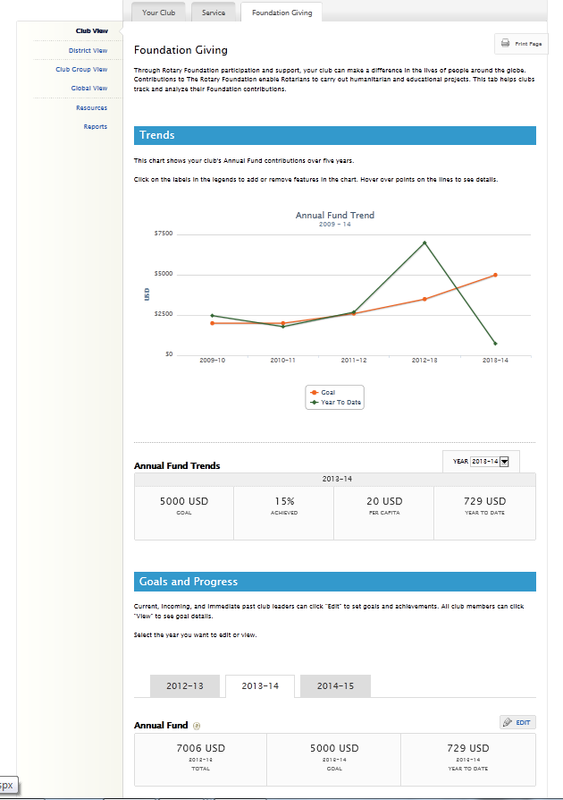

Select **Foundation Giving**.

Use the drop-down to see your club’s donations to the Annual Fund for the last five years.

Then click **EDIT** to update a goal.

Select the year for which you want to set goals.

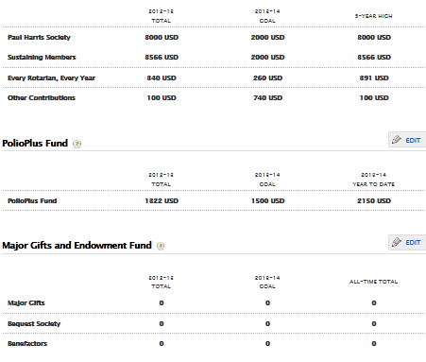

Click **EDIT** to update a goal.

Enter the number of donors you would like to have in each category. Please only enter an individual at their highest giving level.

Enter the average contribution amount for an individual.

Highest amount in any of the past 5 years. Data supplied by Rotary.

**Annual Fund**

Data is automatically calculated based on the goals entered.

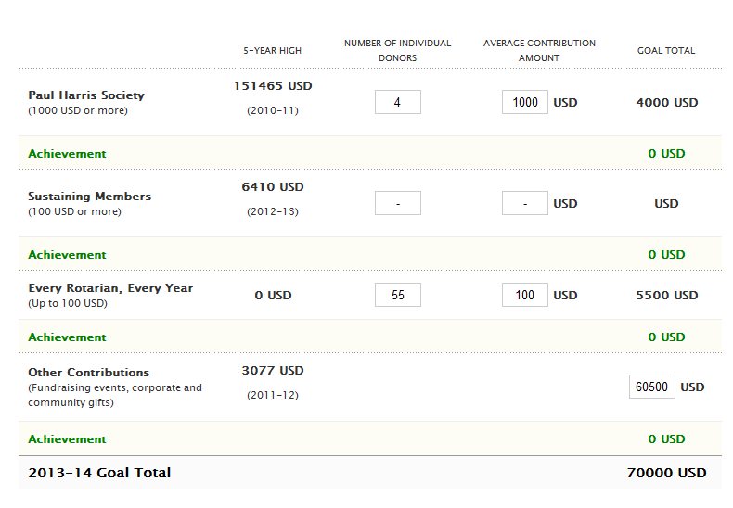

Data supplied by Rotary.

**C:\Users\lazare\AppData\Local\Microsoft\Windows\Temporary Internet Files\Content.IE5\YO635AEY\MC900290930[1].wmfIf unable to enter each area, please use “Other Contributions” to enter lump sum goal.**

**PolioPlus Fund**

Data supplied by Rotary.



Enter the amount your club would like to give.

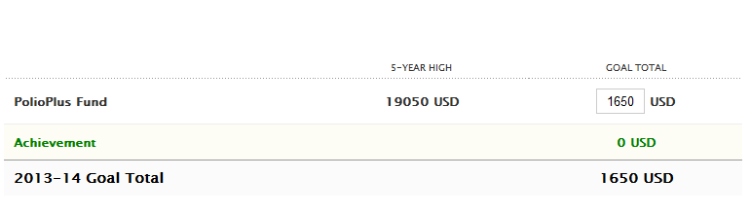

Data supplied by Rotary.

**Major Gifts and Endowment Fund**

The total number of members who have achieved each level during their time as a Rotarian. Data supplied by Rotary.

Enter the number of individuals who will commit to each giving level. The donation doesn’t have to be received during a club leader’s term, but the commitment must be.



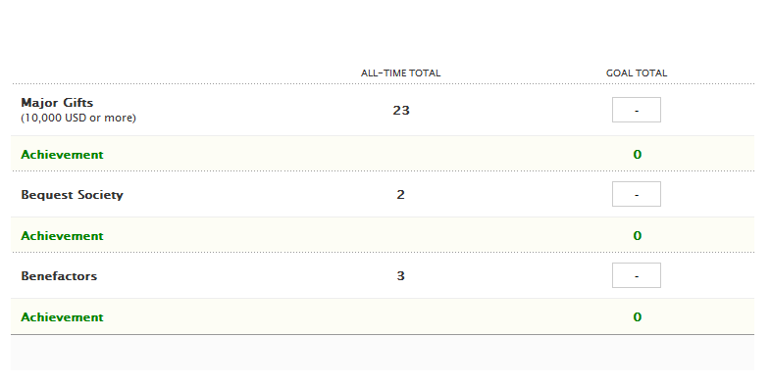

Data supplied by Rotary.

*Request a **Club Fundraising Analysis** from [contact.center@rotary.org](mailto:contact.center@rotary.org) to see a 5 Rotary year dashboard of Annual Fund goals, giving and recognition totals.