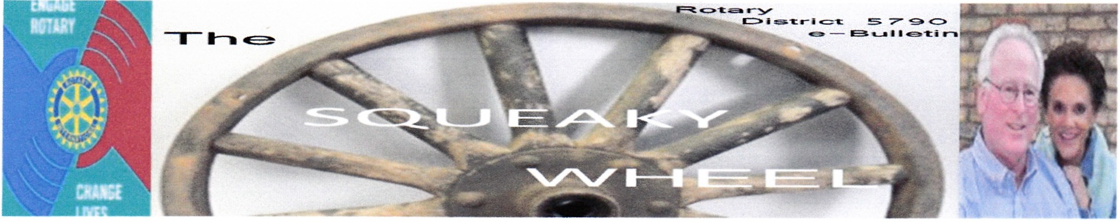Tue Oct01, 2013 Home

September, 2013

District 5790

New Generation Month Newsletter Editor Marilyn Pokorny jmPokorny@verizon.net

Link to District 5790
Website

District Events
District 5790 Institute for Leadership
American Airlines Training
Center
Oct 04, 2013 06:00 PM - Oct 06,
2013 04:00 PM

District 5790 Rotary Foundation Banquet Texas Motor Speedway Oct 25, 2013

News
Looking for Unrversrty of North
Texas Students Aug 15, 2013
by Ernie McGee

Looking for UNT Students to Join Rotaract
Know a young person going to the University of North Texas? Encourage them to join Rotaract at UNT. Need information about Rotaract? Click
on Rotaract Page
For more information about the UNT Rotaract Contact
Penny Gee
Independent Consultant­ Education
Denton office : 940-241-2038 CeU: 940-391..J254
penny@gee-force.net

Governor's Comer Governor Giffin's Rotary Ramblings

As we close August , our membership month, we have been given much to consider about how to grow our clubs. Our Membership committee has done a great job of putting together some exciting programs and idea about how to grow your club. They are available to come to your club (with enough notice) to dever a program. They are also considering multiple club meetings in some areas to hold seminars on Fishing for members:If your club is interested in participating , please contact David Hurt, membership chair.

Iam very proud of our Membership and Foundation committees. These fellow Rotarians worked wonders in delivering the best Membership and Foundation Seminar we have had in many years. Just ask anyone in your club who attended . Kudos and Thanks to all who participated. A special thank you goes to the Rotary Club of Weatherford which hosted the event. Everything went very smoothly due to their hard work.

New Generations is the focus in September. How is your Interact Club doing? Don't have one, you say? Wow, you are realty missing out on a great way to get more involved with the community ...through its youth. Interact is also a great source of candidates for RYLA, your club's scholarships and manpower for your local service projects. Students have parents, too . They might make good candidates for membership. There are lots of uses. The only negative is that it takes someone getting off their chair and doing
something, so lefs get moving!

The Dlsbict 5790 Institute for L•adership is coming your way October 4-6. This year the venue has moved to the American Airines Training Center near DFW Airport and includes two nights lodging, food, fun and Rotary fellowship. A great program will be delivered by your Oistrlct Training Team. Attendance is Nmited to the first 24 registrants. More infonnation Is available on www. Roatary5790 .org.

Things clubs gotta do....complete your SemiAnnualReport (SAR) on you membership and submit your RI and district Dues by September 15. Also , don't forget about good 'ol Uncle Sam. He wants to know about your activities , too. So be sure to file your IRS infonnation return fonn 990by October 15. That is a requirement for your club to retain its charitable organization tax exemption. You will need your own federal tax ID number. Consult with your accountant about how to obtain one If you do not already have it.

The governor's Club visit number 30 is tomorrow at Colleyville . I look forward to visiting you and hearing of the great things your club is planning for this year. Now go out and
.....Engage Rotary - Change Livn

District 5790 News

District 5790 Leadership Training

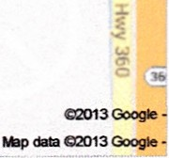Chair: Allen Barraclough
Date: Oct 04, 2013 at 06:00 PM - Oct 06, 2013 at 04:00 PM

Rotary helps Pakistan Battle
Polio & Mistrust

Event Fee:

$400.00 (3 night and all meals)

Jul 22, 2013
by John Pokorny

New York Times writer Donald G. Nigel informs th e world about the ongoing battle against polio, rumors & mistrust about pollo vaccination in Pakistan. In his story he shares how the country has turned the comer thanks to the persista nce of Rotary
lnt ernational,'M-iO & the Gates Foundation. See entire article at Pakistan Battles Polio and It's Peoples Trust
Location: American Airlines Training Center

4501 Highway 360 South
Fort \North , TX , United States
76155

RYLA

(ROTARY YOUTH LEADERSHIP AWARDS)

Clint Ishmael cfint.ishmae@clebume 1net

2013 Granbury/Cleburne Area Disaster Relief
May 18, 2013
by John Lucas

2013 Granbury/Cleburne
Area Disaster Relief
RYLA emphasizes leadership, citizenship, personal growth , and aims to demonstrate Rotary's respect and concern for youth . This program also provKtes an effective training
experience for selected youth,encourages leadership of youth by youth and to recognize pubficly young who are rendering service to their communities .

- ACTION THAT NEEDS TO HAPPEN THtS YEAR :
- Increase number of Rotarian Counselors to accomroodate number of RYLA participants
- Review RYLA program curriculum in relation to size of the group
- Recruit two new RYLA colmlittee members

= D-ona.t.
El

Recent Disasters in Other Rotary Districts Moore, Oklahoma , West, Texas etc
May 25, 2013
by John Lucas

01stnct Leadership Approves
2013-2017 Strategic Plan
May 21,2013
by Charles Kurtzman

During the District Conference Business Meeting, District leadership approved the
2013--2014 Strategic Plan. The plan sets priorities & goals Including the support & strengthening of clubs, focus & Increase humanitarian service, enhance pUblic image and awareness and continue the strategic planning process through ongoing review and updating es needed.

Each of these goals has a series of specific steps that district leadership wm be implementing to assure each goal is addressed and priorities are established that promote these goals within the district.

Club leadership is encouraged to
review these goals and priorities and use them as a template to establishing their own clubs strategic plan for the next 5
years . Click on District 5790 Strategic Plan
2013-2017

District Links
Rotarv Zone 21b-27

Website Sponsors

Youth Exchange

Norman King District Chair

mailtonorm@yahoo.com

Youth. Exchange is a program that promotes internationa l friendship by giving youg men and women between the ages of 15-19 the opportunity to experience a long or short term excha nge (from a few days to a full academic year) in country other than their own.

- ACTIONS THAT NEED TO BE TAKEN:
- Develop a broad base committee represent ing the district
- Complete an area diagnostic to determine w hy some areas are successful in their club Youth Exchange programs.
- Examine demographic factors such school districts size, accessibility to urban versus rural
- Set importa nt dates prior to District Assembty
- Distribute these dates to district website, clubs, committee members sponsors, and host famil ies

Interact • Rotaract Kathy Bauer Chair krbau@r@yahoo .com
The overall goal is to build on the en hance what has already been accomplished by increasing the interaction between Rotary Clubs and theInteract and Rotaract Clubs they sponsor: specifically by:

  - Exploring opportunities fo r establishing new Rotaract Clubs at universities and colleges within the District
  - Strengthening existingInteract Clubs by (1) increasing and diversifying membership and (2) expanding activities, programs, and services in Intereact Clubs at high schools within the District
  - At least half the clubs in the District, with spansoredInteract and/or Rotaract Clubs, will engage those dubs in at least one service project this year .
  - A rranging for Rotaract andInteract clubs to attend and participate in District Conference
  - PromoteInteract and Rotaract at the District Conference and other District Seminars and Assemblies .

District 5790 Three Year (2013-2016) Membership Plan•••.What's Different?
by David Hurt
This three-yea r long-range club membership growt h plan includes club growth strategies and tactics for small, medium, and large clubs to retain members, and also add new members.

Retention: The plan incorporates a "buddy system" and forms fun compet itive teams whose is to bring visitors to the club. Each team has a
leader who keeps track of the efforts and gets the group together every few months to visit ,discuss performance, and fellowship.

An important part of vis itor development is the "buddy system" that also checks on each other if meetings be missed...and perhaps an extra meal together
every now and then.

1io1tul

nnf ,,,

Please visit our Sponsors

Click here to place your ad
Finally , during meetings there will be use of charts visibly positioned to remind members why the join ed Rotary, and the things their club does to make one proud of staying a Rotarian.

New Members: The club will focus on a single "visitor day " each month to improve the dynamics of having multiple visitors. The club program must be of interest to members and guests alike, and club memberS should meet all visitors and provide excellent hospitality.

Before leaving the meeting the membership chair,or designate, will provide the membership guests an educational packet that contains Rotary brochures, as well as club documents that highlight what the club does, and what it cost to be a Rotarian. t also contains an application form. The visitor packet provides an excellent opportunity for the visitor to learn more about Rotary without the awkward pressure of being asked to j oin.

The club approval process Is accelerated so that a letter of invitation to join is sent under the club president's signature...no tater than two weeks after the visit...w hile the club visit is still fresh on the vis itors mind. The letter will include benefits of being a Rotarian and suggest, if interested in joining, the application form be completed and brought to the next club meeting . During this time ,the club member who invited the guest should have a follow-up phone call.

Training and Reporting : The three-year membership plan provides all of the details, including specific workshop traini ng on how to share ones' personal moment and also how to tell the story of Rotary. The plan also discusses listening skills and suggestions on how to ""connect."

Recognition: At the end of the year, all team leaders, the tea m with the most visitors, and the team with the most new members participate in a lotte ry drawing. Each member may chip in $10 or $20 as part of the drawing, and the club also pitches in with something nice, depending on the number of new club members and reaching, or exceedi ng,the club membership goat.

To view the Power Point Presentation from the Dist. Membership Conference click here: Dist. 5790 Three Yea r Membership Plan The three Power Point Presentation are available on left hand side 5790 Web Site.

For the full story about the membership seminar follow this link

Rotary lntemattonal

Get the message out that Rotary connects leaders to exchange ideas and take action in communities.Join leaders at a #R otary dub near you.

Share this message on your social networks and end Membership and Extension Month In August with a Thunderclap! Sign up at http://thndrJt/18DOhuw for TWltter and Facebook, and you'll join others In automatically sending out our Rotary message on 31 August at noon (Chicago time).

Connect ing leaders to do good

www.thunderclap .tt

District Conference By Marci Junge

    - Save the Date!

Save the Date!

Calling all Rotarians from District 5790

Come celebrate the year in the Fort Worth Stockyards.

Calling all Rotarians from District 5790

Come celebrate the year in the Fort Worth Stockyards.

The plans are nearly complete and all we need now is YOU!

May 2-4, 2014

Iam looking for a few eager individuals to work on the planning committee. Please call me or email me if you want to help.

More details to follow.

Marci Junge District Conference Chair
817-366-6138

mjunge@aol.com

Polio News

by David Boyll - Polio Plus Chair Dist 5790
The good news Is that we are better than ever at responding to outbreaks in previously Polio eradicated countries. In 2008 it took an average of 20 weeks to stop a new outbreak. By 2011that time was shortened to 12 weeks. And only one has lasted longer than 6 months according to the post on the Bill and Melinda Gates Foundation blog. Tell your fellow Rotarians and all your friends about this.

You can tell them, also, that our U.S. Senate has confirmed a $207 .1million request for Polio eradication funding this year. The house and Senate have each submitted budget requests and now a separate committee will negotiate a finalized budget. When you talk to your Representative or Senator please thank them for their support of eradicating Polio.

Funding from the U.S. government goes to the Centers for Disease Control and Prevention (CDC), and the US Aid organization. The United Nations helps through the World Health Organization (WHO) and the United Nations Children's Fund (UNESCO). The Bill and Melinda Gates Foundation recently announced they would commit to fund one third of the total goal needed as submitted by the Global Polio Eradication
Initiative (GPEI). Rotary,the initial donor to the GPEI, pledged its commitment through 2018 to raise funds and mobilize support for the Endgame Strategic Plan. Notice the ENDGAME STRATEGIC PLAN. Most Rotarians will be pleased that the end is in sight. We are THIS CLOSE to ending POLIO. We can't quite now because if polio is not eradicated all over the world it will return and be just as devastating as it was generations ago.

If you think polio cannot return to countries originally said to be polio free, just look atIsrael. Sixty cases of polio were reported just this week (August 2013) . Now a major immunization inIsrael is called for to stop polio In its tracks before It spreads further. It is thought that polio was brought into Israel by travelers who were exposed to it in another country. Time will tell. We cannot let our guard down. The fight to end polio goes on. The fight to raise enough money to carry on is our task.

Here is the latest report which was published before the outbreak inIsrael : The Final Five -
Pakistan - 24 Polio cases recorded in 2013 compared to 29 on this date in 2012, with the most recent case reported on July 13, 2013. The case from Gadap is the first in the greater Karachi area since January 2013. But, five environmental samples were found there recently.

Afghanistan - 3 Polio case recorded in 2013 compared to 17 on this date in 2012, with the most recent case reported on une 6, 2013. No wild Polio cases have been reported In southern Afghanistan since November 2012.

Nigeria - 43 Polio cases recorded in 2013 compared to 70 on this date in 2012, with the most recent cases (from Borno) reported on July 23, 2013. Nearly 350/o of children in Borno & Yohe are under-immunized due to a lack of security. The next sub-national activities are planned across the northern states in September.

Somalia - 100 Polio cases recorded in 2013 compared to O in 2012, with the most recent reported on July 10 in Banadir. As many as 1001o of children in security compromised areas and 20% in secure area are under-immunized.

Kenya - 10 Polio cases reported in 2013 compared to O in 2012, with the most recent case reported on July 10. 50°/o of children in the Dadaab area continue to be under-immunized compared to less than 5°/o country-wide.
Vaccination campaigns continue in Ethiopia & Yemen .

Our Goal s Global Polio Eradication!

District 5790 - Club Attendance

July 2013 Report
Rotary uses Club Attendance as a measure of the effectiveness of our weekly club meetings. Rotary recognizes that clubs that consistently provide dynamic speakers, great fellowship good food and an attractive venue will have consistently higher attendance and better make-up compliance for their week ly meetings . For that reason, clubs are requested to report their monthly attendance to the District Secretary. The District Secretary is expected to report monthly attendance for the entire district in it's Monthly Newsletter of e-bulletin .
Congratulations to Wichita Falls North for achieving the July 2013 #1 Rank at 92.00%. Attendance can be reported through your Clubrunner Website by your club secretary. Club secretary's should get in touch with Darhyl Ramsey at d.ramsey5790@ver izon .net if they are unable to report their clubs attendance .
Please click on July 2013 Monthly Club Attendance Report for Full Attendance report .

Club News

ARLINGTON SUNSET

President w Ken Mattner ken.mattnel@gmall.com
Ari ngton Sunset Rotary ts just what you've been looking for! Conve nient and centrally located in the geographic center of the Fort Worth-Dallas Metropolitan area, the club meets
at J Gilligans @ 400 E Abram St, Arlington, TX 76010, on Tuesday evenings @ 6:00 pm . We are not a large organization , but in the few short year.; since our charter, Arlingt on Sunset has accomplished as much or more than much larger and ok:ter dubs. Made up of business and education leaders from all over the metroplex , there is certain to be a place for you . The weekly programs are outstanding and the opportunities are abundant So if your desire to make a difference in this world is strong enough to cause action,
joi n us next Tuesday at 6:00 pm. We'll be there doing our part and looking for you.

BROWNWOOD ROTARY

President Penny Riggs pennykriggs@gmail.com

The Beginnings of the Brownwood Rotary Club

The Fort Worth Rotarians,along with District Governor, Robert E. Vinson,President of the State University,visited Brownwood during September of 1919 to survey Brownwood as a possible site for a new Rotary Club. They met with a small group of businessmen and presented the program of Rotary to them. The organization of the club was an outgrowth of a commission given to French W.Thompson, president of Daniel Baker College who had been a Rotarian in Kentucky.
Wortd War Ihad just ended. Warren G. Harding was elected President of the United States. Brownwood had grown to 8,223 people. tt had 1, 489 telephones ,though onty a handful of businesses had more than one line. None of the four banks had more than a single line. Most of the doctors had a single phone number, w;th office 1 ring,residence 2 rings. There were 20 doctors,8 dentists,3 chiropractors to serve the eight thousand peopte. The Graham Hotel and the Southern Hotel took care of most of the travelers. The Lyric and the Dixie were the only theaters . There were two team-drawn dray lines - Reder's and Thompson 's. No tax icabs,but a Service
Car Center was headquartered in the Southern Hotel Recreation - aside from Coggin Park,it was mostly at the Elk's Club on Brown Street or Hot Wells Swimming
Pool. The Chamber of Commerce was in the Arcade Block, phone No.7.

The temporary organization of the club was made during a luncheon held at the Graham Hotel on March 19,1920,with eighteen members. Chester Harrison was selected to serve as temporary chairman. The group had met the previous week with Or. R. E. Vinson,governor of the Eighteenth Rotary District,to go over the organizational procedures . They agreed that the club would meet each month on the second and fourth Fridays at noon.

Application Made

An application for an official charter for the club was April 1, 1920. On May 1, 1920, it began its first year's work under the guidance of District Governor Robert E. Vinson and President Chester Harrison.
The chartering members of the club were 0. Earl Bell, dentist; Charles M. Carpenter, real estate; Joe E. Dildy, physician ; William L Ellis, cotton dealer; Fred w. Greber, telephones; J. Harvey Grove, furniture; R. Kent Hallum,jeweler; Chester Harrison, banker; Gilbert N. Harrison, attorney; Harry Knox,wholesale fruits and vegetables; Will R. Lambert , l'etail grocer; Joe R Renfro, druggist ;Robert B. Rogers, retail dry goods; O. F. Standtey, cotton ginning;French W.Thompson, college executtve; Lee Watson,hardware; James C.White, newspaper; and Rex B.Wilkes, minister.

BROWNWOOD ROTARY meets at Brownwood Country Cluib 5875 CR 225 Wednesday at 12noon

Rota ry of Fort Worth

President • Timothy Plocica neva@rotaryforworth.org
Welcom e to the Rotary Club of Fort Worth !

We 're the ninth-largest Rotary Club in the world ,established February 27, 1913, as Club No. 75. Our approximately 441members include many of the city 's prominent business, professional and civic leaders.

You'll find that opportunities a re abundant for fellowsh ip at our weekly luncheon meetings and by serving on our club's committees. Proudly guided by Rotary's motto, "Service Above Self, " our members are well known for their friendly and engaging manner . We eagerly take active roles in the club,as well, as its community actlvlt ies.

We invite you to discover all the many positive aspects of our dynamic organization. We look forward to welcoming you to the Fort Worth Rotary Club: Celebrating a Century of Service Above Self.

Fort Worth meets at The Fort Worth Club 306 W. 7th St. 12th floor ·Friday 12:15pm

Rotary Club of Hamlin President - James Edwards johnsonwldsuppl y@att.net
Hamlin is a city in Fisher and Jones Counties in the U.S. state of Texas.The population was 2,124 at the 2010 census.The Jones County portion of Hamlin is part of the Abilene , Texas

Hamlin Rotary meets Wednesday at 12noon at Hamlin Housing Authority 200 SE Avenue A

Lewisville Rotary

By: President - Von Beougher von@gecon.com

Lewi&vllle Noon Rotary Grllbs Hokl of Vkleo Tec:hnology

The Lewisville Noon Rotary is embracing the pOV11er of video for its communications , creating engaging segments to keep club members informed as tNeU as entertained.

In late Juna, the club launched Rotary Roundup, a monthly online talk show currently hosted by club presidf!nt Von Beougher. Eii!Ch segment features Rotarians discussing current topics relevant to the club's activities, such as fundraising efforts and upcoming speakers. The show Is taped on a green screen set at Global'WebHQ Studios in LewisviHe, which happens to be owned by the club's Communications Chair, Craig Thompson.

More recently, the Lewisville Noon Rotary had the honor of hosting a live streaming video chat with Col.Ebno Robison of the 455 Air Expeditionary Wing, a U.S.Air Force trauma center in Bagram,Afghanistan .Tbe video conference was arranged by Col.Donald Taylor,USAF (Ret.}, a former classmate of Rotary Club member Russ Kerbow,and took place during the club's ¥11eekty Wednesday meeting at The Grotto Restaurantin Highland Village.

To see the latest videos from the club, check out the Lewisville Noon Rotary YouTube channel at www.youtube.com/lewisviUenoonrotary

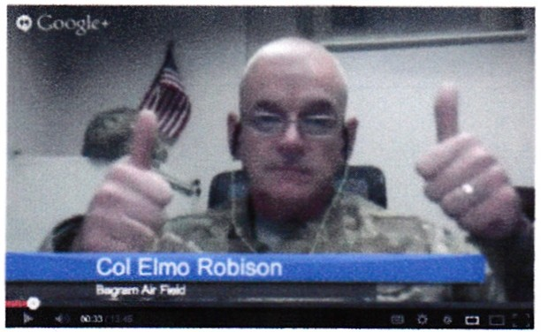
Lewisville Noon Rotary meets Wednesday 12noon at The Grotto 2300 Highland Village Rd

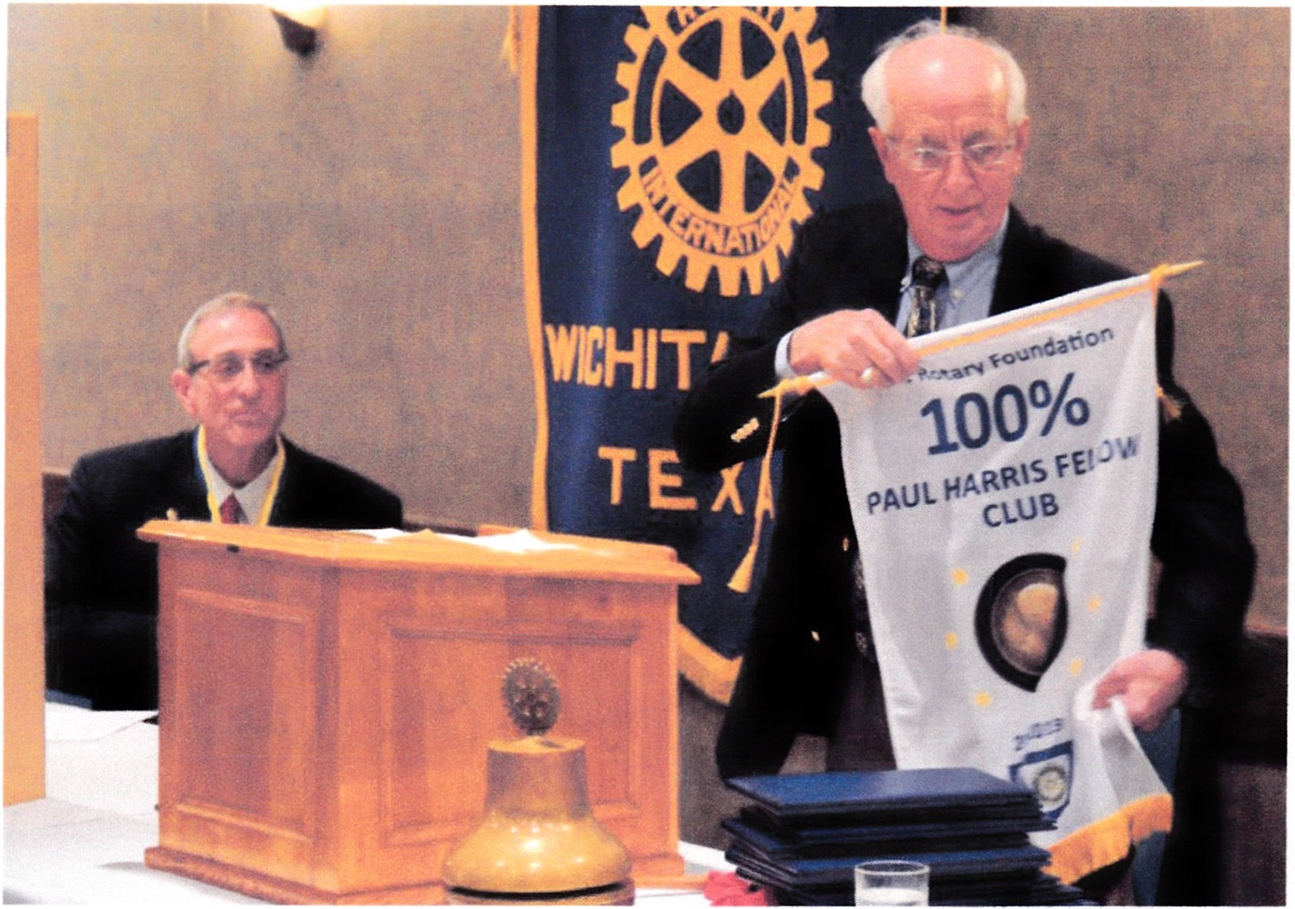Wtchita Fall$

By: President -Thomas ""Tom" Whayten twhayten@wf.netThe

By: Tom Whaylen

Since the last Wichita Falls Rotary Club update in this newsletter,the Club, under the leadership of then President Tim Powers,attained the lofty goal of becoming a 100% Paul Harris Fellow Club! Benay Ayers and Bob Brotherton as well as the entire membership of the Club ably assisted President Tim. This is the first time in the 98 year history of the Club that 100% of the members have been Paul Harris Fellows. Well done Wichita Falls!

The new Rotary year was off to a fast start with District Governor Jim visit the third week into the year. His words served to encourage Club members to surpass the accomplishments of last year.

Long a supporter of the RYLA program, the Wichita Falls Rotary Club sponsored six students to RYLA this summer.

August in Wichita Falls brings the Hotter 'N Hell bicycle race with over a projected 14,000 riders to Wichita Falls. While many in the Club are among the over 4500 volunteers that make the race possible, the Club helps serve the riders during the spaghetti feed on Friday evening prior to the race on Saturday morning.

With Sheppard Air Force Base a large part of the North Texas landscape, the club has redoubled its efforts to support our men and women who serve our great Nation. The Club has adopted two organizations at Sheppard and includes them in Club events.

Wichita Falls meets Thursdays 12noon at Luby's Cafeteria 1801 9th St.

This & That Around the District The nstallation Banauet for Arlington Sunrise

The Arlington Sunrise Club changeover banquet was held at the Dallas Cowboys Stadium. n addition to being wowed by the facilities, club members were also wowed by incoming President Jake Hardin who appea red in disguise - who then introduced his board members, who also appeared in disguise.

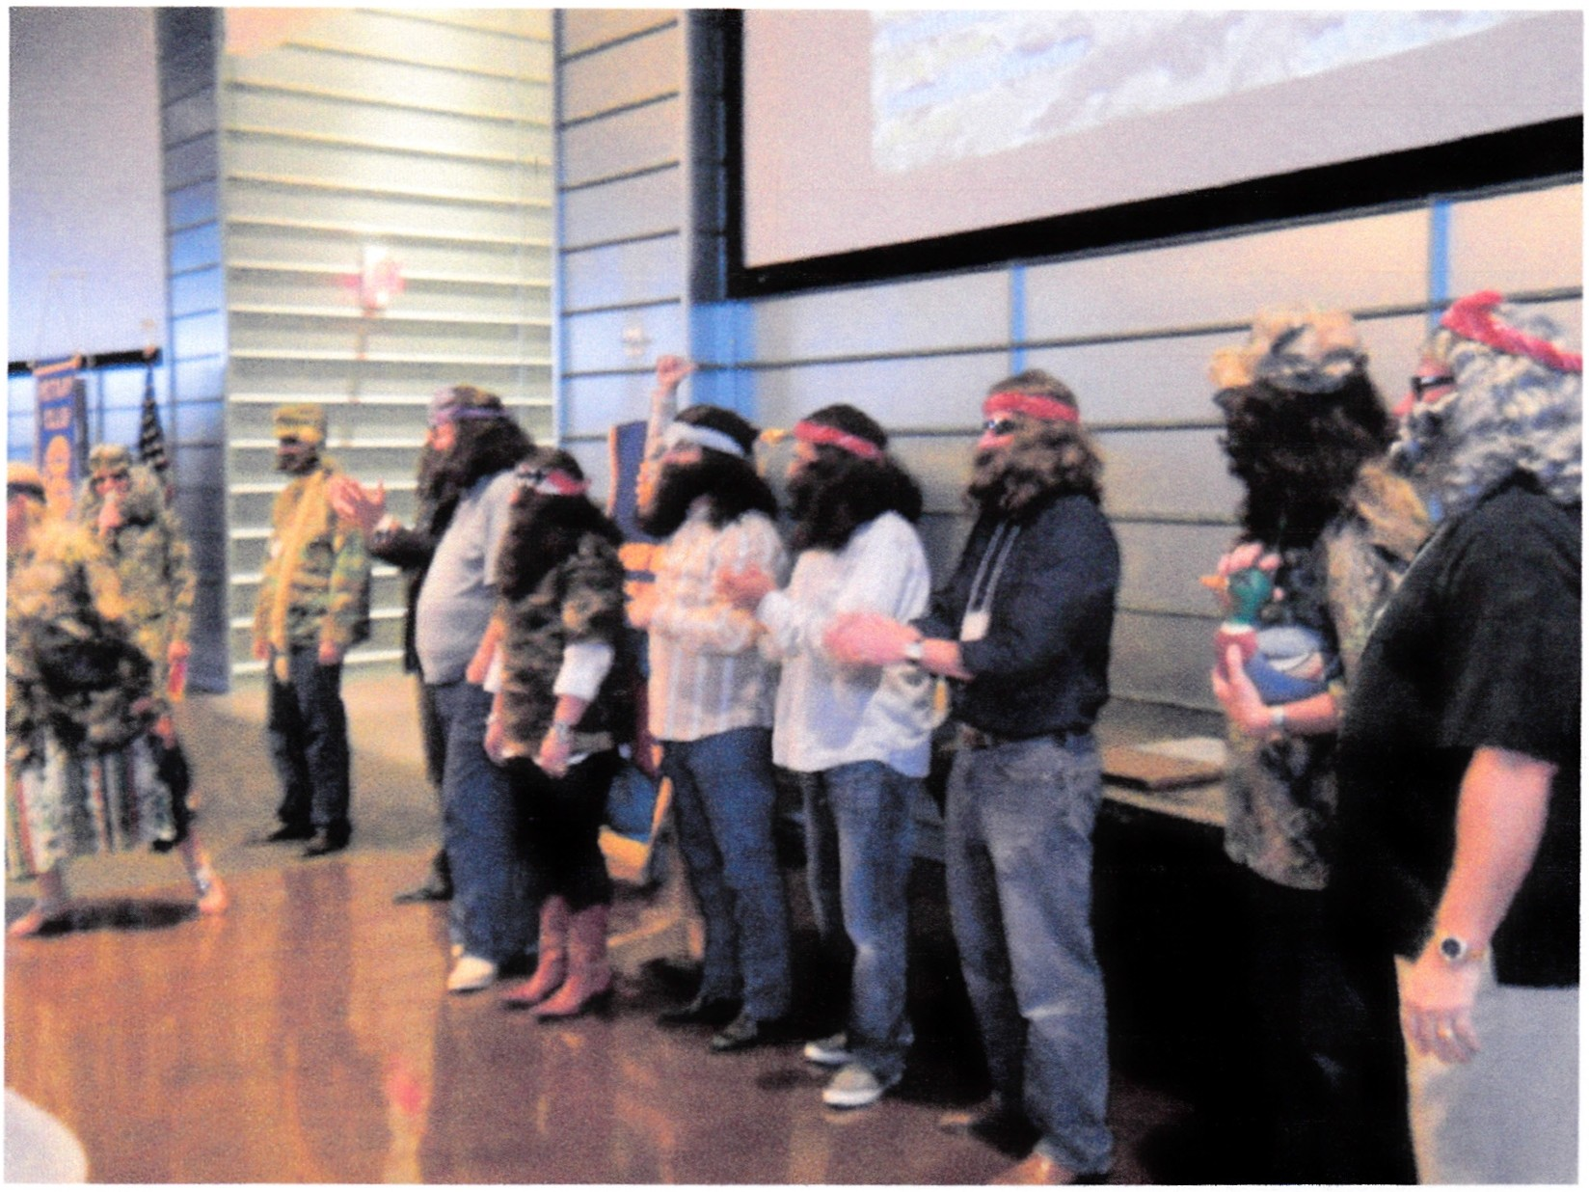In a return to more normal activity, Mike and Sharon Nix were recognized by PDG Bill Harnage! as the newest members of the Rotary Bequest Society .

September 28th 6pm-12midnight
Got your tickets to the Western Days Back Stage _Bash yet?

All donations go towards Lewisville Morning Rotary Charities such as CCA, Pedi-Place,National Honor Society and more.
Your donation gets you a great steak prepared by an wodd champion pit crew all the flx ins,beer and a great seat to the concert . http ://www .clubrunner.ca/Po rtal/SitePages/ SitePage.aspx?cid = 1833&pid = 3406&accou ntid= 1833

Lewisville Morning Rotary Club

www. clubrunne r.ca

Official Website for Lewisville Morning Rotary Club. Powered by ClubRu nner.

Tickets $60 per $100 couple

Do you want to print the Squeaky Wheel?
Instructions below guide you to do just that...
Enjoy your SQUEAK Y Wheel in printed form

Last month a few District 5790 Rotarians expressed disappointment that they could not print out a nicely formatted copy of the e-bulletin.

For those members that prefer to read a paper newsletter, it is possible to print a nicely formatted copy of the e-bulletin by following the following steps:

1. Open a "Firefox browser by typing http://www.foxfire.com!

2. In the tool bar at the top of the Firefox browser type http://www.rotary5790.org/

- Once the District 5790 opens, click in "District e-Bulletin on left side of page

- In the upper left hand comer find and click on the orange bar marked •Firefox

- A window will open with a few options. One option is to "plint"

