WELCOME TO YOUR “ROTARY RISES” PUBLICATION KIT.

You will find four items in this kit. All are intended to help you share the success of the ROTARY RISES Global Grant with your local media, club members, and community. A description of each piece and the intended use follows:

PRESS RELEASE:
This template is intended to describe both the ROTARY RISES project and your local club project/s related to COVID-19 relief to your local newspaper or other media outlets. Please update the fields in parentheses and email or otherwise deliver to your local newspaper and media contacts.

TALKING POINTS:
Please use this list of commonly asked questions and key information to describe the ROTARY RISES project and your local club project/s related to COVID-19 relief to your local newspaper or other media outlets. Secondarily, the document can be used to inform your club members about the details of the ROTARY RISES grant and the value of their contribution.

INFOGRAPHIC:
This infographic is intended to summarize the key points of the ROTARY RISES project and your local club project/s related to COVID-19 relief. It can be used in your club meetings as part of the slide presentation or shared with interested third parties. The LOCAL CLUBS section may be edited to describe your local events or activities. For assistance in updating, please email Belinda Gist at belinda@rt3p.com.

SOCIAL MEDIA POSTS TEMPLATE:
Post 1:
Rotary Club <<INSERT CLUB NAME>> supports our local food banks during #COVID-19. Want to help? Donate to the Rotary International Annual Fund here: https://www.rotary.org/en/donate Your tax-deductible gift will provide help to those most in need today and into the future.

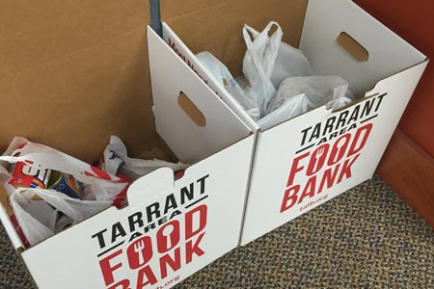

Post2:
Consider giving to the Rotary International Annual Fund to help Rotary clubs lead disaster recovery efforts, including projects related to #COVID-19 https://www.rotary.org/en/donate Your tax-deductible gift will provide help to those most in need today and into the future.

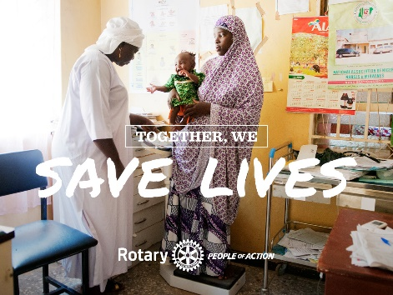

Post 3:
Texas Health Resources Hospitals, Hendrick Health System in Abilene, and United Regional Hospital in Wichita Falls received funds from #RotaryDistrict5790 to purchase personal protective equipment, testing kits, thermometers, hazmat suits, and other consumable medical goods. To learn more, email <INSERT CLUB CONTACT EMAIL> #PeopleOfAction #RotaryRises

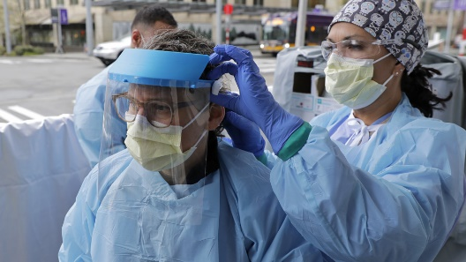

Post 4: #COVID-19 has made many families food insecure. #RotaryDistrict5790 is helping. Tarrant Area Food Bank, Wichita Falls Area Food Bank, and Food Bank of West-Central Texas in Abilene were supported. Agencies provide service through distribution centers, mobile food delivery, emergency food boxes, and supplemental school feeding programs. Get involved with Rotary. For your invitation to visit our club, email <INSERT CLUB CONTACT EMAIL> #PeopleOfAction #RotaryRises

