Rotary Club Virtual Meeting Options

Clubs that wish to engage their members and guests without hosting a physical meeting should consider the Virtual Meeting Option. There are several tools available that allow clubs to host a virtual meeting. The following are just a few for clubs to consider:
- Rotary District 5790 District Governors have been hosting leadership meetings via Go-to-Meeting for a few years now. 3 Plans are available; Professional plan for less than 150 participants, Business plan for less than 250 participants and the Enterprise version for up to 3000. For all but our largest clubs, the professional version should serve the needs of a typical Rotary Club meeting. Monthly subscription is $14/month if you use monthly billing. They used to require an annual subscription (needs to be confirmed).
- Zoom.us has 4 options; Personal option is free for up to 100 participants, however your meetings have to be less than 40 minutes; Pro version is $14.99/mo/host for up to 100 participants with meeting duration limited to 24 hours; the Business version for up to 300 participants and 10 hosts for $19.99/mo; the Enterprise version for up to 500 participants and 50 hosts. Billing is monthly and can be cancelled any time, a small fee reduction is available for those willing to prepay for entire year. Zoom is available through Rotary Rewards, includes a 20% fee reduction when using code “ZOOM ROTARY. Also know that a small a portion of your subscription cost is used to support the Rotary Foundation.
- Cisco Webex; Personal option is free for up to 100 participants and unlimited meeting time, including desk top share options of applications, files and whiteboard. Also has video conferencing, recording (to local computer) and mobile features with online and voice support. Good security. They also offer 3 paid options including Starter for $13.95/mo/host, Medium Teams for $17.95/mo/host and Business at $26.95/mo/host that will allow up to 200 participants. Each of these paid subscriptions has varing degrees of additional functionality that need to be assessed in terms of need for your Rotary Club. Click here for link to descriptions of options. Except for large Rotary clubs (100 participants plus per meeting) the personal option will meet the needs of the average Rotary club.
- Facebook Live Stream. Some of our clubs are already using this service for their members that cannot attend their normally scheduled meetings. The service is free to all those that have a Facebook account which of course is a drawback for those members without an account. See pro and con comments of using Facebook live stream for your meeting in a separate portion of this document.
There are several webinar/meeting apps available online. For purposes of this document, we have focused on the 3 in greatest use among District 5790 members. Those with experience with other providers should forward information regarding other virtual meeting service providers to members of the Public Image and Technology Committee.

Other Best Practice Considerations for Virtual Meetings
As with any Rotary meeting, planning is important to a successful meeting. This is particularly true for virtual meetings. The following are items to consider when hosting a virtual meeting:
- Camera location – weather you are using a laptop camera, a video camera or your smartphone, preplan the location for the device. Camera should be located where people will not block the camera view. If you are using a smart phone or a video camera, a tripod is a good investment. Amazon prime has such a tripod for under $30. https://www.amazon.com/UBeesize-Extendable-Bluetooth-Aluminum-Lightweight/dp/B07NWC3L95/ref=sr_1_4?crid=3D6YSLXV8EPUU&keywords=tripod+for+iphone&qid=1584467694&sprefix=tripo%2Caps%2C189&sr=8-4. They also have a tripod version that has lighting if you are in a poorly lit room.

Locating a laptop properly is a little harder. We recommend doing a premeeting to figure out where best to locate the laptop.

- Staging – consider how your meeting will appear on both a computer screen monitor and a smart phone screen. Speakers need to be stationary in the center of the screen. As with all Rotary meetings having a Rotary background is important. So, continue to use your club banners in the background of your club president and or speakers.
- Make sure speaker and the participating members do not have their cameras facing a window. Light from window washes out image.
- Set-up. Depending which tool used for the meeting, make sure participants are muted as they come on line. Designate someone to monitor attendees and provide instructions how to unmute if they would like to speak. You may wish to use the chat function to have participants request to speak before unmuting.
- Audio considerations – make use sound systems. Make sure club president and/or speakers use the microphone. If you are considering a panel discussion, multiple microphones are needed. Request participants to use ear buds or head phones, so that their surrounding noise does (dog barking) does not disrupt meeting.
- Lighting – to the greatest degree possible, have the speaker podium located in an area with good lighting.
- Audience decorum – while it is understood that the audience will be small, please make sure audience understands the importance of maintaining silence, speaking only when called upon and when speaking, use their “outside voice” so that the virtual audience can hear the question.
- Script – Most club presidents prepare an agenda that essentially becomes their script for a physical meeting. The agenda should take into consideration the staging. Waiting for members to walk up to podium in order to speak may work in a physical meeting, but these few seconds are dreaded dead time on a computer screen or smart phone screen. So, minimize these periods by having members nearby and ready to be in front of the camera quickly when called upon. Or, delete this practice completely for virtual meetings.
- Opening and ending comments. For a virtual meeting, a full and formal meeting introduction is required at the beginning, include your name, your title, the name of your club or committee and an overview of the agenda. For a virtual meeting, you may wish to dispense with some the typical Rotary meeting practices that will not be practical in the virtual meeting world. Club president should make sure the on-line audience knows the meeting is ended.

How to Set-up a Live Stream Meeting on Facebook

There are several video’s available on the internet describing the process for a live stream video. This link from Hub Spot is one you may wish to read https://blog.hubspot.com/marketing/facebook-live-guide
A few issues you may wish to consider before using FB Live as your virtual meeting broadcast tool:
- Major advantage is cost. Facebook Live costs nothing to your club or your members
- Your live stream is available on your clubs Facebook page for members and in fact everyone that has liked your clubs Facebook page. Can be viewed for as long as you want that post to be seen.
- Disadvantages to consider:
  - Available only to those members that have subscribed to Facebook
  - Interaction between speaker and audience is limited to use of the comment section
    - Need to communicate to audience that comments and questions will be monitored in the comment section of post
    - Need another person in room to monitor comments and relay those to the speaker
  - Limited screen share capability, so if speaker is using a Power Point Presentation, the only thing the audience sees is the presentation. When presentation ends, live stream ends
  - Without good preparation, these live stream videos can be unwatchable. Clubs need to think about staging, audio quality, content and audience decorum. Since these videos are now out there for the digital world, poor video quality could have a negative impact on the non-Rotarian audience.

How to Set Up a Zoom
- Go to https://zoom.us/ or use the 20% ZoomRotary discount coupon at https://my.rotary.org/en/member-center/rotary-global-rewards/offers?#/offers/featured – you will need to sign-in to your MyRotary account.

- Zoom offers many products to facilitate virtual meetings. Click Solutions to explore the products offered.

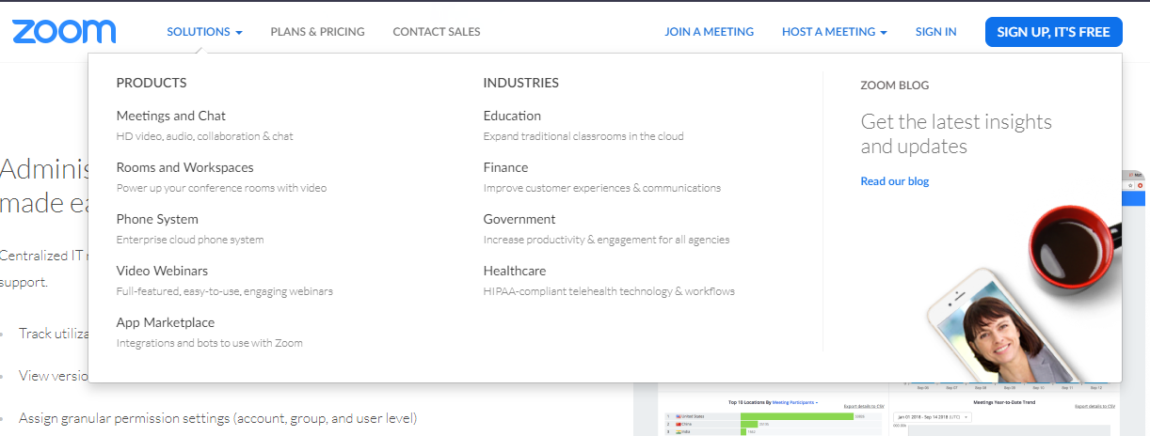

- Watch this video to see how Zoom can work to host an online meeting. https://www.youtube.com/watch?v=VnyitUU4DUY

- Located in the Plans & Pricing Tab are the options on Zoom that might work best for your Club
- Free Plan with 100 participants and a 40-minute meeting time limit
- $14.99 Pro Plan for Small [Clubs] Teams of up to 100 participants and a 24-hour time limit.
- $64.99 Pro Plan for Large [Clubs] Teams of up to 500 participants and a 24-hour meeting time limit

- Choose the Plan that works best for you. Options to Pay Monthly or Annually are available. A discount is available with an Annual payment Increasing Hosts does increase the cost of the plan. For Clubs needing to host more than 100 participants, select ‘Available Add-ons’ to increase to up to 500 participants.
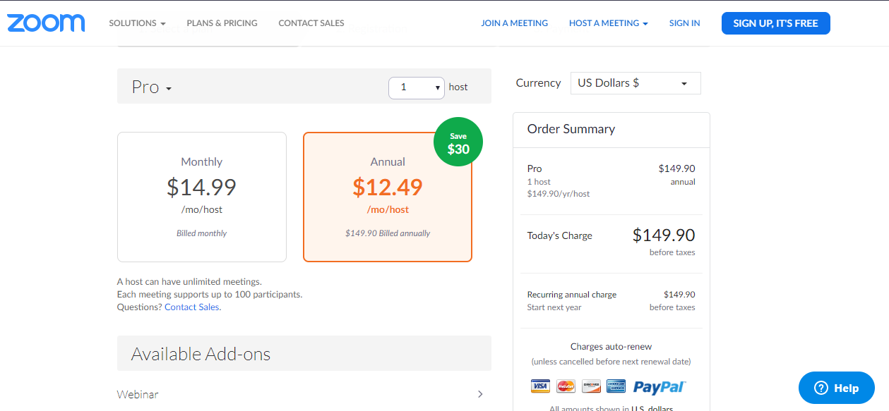

- Watch this video to learn how to set up and use Zoom across phone, and computer platforms.
https: //www.youtube.com/watch?v=-ik5o6WptX0

