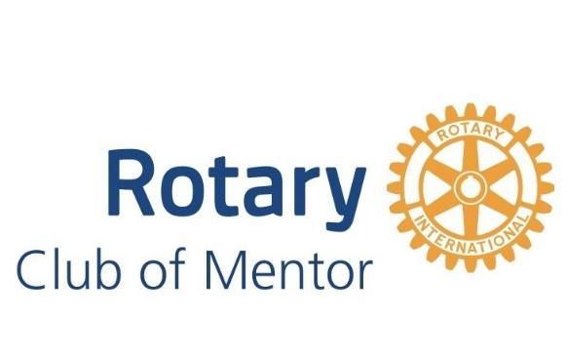

Welcome to your XXXXX Rotary Club Meeting!

We are so excited to have you with us! Rotary at first can be a little confusing, so this sheet will help through your first meeting. If you have any questions, feel free to ask. We promise...we don’t bite :)

- It’s 12:15 - why hasn’t the meeting started? The beginning of the meeting is a time for all of our members to catch up with each other and connect with new guests to our club. We normally start the “formal” portion of our meeting around 12:20 PM. As a guest, feel free to help yourself to the lunch buffet along with our members and other guests!!
- Go Back to Grade School - After the bell rings, each meeting starts with the Pledge of Allegiance. We stand up for the invocation, pledge and 4-way test. Then we get to sit back down for the rest of the meeting and enjoy dessert.
- Start your Meeting Right - After the pledge, we all recite the 4-way test. This is a guiding principle in rotary. You don’t have to worry about reciting it, but here it is so you know what we are saying
Of the things we think, say or do
- Is it the TRUTH?
- Is it FAIR to all concerned?
- Will it build GOODWILL and BETTER FRIENDSHIPS?
- Will it be BENEFICIAL to all concerned?
- Be our Guest! After we sit back down, we will introduce you to the rest of the club very quickly!
- What’s with all the Announcements? Our fellow members are our family – we want to know how they are doing and share any member concerns so that we can support one another. We also have many social and service activities to track and share.
- What’s Happening Around Town? Most weeks in Rotary we have a weekly presenter that will share with us something about what is happening in our local community, and how as Rotarians we can become involved.
Still interested in joining? Check out the back of this pamphlet to see how you can test out Rotary and see if we might be the right fit for you!
Interested in Joining District 6630 Rotary?

Here are some tips before filling out the application
Grab a cup of coffee with a club member
Learn why we love this organization, and what the time commitments are if you are interested in joining.
Attend a couple of meetings
You can come to as many meetings as you like when you are deciding if Rotary is the organization for you! We would love to continue to have you as a guest
Check out ALL of your options for Rotary
Did you know we have other Rotary Clubs in Lake County and northeast Ohio? . Each club benefits the same mission, but hosts different events to serve that mission. You can learn about meeting times, locations and contact information for them at https://rotarydistrict6630.org/clubdirectory/
Still Interested?
What to expect as a club member:
    - There are weekly club meetings at noon at the Mentor Harbor Yachting Club
    - We have service and social events throughout the year which you can attend if you are available
    - Each quarter, club dues are $200 to help pay for international and district dues, club costs and your lunch!
    - Have more questions about joining or interested in an application?
Ask our membership chair
Member Chair – memberschair@gmail.com
Club President - yourhonor@gmail.com

