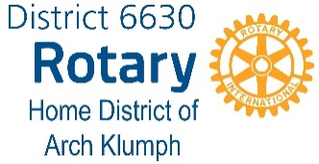
MEMBERSHIP SUMMIT

5:00 p.m., Monday, July 23, 2018
Crowne Plaza, Independence, OH

AGENDA

I. Welcome and Introductions

A. Purpose of Meeting – Brainstorming Membership Development Ideas
1. No negative feedback
2. Focus on quantity over quality
3. Use each others’ ideas as launch pads
4. We want “big thinking” (outside of the “box” – there is no wrong answer)

B. We already know THE WHAT - Review of Handouts

1. Member Viability and Growth
2. District Growth
3. Membership Leads Progress Analysis
4. Membership Resource Guide
5. RI State of Membership
6. Alternative Meeting Structures
7. FAQ’s

II. Now for THE HOW
A. The Successes - What has worked recently and why
B. The Risk-takers – Pro’s and Con’s (revisions to monthy and weekly meeting structures)
C. Why did they say they wouldn’t or couldn’t join and why did they leave?
D. What do our Rotary clubs have to offer? (demographics of each are different – age,
gender and cultural diversity, different vocations or avocations – is there an under-
represented group in their demographic/from their community)

E. What type of member do we want? Where do we find them?

F. What can we do to make ourselves more attractive and communicate the value of
membership to recruit new members?

G. What do you see challenging our membership development efforts most?

III. Exercise on the “five” hottest topics

IV. Next Steps…

A. Where do we go from here – how do we get EVERYONE in the district involved?

B. Multi-District Membership Seminar

