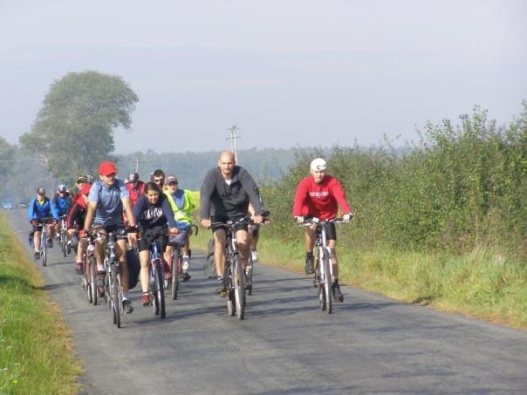
ROTARY DAYS
2015 Charity Bicycle Ride
May 30, 2015
Along the Western Reserve Greenway Trail
In Ashtabula and Trumbull Counties
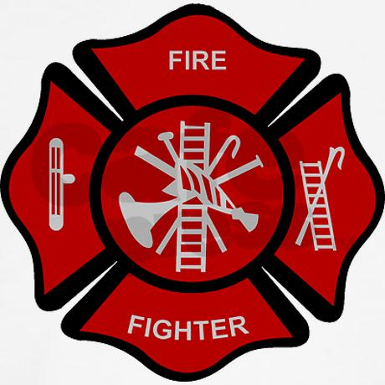
IN PARTNERSHIP WITH
AREA FIRST-RESPONDERS
Participants can start anywhere/anytime between 8 a.m. to 1 p.m. along the 44 mile route of the
Western Reserve Greenway Trail
Distances are determined by the Participants.
Each participant is given a route card which is stamped at the checkpoints/rest stops along the trail.
Checkpoints/rest stops staffed by First-Responders and Rotarians and will provide:
Staffed by First-Responders and Rotarians
First-Aid
Bicycle maintenance
Refreshments
Route Card Stamps
Lamson Rd. Rallying Point between 11 am -1pm where participants and their families can enjoy:
Food/refreshments for sale, entertainment and other activities
Rotary information booths (all clubs, highlighting activities/charities
First-responder demonstrations
Check points for picking up packets (No need to start at Lamson Rd.)

COST: $30 PER PERSON, $100 PER FAMILY
FOR REGISTRATION INFORMATION GO TO: http://rotarydistrict6630.org/SitePage/2014-15-rotary-days-events-information
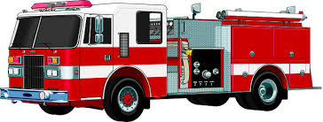
A Charity Ride benefiting
Rotary Charities & First Responders

