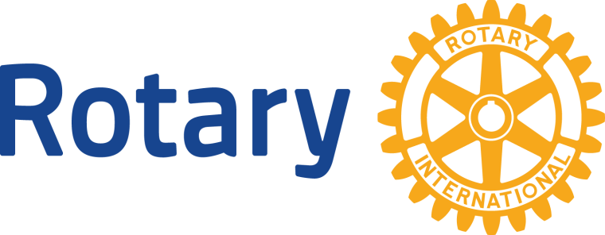
Dear ______

The Rotary Clubs of Ashtabula and Trumbull Counties and the First Responders of the area are
sponsoring the first Rotary Days Charity Bicycle Ride / Walk May 30 , 2015 from 8 AM until 1 PM. We are anticipating well over 500 participants in our inaugural event!

Our goals are to raise awareness of Rotary and of the Western Reserve Greenway Trail by promoting wellness and exercise for families and individuals of all ages, and raise funds for our two entities. Rotary is over 100 years old and has 1.2 million members across the globe with the singular focus of “Service above Self.” Local programs that our Rotary Clubs support are our schools, food pantries, HALO, libraries, youth scholarships, etc. International efforts have been the elimination of Polio throughout the world, fresh water wells, sanitation, education, youth exchanges, medical assistance, etc.

The First Responders in our area work daily to save lives. Consisting of Fire Departments and Ambulance/EMS Services, many of these organizations are volunteer and those that are not are still in need of those extra funds to operate a safe and up-to-date response force.

We invite you and/or your company to join us by sponsoring the Rotary Days 2015 Charity Bicycle Ride, on May 30th.

Sponsorships are available at the flowing four (4) levels:

Silver - $100.00 – Name Listed in Program
Gold -$150.00 – Silver + Sign on Greenway
Platinum - $200.00 – Silver + Gold + Name on shirt
Primary -$1000.00+ Silver + Gold + Platinum + Full page on Program and Enlarged name on shirt
A flyer with more information about the event is enclosed or attached. If you have additional questions, please contact: Jack Nettis, President, Rotary Club of Rock Creek/Grand Valley – 440-352-3249

Checks may be made payable to: Rotary Club of Rock Creek/Grand Valley,
P.O. Box 365, Orwell, OH 44076

Due to the printing deadline, we ask that your response be received by April 15, 2015.

Thank you for your support of these causes.

