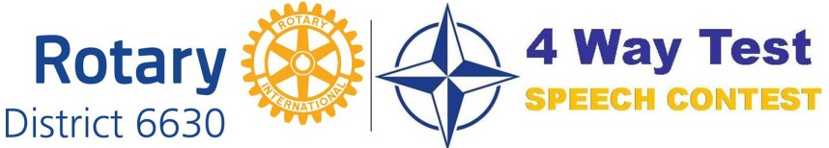
2026 Contest Entry Form
School Name: _________________________ Name of School Contact: _________________________
Tel#: _________________________ E-mail: _________________________
Student Name: _________________________ Grade: _____ Tel#: _________________________
Address: _____________________________________________________________________________
E-mail: ______________________________________________________________________________
I declare that the content of my speech is mine.
By participating in this contest, I do hereby relinquish any and all rights to quotations, photographs, portraits, transparencies, negatives, prints, Polaroids, or other photographic reproductions captured with still, motion picture, video, digital or other cameras for use by Rotary International District 6630, Rotary International, the Rotary Club of Port Summit, and the officers, trustees, directors, and members (collectively “Rotary”) in connection with the promotion of this contest. Use may include, but not excluded to, broadcast, internet, and/or print forms.
I understand that if I am among the top three (3) prize winners of the district-level contest on Saturday, April 18, 2026 at Springfield High School, 1880 Canton Road, Akron, Ohio 44312, I will need to provide my social security number and complete form W-9, to receive my prize.
I also understand that I will receive my district-level prize after delivering my winning speech at the Rotary District Conference on Saturday, April 25, 2026, at Cleveland Marriott East, 26300 Harvard Rd., Warrensville Heights, OH 44122
Student’s Signature: ________________________________________________ Date: _____________
Parent/Guardian Name: _______________________________________________________________
Parent/Guardian Signature: __________________________________________ Date: _____________

