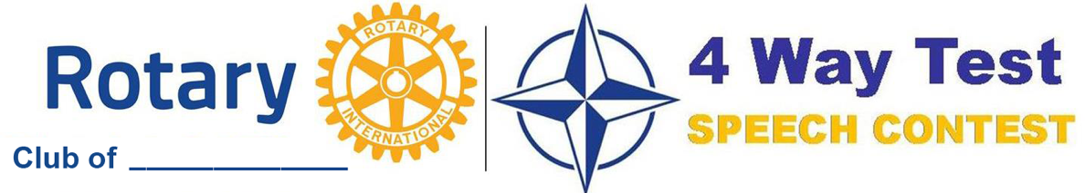
OPEN TO ALL STUDENTS
Date: ________________________
1st Prize: $_______
2nd Prize: $_______
3rd Prize: $_______

The purpose of the speech is to apply the principles of Rotary International’s 4 Way Test to a current ethical issue. Identify a topic you feel passionate about, adopt a point of view and persuade others. Evaluate your recommendation by answering the following questions:
- Is it the Truth?
- Is it Fair to All Concerned?
- Will it build Goodwill and Better Friendships?
- Is it Beneficial to All Concerned?
The speech should be 5 to 7 minutes long. The District Contest Guide along with videos of previous winning speeches is available at www.rotarydistrict6630.org under the 4 Way Test Speech Contest tab.
. . . . . . . . . . . .
Top winner advances to the District Contest on Saturday, April 18, 2026.

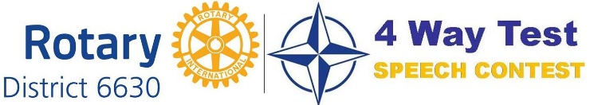
District Prizes
1st Prize: $1200
2nd Prize: $900
3rd Prize: $700
Honorable Mentions: $200

Contact ____________________________ to participate.

