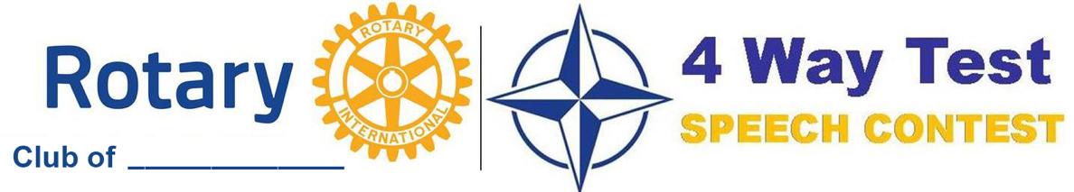

**OPEN TO ALL STUDENTS**

**Date: ________________________**

**1st Prize: $_______**

**2nd Prize: $_______**

**3rd Prize: $_______**

The purpose of the speech is to apply the principles of Rotary International’s 4 Way Test to a current ethical issue. Identify a topic you feel passionate about, adopt a point of view and persuade others. Evaluate your recommendation by answering the following questions:

* **Is it the Truth?**
* **Is it Fair to All Concerned?**
* **Will it build Goodwill and Better Friendships?**
* **Is it Beneficial to All Concerned?**

The speech should be 5 to 7 minutes long. The District Contest Guide along with videos of previous winning speeches is available at [www.rotarydistrict6630.org](http://www.rotarydistrict6630.org) under the 4 Way Test Speech Contest tab.

**. . . . . . . . . . . .**

**Top winner advances to the District Contest on Saturday, April 6, 2024.**

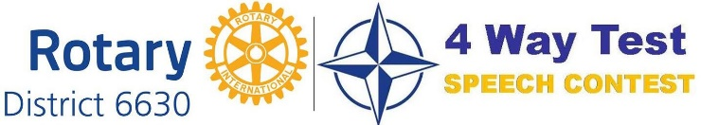



**District Prizes**

**1st Prize: $1200**

**2nd Prize: $900**

**3rd Prize: $700**

**Honorable Mentions: $200**

**Contact ____________________________ to participate.**