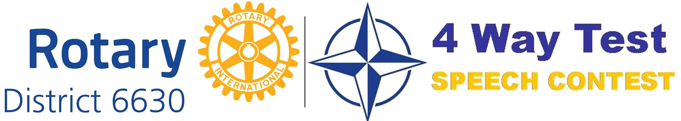
[DATE]
The Principal
XYZ High School
Ohio
Dear Sir/Madam:
Invitation to participate in 2024 Rotary District 6630 – 4 Way Test Speech Contest
Over the years, Rotary Clubs in District 6630 have partnered with schools and offered this opportunity for high school students to develop critical thinking, ethical decision making and public speaking skills. Feedback about this program from teachers, students and parents has been consistently positive with strengthened ties to the local community.
The purpose of the 5 to 7 minute speech is to apply the principles of Rotary International’s 4 Way Test to a current ethical issue. Students are challenged to identify a topic they feel passionate about and to adopt a point of view from which they will seek to persuade others. In doing so they are required to evaluate their recommendation by answering the following questions:
● Is it the Truth?
● Is it Fair to all concerned?
● Will it build Goodwill and Better Friendships?
● Is it Beneficial to all concerned?
The contest takes place at School, Club and District levels. Three contestants per school compete at the Club level and the top winner from each school advances to the District level. In addition to recognition, students can also win cash prizes at the Club and District levels of the contest. District level prizes range from $200 to $1200. The Contest Guide along with videos of previous winning speeches is available on www.rotarydistrict6630.org under the 4 Way Test Speech Contest tab.
Please let me know a good day and time for us to meet to discuss how we can work together to implement this program. It would also help if you could invite a school point of contact (either a faculty member or an administrator) to our meeting. I can be reached by telephone _________ or by e-mail: _________________________

Thank you.

Sincerely,
[Name of Rotarian]
Contest Chair – Rotary Club of ________

