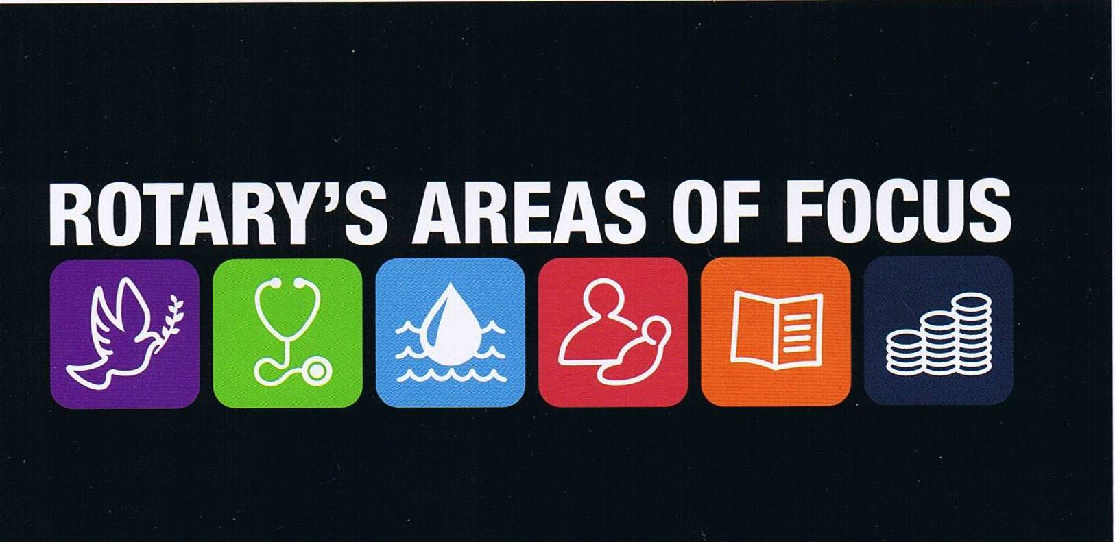
Helping Rotary Clubs Help Others

Foundation Six Areas of Focus | Greatest need | Foundation Support | RAWCS Projects | RAWCS Volunteers | Donations In Kind | RAM | Save Water Saves Lives
Promoting peace | Overseas | YES | Yes | Yes | Yes | Yes | Yes
Fighting disease | Overseas | YES | YES | YES | YES | YES | YES
Providing clean water | Overseas | YES | YES | YES | Yes |  | YES
Saving mothers and children | Overseas | YES | YES | YES | YES | YES | YES
Supporting education | Overseas | YES | YES | YES | YES | Yes | YES
Growing local economies | Overseas | YES | YES | YES | YES | Yes | YES

While there are areas of need in Australia, we are one of the richest countries in the world and we have a wonderful opportunity to help developing countries. If you reflect on the World Presidents Speech and read the Foundation information on this subject we are being urged to help developing countries. There are some excellent Major International Health Projects that Clubs can support financially, but if Clubs want to run their own projects their main source of support is from The Rotary Foundation and from Rotary Australia World Community Service and its projects. Some of the RAWCS Projects work directly on an area of focus but we should not overlook the benefits that clean water and improved sanitation and health provide the whole community. Whenever Rotarians show that they care and make a contribution to a community we strengthen the bonds that encourage peace.
There are opportunities at many levels for Clubs to get involved and make a significant difference, but many are unaware of the support available and how easy it is to get involved. The support allows Club to run projects that are well beyond their expectations with the maximum benefits occurring when support is obtained from both sources.
There is a project available for your Club to adopt that will suit your areas of interest and capabilities.
Call to action

