Club Project Support – Choosing an International Project
If you want to run your own project you may wish to consider the following.
International Projects are different. It takes a long time to identify a problem, make contact with the people involved, find a solution where your Club can be effective, get permission to do the project and then take action. Many projects also require ongoing follow up for maintenance and training. You don’t have to do it on your own and we can help you speed up the process.
If you have a project in mind a lot of assistance is available from Donations In Kind. Having shipped over 500 containers from the Victorian Stores in the last 14 years to 20+ countries there is a lot of knowledge to tap into, that may save you considerable time, effort and often funds. When you have defined your project contact your local DIK Store and discuss how they can help.
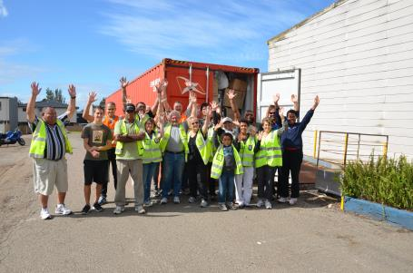
Running your own container project is a wonderful experience for your Club and one of the most cost effective ways to help people.
Another great option is a partnership where you run your own independent project in an area where another Club is operating. Many Clubs identify other projects in the region they are supporting, which are beyond their capacity to handle. They have done the research and often have projects ready for another Club to adopt. Using this approach will save a major amount of time and energy. It also allows you to select projects to suit your Clubs capabilities and interests.
If you have identified Potential Projects in the area you are supporting, please let us know and we will promote the opportunity.
If you are looking for a project, identify the type of projects and countries you are interested in, how you want to be involved and contact us. We will match your requirements with current Potential Projects and send you the details.
Our aim is to help you with your projects and if we can help you save time or effort it will allow you to do more for the people you want to help.
The DIK Club Project Support Team
Helping Rotary Clubs help others
For more information, contact your District Donations In Kind Representative or
DIK Store: Geelong info@rotarydonations.org.au West Footscray dik.vic.rotary@gmail.com

