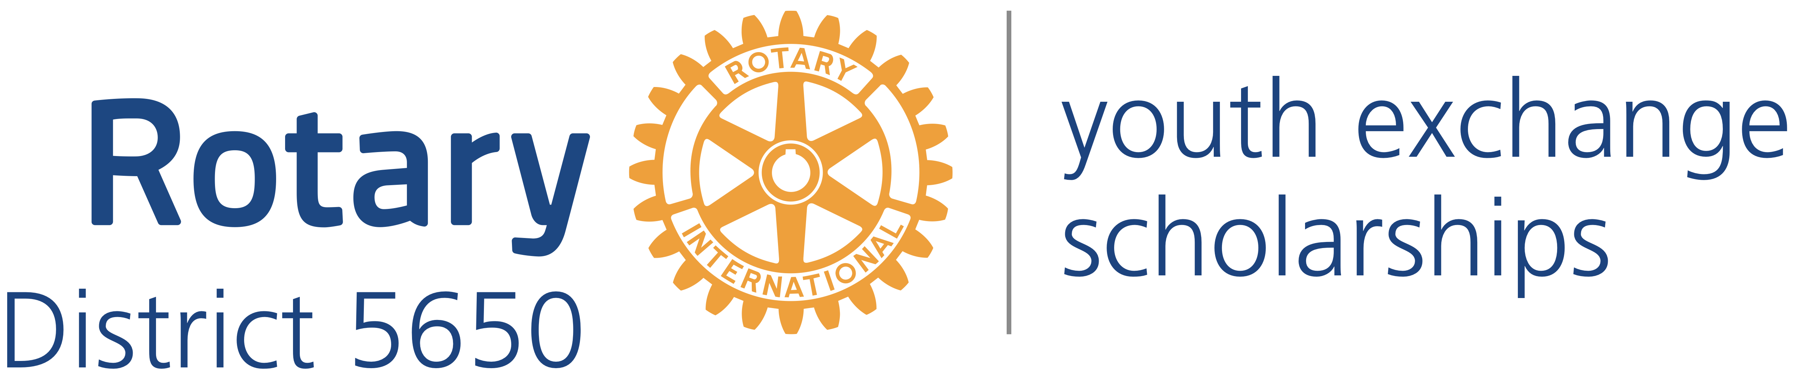
Western Iowa and Eastern Nebraska

Gary Bren
District Governor
4202 N. Branch Dr.
Omaha, NE 68116
(402) 881-0665
gbren@tacnet.com

Bob Rauner
District Youth Exchange Chair
5100 Valley Rd.
Lincoln, NE 68150
(402) 450-1859
brauner@healthylincoln.org

Stephen L. Gerdes
International Liaison &Advisor
11920 Burt St., Suite 145
Omaha, NE 68154
(402) 677-3743
yeo1@rotarydistrict5650.org

Curt Peters
Omaha Area Chair
11112 John Galt Blvd
Omaha, NE 68137
(402) 510-6728
curt@integratedsolutions.net

August 12, 2016
Dear Educator:

We are writing to inform you about an opportunity for one of your students to become fluent in another language and culture as a Rotary Youth Exchange student. The Rotary Youth Exchange Program began in 1927 and continues today with over 8,000 students in the 2016-17 school year.

What is Rotary?
Rotary International, which sponsors this program, is an international volunteer organization comprised of Rotarians around the world dedicated to improving their communities, locally and globally, through service to others. Rotary International District 5650 consists of 45 Rotary clubs in eastern Nebraska and western Iowa.

What Are the Goals of Rotary Youth Exchange?
- To further international goodwill and understanding by enabling students to study firsthand problems and accomplishments of people in lands other than their own.
- To enable students to advance their education by studying for a year in an environment entirely different from their own.
- To give students opportunities to broaden their outlook by learning to live with and meet people of different cultures, creeds, and colors.
- To have students act as ambassadors for their own country by addressing Rotary Clubs, community organizations and youth groups in their host country; by imparting as much knowledge as they can of their own country.
- To provide sufficient time to study and observe another country's culture, so that upon returning home students are fluent in the language and culture of their host country.

How Can Your Students Become Rotary Youth Exchange Students?
During the fall, we will conduct screening interviews of students who are interested in becoming exchange students during the 2017-18 academic year. A student’s first step is to fill out the Preliminary Application and portions of the Long Term Application that are available on the District 5650 website: http://rotarydistrict5650.org/SitePage/application-and-interview. The student submits the application to a local Rotary Club and the Rotary Youth Exchange Committee. During September, October, and early November, the student and the student’s parents must interview with a local Rotary Club and with our District Youth Exchange Committee. If the Rotary Club and District 5650 decide to sponsor the student, then the student and his or her parents attend an initial orientation in Lincoln on November 19-20 and a second orientation in Grand Island on February 18-19. 2017. There is a deposit of $50 for the November orientation weekend which is applied to the $600 application fee if accepted.

How Much Does It Cost to Be a Rotary Youth Exchange Student?
The Rotary Youth Exchange Program is one of the least expensive exchange programs averaging approximately $5,000 depending on the country. These costs are mainly direct costs involving the application cost, plane fare, health insurance required by the host country, passport and visa fees. Need based scholarships are available for exceptional students.

The application fee covers Rotary District 5650’s costs for processing the application and for providing services to the exchange student who District 5650 will receive from the foreign District to which the American student is sent. (The foreign District charges a similar fee to the foreign student to cover its cost of providing services to our exchange student.) The roundtrip airfare is higher than discount coach fares because the ticket is an “open” ticket or one that allows for changes in the return date at little or no cost. The policy is necessary because on rare occasions an exchange student will have to return home earlier than scheduled.

We mailed your principal a promotional poster, Preliminary Application, and Long Term Application. We are sending you electronic copies of the same materials. We would appreciate it if you would share this information with students who perhaps have mentioned doing a Foreign Exchange or who might benefit greatly from the program.

The Rotary Student Exchange Program is unique in that we work with Rotary Clubs in foreign countries to make these reciprocal Exchanges occur. This results in a relatively small fee to enroll in the program. The hosting clubs also pay the student a small stipend ($100 per month) to help with expenses. This creates a reasonably low cost to the student and his or her family compared to many other programs and is affordable for most students. Many of the students traveling in both directions say their Exchange stays have changed their lives forever.

Please consider sharing this great program with your students. If you or your counselors or teachers have further questions, please feel welcome to call or email us. There is also some great information at the web site http://rotarydistrict5650.org/SitePage/youth-exchange. We look forward to working with you.

Sincerely yours,
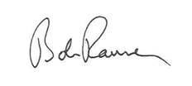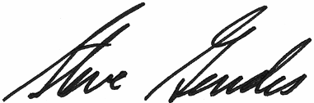
Robert Rauner Stephen L. Gerdes

