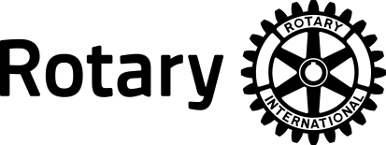 | ROTARY INTERNATIONAL  SIGNIFICANT ACHIEVEMENT AWARD

PURPOSE AND CRITERIA
The Significant Achievement Award of Rotary International recognizes club projects that have done the following:
• Addressed a significant problem or need in the local community (international service projects, no matter how worthy, are not eligible for this award)
• Involved most or all of the club’s members in personal rather than monetary service
• Been commensurate with the size of the club and its available resources
• Enhanced the image of Rotary in the community
• Been able to be emulated by other Rotary clubs
• Been active during the Rotary year for which the award is being given (though it need not have been initiated, and may have been completed, in the current Rotary year)

ELIGIBILITY
• Only projects carried out by a single club are eligible for the award
• Projects previously recognized with an RI Significant Achievement Award are not eligible.
• Recipients will be selected by an officer appointed by the RI president.

ROTARY DISTRICT 5650 NOMINATION PROCESS
District Governors must adhere to very strict guidelines to submit nominations using a Rotary International form. Therefore, nominations from clubs in Rotary District 5650 must follow the guidelines below. Nominations . . .
. . . must be returned to the Rotary District 5650 Awards Chair
. . . must be received by the District Awards Chair by February 1
. . . must be typed
. . . must be submitted on this form
. . . must not exceed the space provided (and additional supporting materials will not be accepted)
. . . are limited to one nomination per club per year

The Rotary District 5650 Awards Committee and District Governor will review all submissions. Qualifying nominations will be considered but only one can be submitted to Rotary International.

Rotary Club: Club ID:
Project title:
Number of Members in the Club: Number of Members Participating in the Project:
Club President Name: Member ID:
Nomination information must fit in this box – font= Arial 10.5 only; approximately 1000 words maximum.

