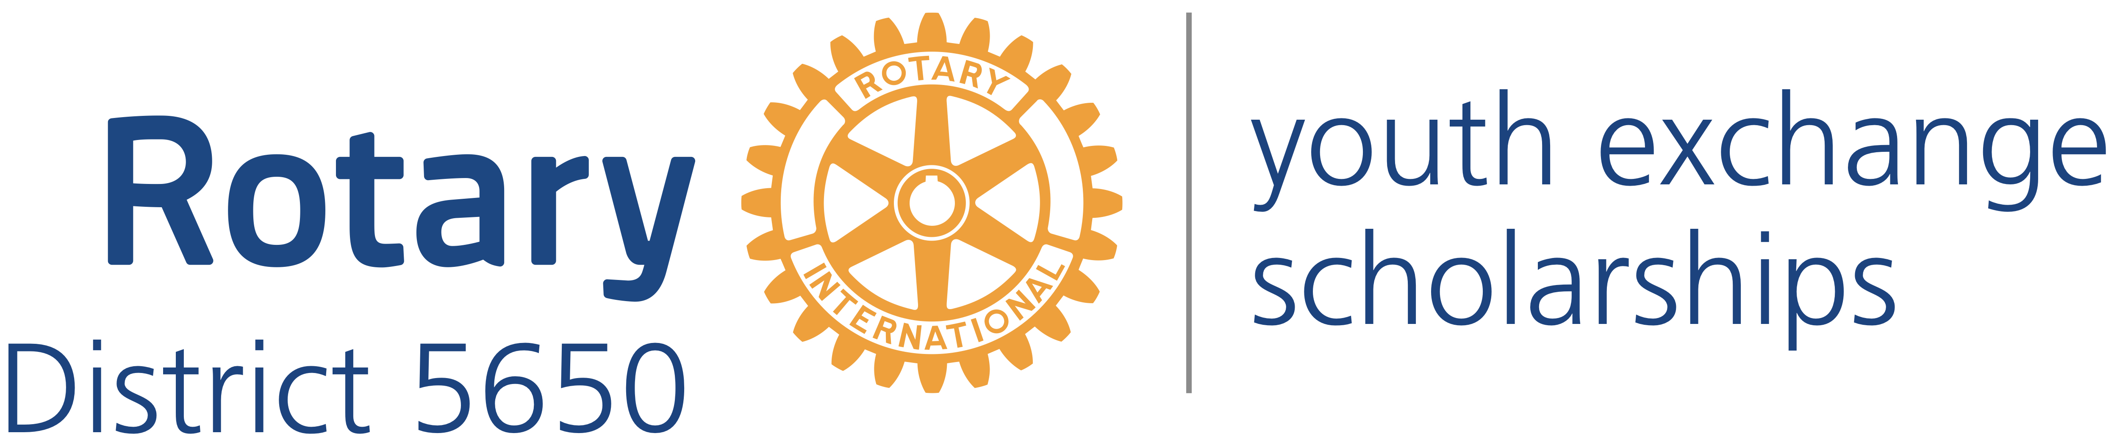
Western Iowa and Eastern Nebraska

Mick McKinley
District Governor
122 Highclere Circle
Council Bluffs Iowa, 51503
(402) 499-0389
mick.mckinley71@gmail.com

Robert Rauner
District Youth Exchange Chair
5100 Valley Rd.
Lincoln, NE 68150
(402) 450-1859
drbobrauner622@gmail.com

Stephen L. Gerdes
International Advisor
11920 Burt St., #145
Omaha, NE 68154
(402) 677-3743
yeo1@rotarydistrict5650.org

Curt Peters
Omaha Area Chair
11112 John Galt Blvd
Omaha, NE 68137
(402) 510-6728
curt@integratedsolutions.net

Roxy Orr
District Governor=elect
807 N 131st Plaza
Omaha, NE 68154
(402) 290-6800
Roxyann01@cox.net

MickMcKinley
District Governor
122 Highclere Circle
Council Bluffs, Iowa 51503
402-499-0389
Mick.mckinley71@gmail.com

Thomas Cardwell
Past District Governor
7221 South 33rd Street
Lincoln, NE 68516
(402) 239-997
Thomasrcardwell@yahoo.com

Roxy Orr
District Governor Elect
District Youth Exchange
Inbound Coordinator
Cell 402-290-6800
Roxyann1@cox.net

James Griesen
District Youth Protection Officer
Cell: 402-450-6322
jgriesen1@unl.edu

Joanne Peters
District Youth Exchange Compliance Coordinator
Cell: 402-510-8143
jp@jlpconsultinginc.com
Bob Rauner
District Youth Exchange Chair
Lincoln Area Youth Exchange Coordinator
5100 Valley Rd.
Lincoln, NE 68150
(402) 450-1859
drbobrauner622@gmail.com

Curt Peters
District Youth Exchange Outreach Coordinator
Omaha Area Coordinator
11112 John Galt Blvd
Omaha, NE 68137
Cell: (402) 510-6728
Office: (402) 331-4122
curt@integratedsolutions.net

Stephen L. Gerdes
District Youth Exchange International Coordinator
11920 Burt St., Suite 145
Omaha, NE 68154
Cell: (402) 677-3743
Office: (402) 393-1435
Home: (402) 399-9303
Fax: (402) 393-0629
yeo1@rotarydistrict5650.org

