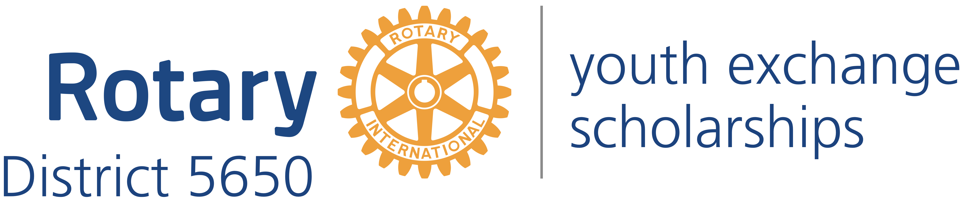
Western Iowa and Eastern Nebraska

Mick McKinley
District Governor
122 Highclere Circle
Council Bluffs Iowa, 51503
(402) 499-0389
mick.mckinley71@gmail.com

Robert Rauner
District Youth Exchange Chair
5100 Valley Rd.
Lincoln, NE 68150
(402) 450-1859
drbobrauner622@gmail.com

Stephen L. Gerdes
International Advisor
11920 Burt St., #145
Omaha, NE 68154
(402) 677-3743
yeo1@rotarydistrict5650.org

Curt Peters
Omaha Area Chair
11112 John Galt Blvd
Omaha, NE 68137
(402) 510-6728
curt@integratedsolutions.net

Roxy Orr
District Governor=elect
807 N 131st Plaza
Omaha, NE 68154
(402) 290-6800
Roxyann01@cox.net

Dear Host Parents:

Thank you for agreeing to host a Rotary International Exchange Student. You are about to become a new parent, probably not for the first time, but this time your new child will be a teenager upon arrival, may not speak fluent English, and will certainly have cultural traits different from yours.

By agreeing to be a host family, you have agreed to assume parental responsibility for this young ambassador from another country, to provide shelter and sustenance, guidance and counsel, and love and support to this child of strangers who live thousands of miles away.

However, you are not alone in this responsibility. Rotarians from your local community and from RI District 5650’s Youth Exchange Committee will do everything we can to help make this exchange a successful one. We will provide you with the information you need, through this host family booklet, through orientation meetings, and through the Youth Exchange Officer or Counselor of your local club. We will, throughout the exchange period, be in contact with both you and your hosted student to answer questions, address concerns, and resolve problems.

This host family booklet provides much of the information you need to be a successful Host Family. All too soon, your student will move on to the next host family or return home at the end of the exchange year. Many host parents have found that they do not say “goodbye” when that time comes, but instead “farewell; until we meet again!”

The Rotary goal of establishing goodwill, peace and friendship among exchange countries is one that we hope you will experience first-hand. Indeed, many host families and their students do meet again, and we hope that you and your student will form lasting bonds of friendship, respect, and love.

We are enclosing a copy of the following documents to help you with your student:
- Rotary Application of your student;
- Host Family Toolkit, which includes a copy of the Department of State Rules for Youth Exchanges, the Department of State letter of appreciation, and detailed information about being a host family;
- Rotary District Calendar of events; and
- Statement of Health Insurance Coverage and information on how to file an insurance claim for your student.

The Department of State requires Rotary to provide you certain contact information.
- Rotary District 5650 is part of a multi-district organization known as South Central Rotary Youth Exchange (SCRYE). Under the Department of State regulations, SCRYE is the program sponsor for this exchange.
- The contact information for the District 5650 Youth Exchange Officer is Bob Rauner (402) 450-1859 and drbobrauner622@gmail.com. There are two local coordinators responsible for this exchange. The contact information for the local coordinator who serves as the Rotary Club Youth Exchange Officer is Club YEO Name Club YEO Cell Phone and Club YEO Email. The contact information for the local coordinator who serves as the Rotarian counselor for the student is Rotarian Counselor Name Counselor Cell Phone and Counselor Email.
- The toll free emergency number at the Department of State is 800 283-9090.
- Contact information for the Department of State Office of Designation is:
Academic and Government Programs Division
ECA/EC/AG –SA-5, Floor C2
2200 C Street, NW
Washington DC 20522-0582
Phone 202 632-9310
FAX: 202 632-2701

Even though you will not be hosting your student for the entire year, under the Department of State regulations you are considered a “permanent” host family as opposed to an “arrival” host family.

The Department of State also now requires that you advise us if there is a change in your family’s status including address, finances, employment, and criminal arrests.

Please feel free to contact any Youth Exchange Committee member for assistance.

In Rotary Service,

