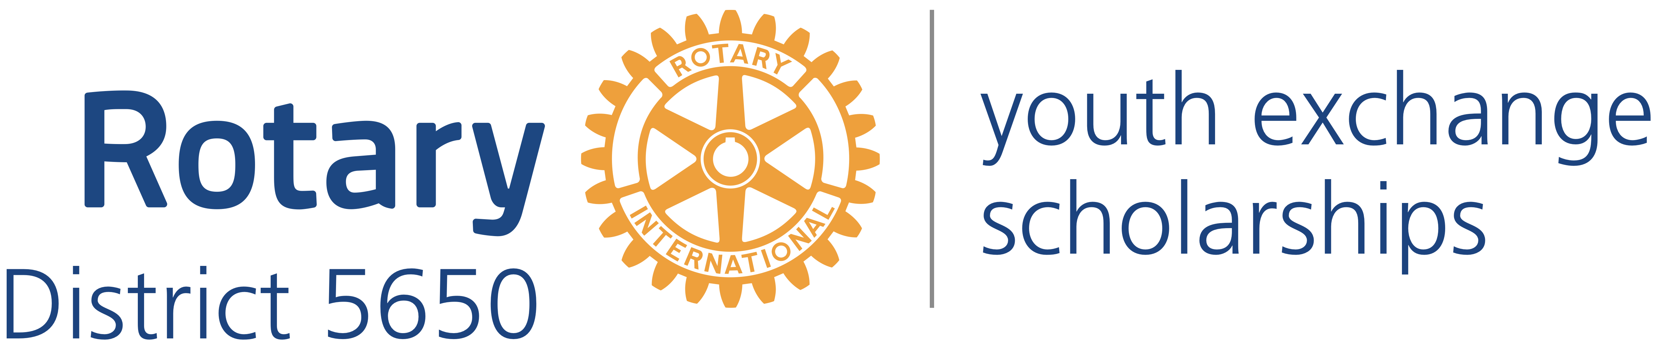
Western Iowa and Eastern Nebraska

Mick McKinley
District Governor
122 Highclere Circle
Council Bluffs Iowa, 51503
(402) 499-0389
mick.mckinley71@gmail.com

Robert Rauner
District Youth Exchange Chair
5100 Valley Rd.
Lincoln, NE 68150
(402) 450-1859
drbobrauner622@gmail.com

Stephen L. Gerdes
International Advisor
11920 Burt St., #145
Omaha, NE 68154
(402) 677-3743
yeo1@rotarydistrict5650.org

Curt Peters
Omaha Area Chair
11112 John Galt Blvd
Omaha, NE 68137
(402) 510-6728
curt@integratedsolutions.net

Roxy Orr
District Governor=elect
807 N 131st Plaza
Omaha, NE 68154
(402) 290-6800
Roxyann01@cox.net

Dear School Administrator:

Re: Exchange Student

Thank you for agreeing to host a Rotary International Exchange Student. The Rotary Youth Exchange (RYE) Program makes possible a cultural and educational experience for both the student and those serving as hosts. Rotary District 5650 is accredited by CSIET (Council on Standards for Educational Travel). We hope that your school’s experience with our Rotary Exchange Student will be one in which both parties gain knowledge and a unique understanding of cultural differences as well as the many similarities between nations, cultures and people.

Upon arrival, the exchange student may speak limited English. At the same time, he or she will be learning and adapting to many new ideas and activities. The school, as the center of activity in the student’s life, will play an important role in the learning process.

The RYE student is expected to attend class, to participate, and to make an honest attempt to succeed in his or her new learning environment. In addition, the student is expected to comply with all the rules and conditions of the RYE program.

The local Rotary Club President, Youth Exchange Officer, or Club Counselor will assist as necessary in enrolling the student in classes and informing the school as the student changes host families. Rotary exchange students typically stay with two or three host families during the school year. The counselor or host parent will also assist with other requirements such as lunch tickets or program fees.

We hope that the student will be involved in student activities such as clubs or sports programs. We also hope that the school will provide opportunities for the student to give presentations about his or her country, traditions and customs. Rotary students are good ambassadors, enthusiastic to share their experiences. And, of course, we hope that laughter, fun, and lasting friendships are all a part of the student’s exchange year.
Enclosed are:
- Copy of the Rotary Student Application, which includes a summary of the student’s academic record in English, medical history, and immunization record;
- List of Rotary and Local and Community Contacts; and
- Host School Toolkit, which includes the Department of State’s rules for student exchanges.

We understand that no tuition will be charged but that the student will be responsible for fees for which other students are responsible such as the school activity fee. If this understanding is not correct please advise us in writing immediately. Exchange Student completed secondary school. Exchange Student has completed years of school. In the student’s country, a student is required to complete years of school (excluding Kindergarten, if any) in order to complete secondary school.

The Department of State requires Rotary to provide you certain contact information. Rotary
- District 5650 is part of a multi-district organization known as South Central Rotary Youth Exchange (SCRYE). Under the Department of State regulations, SCRYE is the program sponsor for this exchange.
- The contact information for the District 5650 Youth Exchange Officer is Robert Rauner (402) 450-1859 and drbobrauner622@gmail.com.
- There are two local coordinators responsible for this exchange. The contact information for the local coordinator who serves as the Rotary Club Youth Exchange Officer is Club YEO Name Club YEO Cell Phone and Club YEO Email. The contact information for the local coordinator who serves as the Rotarian counselor for the student is Rotarian Counselor Name Counselor Cell Phone and Counselor Email.
- The toll free emergency number at the Department of State is 800 283-9090.
- Contact information for the Department of State Office of Designation is:
Academic and Government Programs Division
ECA/EC/AG –SA-5, Floor C2
2200 C Street, NW
Washington DC 20522-0582
Phone 202 632-9310
FAX: 202 632-2701

Again, thank you for agreeing to host a RYE student. We trust that this exchange will be an exciting and beneficial experience for all involved. Do not hesitate to call the club counselor or president should you have any questions or concerns during the year.

Sincerely yours,

