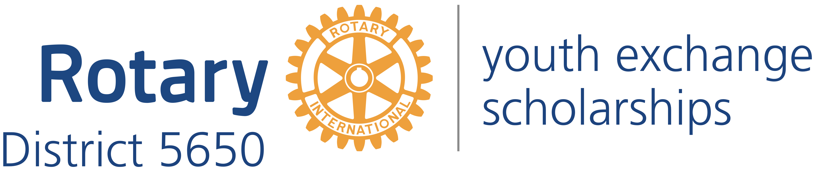
Western Iowa and Eastern Nebraska

Mick McKinley
District Governor
122 Highclere Circle
Council Bluffs Iowa, 51503
(402) 499-0389
mick.mckinley71@gmail.com

Robert Rauner
District Youth Exchange Chair
5100 Valley Rd.
Lincoln, NE 68150
(402) 450-1859
drbobrauner622@gmail.com

Stephen L. Gerdes
International Advisor
11920 Burt St., #145
Omaha, NE 68154
(402) 677-3743
yeo1@rotarydistrict5650.org

Curt Peters
Omaha Area Chair
11112 John Galt Blvd
Omaha, NE 68137
(402) 510-6728
curt@integratedsolutions.net

Roxy Orr
District Governor=elect
807 N 131st Plaza
Omaha, NE 68154
(402) 290-6800
Roxyann01@cox.net

Dear District 5650 Rotary Club President:
I am writing to provide you with a copy of materials about Rotary Youth Exchange that have been sent to all high school principals in our District. Your club can use these same materials to directly recruit students. If you need more copies of the materials, you may copy what I have sent to you, or you may obtain electronic copies on the District website: http://www.rotarydistrict5650.org Emails have also been sent to many guidance counselors, world language teachers, and social studies teachers.
I encourage each club to appoint a Youth Exchange Officer (YEO) even if it has not participated in youth exchange in recent years. The role of the YEO in the fall is to make sure that the high school or schools in your community have information about the Rotary Youth Exchange program. The Rotary Youth Exchange program is the best in the world, and we want to make sure that high school students are aware of this great opportunity. If you have any questions regarding the program, you may contact Joanne Peters, District 5650 Compliance Officer at 402-510-8143 or jp@jlpconsultinginc.com
Applications should be submitted to your club and to me by October 1. Local club interviews of the student and his or her parents need to be completed before the District Interviews on the afternoon of November 9 & 10 in Lincoln. Ideally your club interviews should be completed by October 15. If you interview a prospective student who you believe would be a good ambassador for your club and our District, you need to sign the student’s applications so that he or she can bring them to the District Interviews. Only students sponsored by a local Rotary Club are allowed to become exchange students.
Students with additional questions should be directed to the Rotary District 5650 website: http://www.rotarydistrict5650.org, the Rotary International Youth Exchange website: https://my.rotary.org/en/get-involved/exchange-ideas/youth-exchanges or the South Central Rotary Youth Exchange website: http://scrye.org/youth-exchange/. These websites also have helpful information for local clubs about interviewing prospective exchange students. If you have further questions, you or your club’s Youth Exchange Committee chairperson should call or email me.

Sincerely yours,

Enclosures
Promotional brochure
Letter to educators
Letter to principals
Preliminary Application
Long Term Application

Contact Information for High School Student

