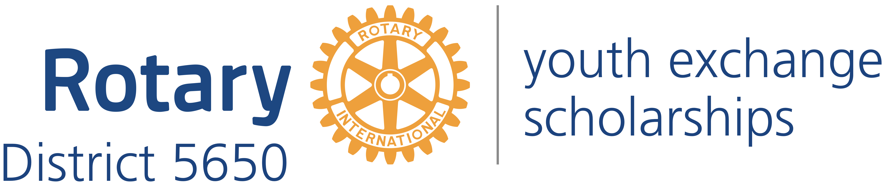
Western Iowa and Eastern Nebraska

Mick McKinley
District Governor
122 Highclere Circle
Council Bluffs Iowa, 51503
(402) 499-0389
mick.mckinley71@gmail.com

Robert Rauner
District Youth Exchange Chair
5100 Valley Rd.
Lincoln, NE 68150
(402) 450-1859
drbobrauner622@gmail.com

Stephen L. Gerdes
International Advisor
11920 Burt St., #145
Omaha, NE 68154
(402) 677-3743
yeo1@rotarydistrict5650.org

Curt Peters
Omaha Area Chair
11112 John Galt Blvd
Omaha, NE 68137
(402) 510-6728
curt@integratedsolutions.net

Roxy Orr
District Governor=elect
807 N 131st Plaza
Omaha, NE 68154
(402) 290-6800
Roxyann01@cox.net

Dear Educator:

We are writing to inform you about an opportunity for one of your students to become fluent in another language and culture as a Rotary Youth Exchange student. The Rotary Youth Exchange Program began in 1927 and continues today with over 8,000 students each year. Rotary District 5650 is accredited by CSIET (Council on Standards for Educational Travel).

What is Rotary?
Rotary International, which sponsors this program, is an international volunteer organization comprised of Rotarians around the world dedicated to improving their communities, locally and globally, through service to others. Rotary International District 5650 consists of 47 Rotary clubs in eastern Nebraska and western Iowa.

What Are the Goals of Rotary Youth Exchange?
- To further international goodwill and understanding by enabling students to study firsthand problems and accomplishments of people in lands other than their own.
- To enable students to advance their education by studying for a year in an environment entirely different from their own.
- To give students opportunities to broaden their outlook by learning to live with and meet people of different cultures, creeds, and colors.
- To have students act as ambassadors for their own country by addressing Rotary Clubs, community organizations and youth groups in their host country; by imparting as much knowledge as they can of their own country.
- To provide sufficient time to study and observe another country's culture, so that upon returning home students are fluent in the language and culture of their host country.

How Can Your Students Become Rotary Youth Exchange Students?
During the fall, Rotary District 5650 will conduct screening interviews of students who are interested in becoming exchange students during the 2019-2020 academic year. A student’s first step is to fill out the Preliminary Application and portions of the Long Term Application that are available on the Rotary District 5650 website:https://rotarydistrict5650.org/sitepage/youth-exchange. The student should submit the applications to a local Rotary Club and to the Rotary Youth Exchange Chairman. During September, October, and early November, the student and the student’s parents must interview with a local Rotary Club. If the Rotary Club decides to sponsor the student, then the student and his or her parents go on to interview with the District Youth Exchange Committee on November 3rd and 4th in Lincoln. If the District Youth Exchange Committee approves the student, the student needs to promptly fill out the remaining portions of the Long Term Youth Exchange Application and submit them along with a check for $600 to the District Youth Exchange Chairman. The process of matching the student with a country cannot begin until the student’s completed application has been received. Early submission of the completed application improves the odds of receiving a more advantageous placement. Formal orientation for the accepted students occurs in February. A four day outbound camp with students from other Rotary districts is held in June in Arkansas.

How Much Does It Cost to Be a Rotary Youth Exchange Student?
The Rotary Youth Exchange Program is one of the least expensive exchange programs. Rotary District 5650 uses a flat fee of $5,000. This covers direct costs involving the application, plane fare, visa, health insurance required by the host country, and orientation weekends. Need based scholarships are available for exceptional students.

Your host Rotary Club will provide free room and board and schooling. The Rotary Club in your host country, besides providing host families for your stay, will give you a monthly allowance of approximately $100 buying power in its currency to help with day-to-day spending and incidental costs.

Note: The roundtrip airfare is generally higher than discount coach fares because the stay is longer than 30 days and the ticket is special ticket that allows for changes in the return date at little or no cost. The policy is necessary because on occasions an exchange student may want to stay later or will have to return home earlier than scheduled.

We mailed your principal a promotional poster, Preliminary Application, and Long Term Application. We are sending you electronic copies of the same materials. We would appreciate it if you would share this information with students who perhaps have mentioned doing a Foreign Exchange or who might benefit greatly from the program.

The Rotary Student Exchange Program is unique in that we work with Rotary Clubs in foreign countries to make these reciprocal Exchanges occur. This results in a relatively small fee to enroll in the program. The hosting clubs also pay the student a small stipend ($100 per month) to help with expenses. This creates a reasonably low cost to the student and his or her family compared to many other programs and is affordable for most students. Many of the students traveling in both directions say their Exchange stays have changed their lives forever.

Your local Rotary Club sponsors your outgoing students, and generally will host incoming students. Please consider sharing this great program with your students. If you or your counselors or teachers have further questions, please feel welcome to call or email us. There is also some great information at the web site http://www.rotarydistrict5650.org/youthex. Change to If you have questions, please contact Joanne Peters at jp@JLPConsultinginc.com or Curt Peters at curt.peters@integratedsolutions or Bob Rauner at drbobrauner622@gmail.com. We look forward to working with you.

