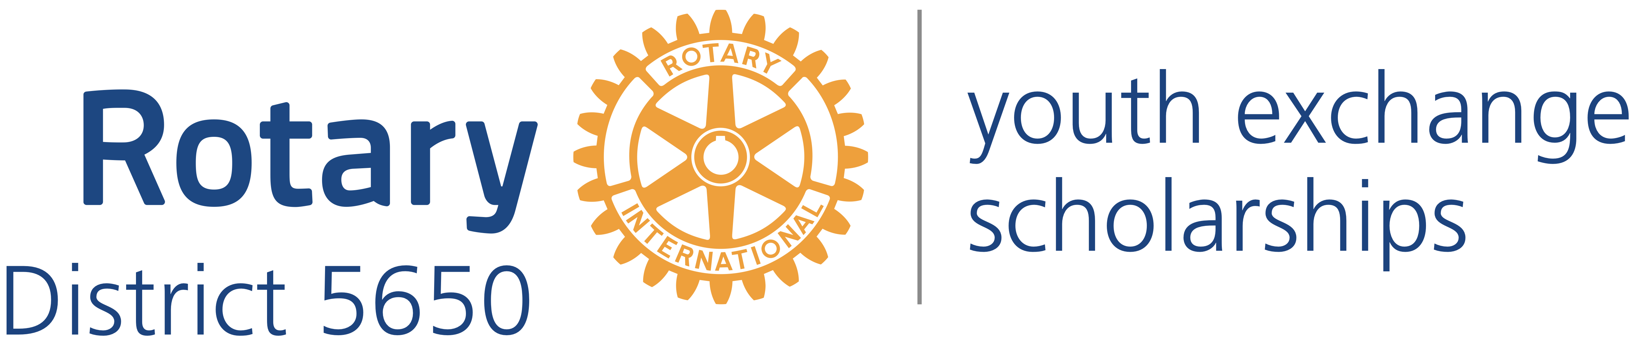
Western Iowa and Eastern Nebraska

Mick McKinley
District Governor
122 Highclere Circle
Council Bluffs Iowa, 51503
(402) 499-0389
mick.mckinley71@gmail.com

Robert Rauner
District Youth Exchange Chair
5100 Valley Rd.
Lincoln, NE 68150
(402) 450-1859
drbobrauner622@gmail.com

Stephen L. Gerdes
International Advisor
11920 Burt St., #145
Omaha, NE 68154
(402) 677-3743
yeo1@rotarydistrict5650.org

Curt Peters
Omaha Area Chair
11112 John Galt Blvd
Omaha, NE 68137
(402) 510-6728
curt@integratedsolutions.net

Roxy Orr
District Governor=elect
807 N 131st Plaza
Omaha, NE 68154
(402) 290-6800
Roxyann01@cox.net

Dear High School Principal

We are writing to inform you about an opportunity for one of your students to become fluent in another language and culture as a Rotary Youth Exchange student. The Rotary Youth Exchange Program first began in 1927 and continues today with over 8,000 students in the Youth Exchange Program each year. Our goals are quite simple: To Promote World Peace and Understanding.

We have included the following information:
- Promotional Poster;
- Preliminary Application;
- Long Term Application; and
- Letter to Educator.
We would appreciate it if you would share them with your counseling staff, foreign language teachers, and social studies teachers and encourage them to look for students who perhaps have mentioned doing a Foreign Exchange or who might benefit greatly from the program.
The Rotary Student Exchange Program is unique in that we work with Rotary Clubs in foreign countries to make these reciprocal Exchanges occur. This results in an exchange experience at a much lower cost than other programs (around $5,000 compared to $20-40,000 for other programs). Need-based scholarships are also available for exceptional students. Many of the students traveling in both directions say their Exchange stays have changed their lives forever.
Your local Rotary Club sponsors your outgoing students, and generally will host incoming students. Please consider sharing this great program with your students. If you or your counselors or teachers have further questions, please feel welcome to call or email us. There is also some great information at the web site http://rotarydistrict5650.org/SitePage/youth-exchange. We look forward to working with you.

Sincerely yours,

