Rotary District 5650 Grants
Club Planning Worksheet
Not to be submitted to the District

This is NOT THE DISTRICT GRANT PROJECT APPLICATION
- To apply (and report), clubs will access District Grants through www.rotarydistrict.5650 / Grants module
- This is a Club Planning worksheet
  - This worksheet has been designed by clubs to assist with internal process and planning
  - This worksheet is laid out in the order of, and with the information from, the Grants module screens
  - Only certified individuals of certified clubs can view the online application, this was designed so that you will know the information that will be requested
  - Clubs may opt to use this form but it is not required by the District
  - The Club Use section can be customized by the club (using the form fields provided)
  - DO NOT SUBMIT THIS WORKSHEET to the District

For Club Use Only

Club Committee Club Committee Representative

I certify that I have, or will, attend the Grant Management Seminar On (Date):

Enter Club Question

Enter Club Question

Signature Signature

Submit a Grant Request
Initial Grant Application Screen

Project Name - very short - this will become the Subject Line of emails - no more than 25-30 characters

Description - briefly explain the proposed District Grant Project - what you will be doing, who it will benefit and what humanitarian need it fills. Keep it brief as this will feed into a spreadsheet field.

Estimated Budget - the total amount of the District Grant Project. For larger projects, enter only the amount that Rotary will be managing. Enter the total of 1) the amount that your club will be providing, 2) the amount other Rotary Clubs are providing, and 3) the requested District Grant Match.

Details Tab

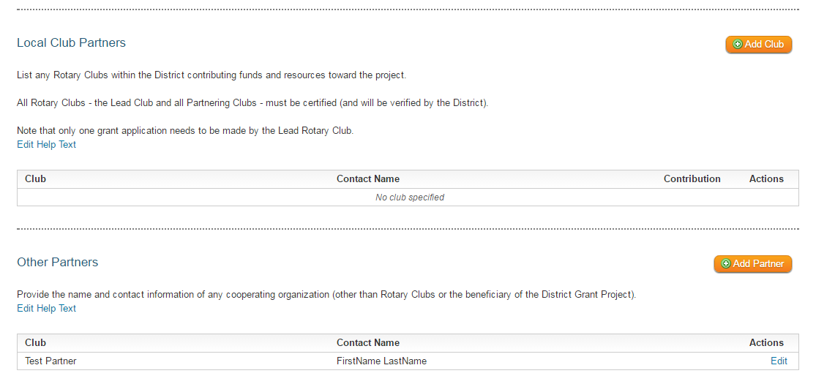

List any Rotary Clubs within the District contributing funds and resources toward the project.

Provide the name and contact information of any cooperating organization (other than Rotary Clubs or the beneficiary of the District Grant Project).

Application Tab
Multiple Sections

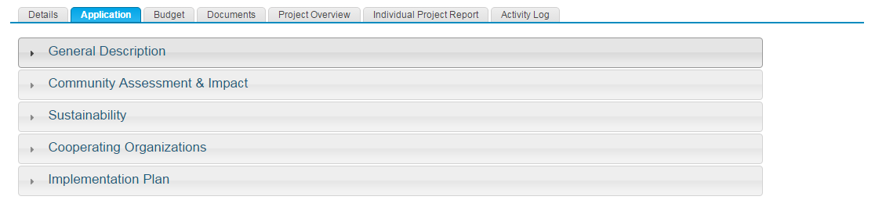

Application Tab
General Description

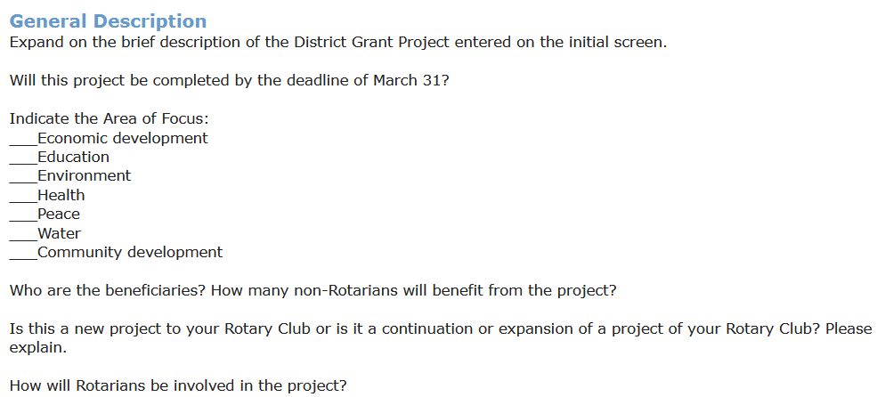

Expand on the brief description of the District Grant Project entered on the initial screen.

Will this project be completed by the deadline of March 31?

Indicate the Area of Focus:

Who are the beneficiaries? How many non-Rotarians will benefit from the project?

Is this a new project to your Rotary Club or is it a continuation or expansion of a project of your Rotary Club? Please explain.

How will Rotarians be involved in the project?

Application Tab
Community Assessment & Impact

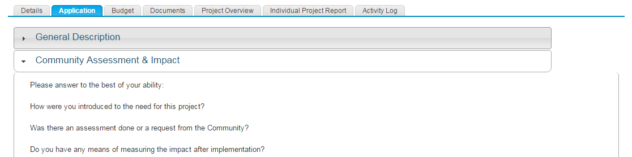

Please answer to the best of your ability:

How were you introduced to the need for this project?

Was there an assessment done or a request from the Community?

Do you have any means of measuring the impact after implementation?

Application Tab
Sustainability

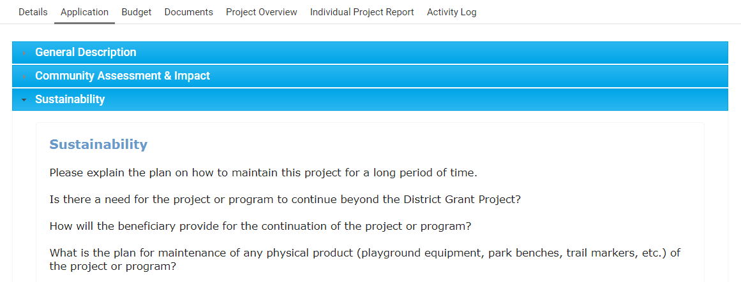

Please explain the plan on how to maintain this project for a long period of time.

Is there a need for the project or program to continue beyond the District Grant Project?

How will the beneficiary provide for the continuation of the project or program?

What is the plan for maintenance of any physical product (playground equipment, park benches, trail markers, etc.) of the project or program?

Application Tab
Cooperating Organizations

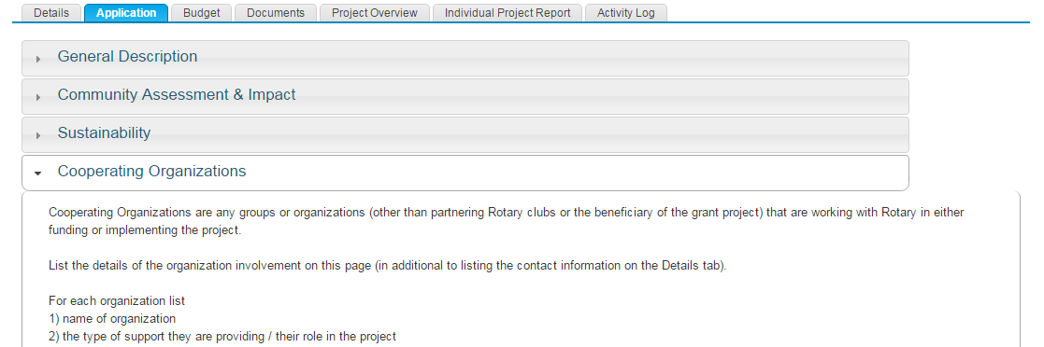

Cooperating Organizations are any groups or organizations (other than partnering Rotary clubs or the beneficiary of the grant project) that are working with Rotary in either funding or implementing the project.

List the details of the organization involvement on this page (in additional to listing the contact information on the Details tab). For each organization list
1) name of organization
2) the type of support they are providing / their role in the project

Application Tab
Implementation Plan

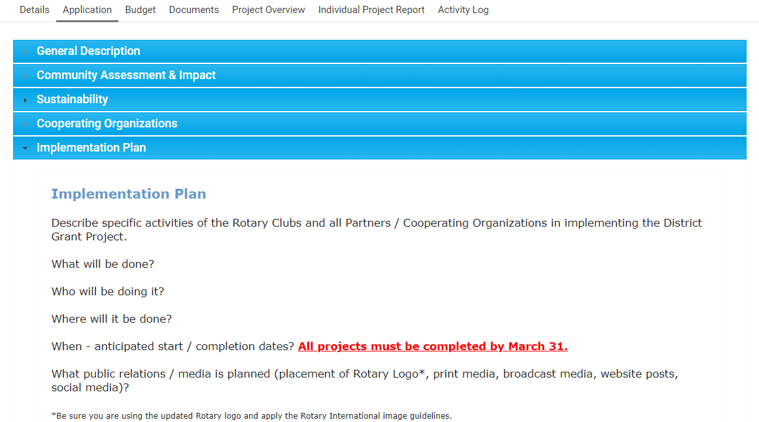

Describe specific activities of the Rotary Clubs and all Partners / Cooperating Organizations in implementing the District Grant Project.

What will be done?

Who will be doing it?

Where will it be done?

When - anticipated start / completion dates? (All projects must be completed by March 31.)

What public relations / media is planned (placement of Rotary Logo*, print media, broadcast media, website posts, social media)?

Budget Tab
Expense and Income Sections

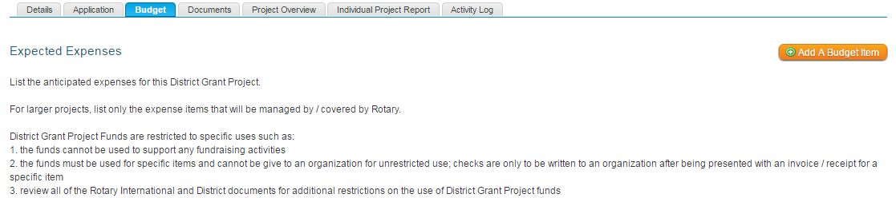

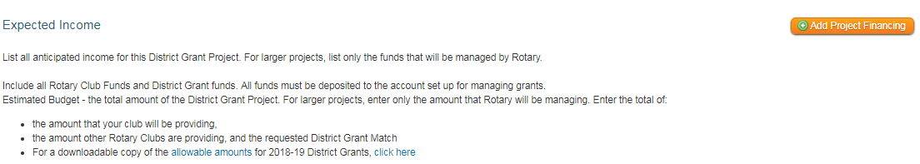

Allowable Amounts:  From the document District Grants Basic Information | 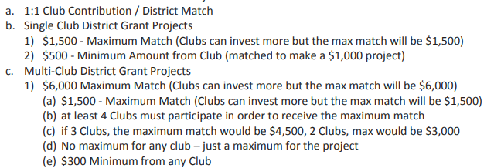

Anticipated Expenses (description and amount) Anticipated Income (description and amount)

Total Anticipated Expenses Total Anticipated income

