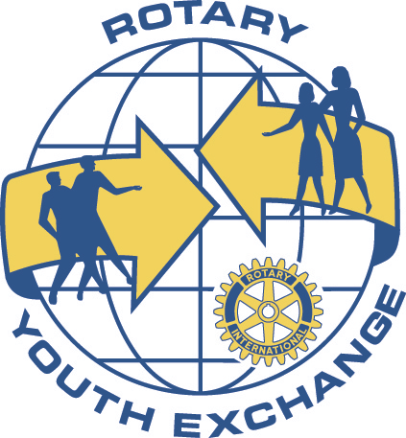
Rotary International
Youth Exchange Program
District 5650
Nebraska - Iowa

Natural Parent Travel Permission Form

An Exchange Student is allowed to travel within District 5650 when the student has obtained prior permission from the student’s Host Family and Host Rotary Club. All trips must be properly chaperoned by adults. If the trip requires that the student travel outside Nebraska and Iowa, the student must obtain prior written permission from the student’s:
- Natural Parents
- Host Parents
- Rotary District Youth Exchange Chairman
Travel will be approved only if it is consistent with the J-1 visa status of the exchange students. Reasonable requests will not be denied. However, if any one of the above concludes that such a trip would put the student or the student’s health at unnecessary risk, or that for any other reason the student should not go, the student will not be allowed to go.

We are the natural parents of Rotary Youth Exchange student, .
- We give permission for our child to travel within District 5650 provided that the Host Parents and Host Rotary Club give their permission.
- We give permission for our child to travel change to outside Nebraska and Iowa provided that the Host Parents, Host Rotary Club, and the Rotary District 5650 Youth Exchange Chairperson give their permission.
This permission statement covers all arranged and approved travel opportunities during the current Exchange year.

Natural Father / Date - _________________________________________

Natural Mother / Date - ________________________________________

Faxed and email signatures are valid.

