**What does RYLA offer 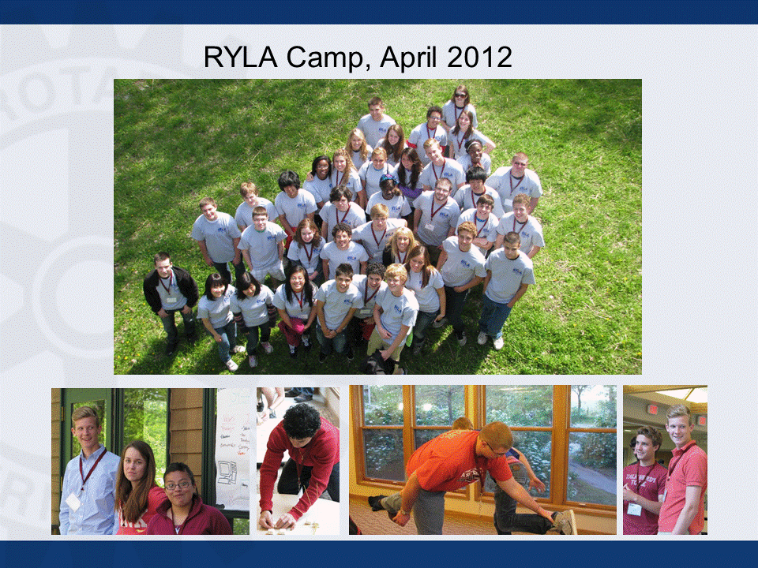to young people?**

* During a RYLA program, participants will:
* Think critically about important issues and share ideas with talented peers.
* Learn how to coordinate and lead community service projects.
* Discuss the importance of good governance and civil society to the world.
* Learn to think globally and explore issues that transcend national borders
* Meet Rotary leaders and learn about other Rotary programs and opportunities
* Explore new career paths and hear from successful leaders and professionals.

Who participates in RYLA?

RYLA events are for young adults with leadership experience and/or potential. Leaders are intentionally selected from diverse backgrounds.

RYLA provides a unique opportunity to learn, grow, have fun, and make new friends

The RYLA experience prepares young people to be leaders in their community, profession, and other facets of everyday life.

Eligible participants are High school juniors.

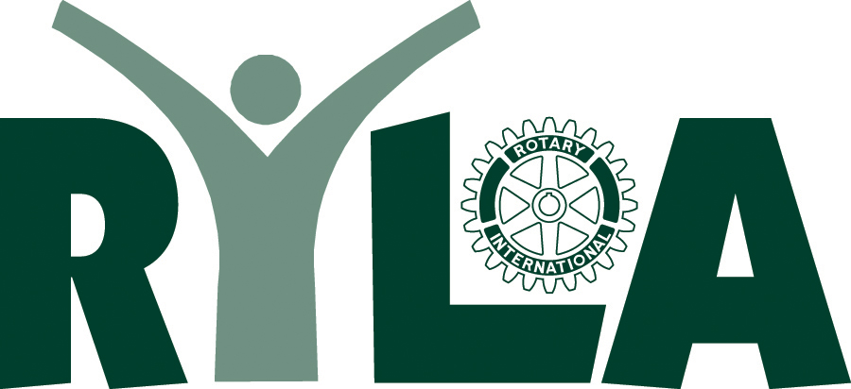

**What is RYLA?**

Rotary Youth Leadership Awards (RYLA) is an intensive training program for High School Juniors. Talented young people attend a 3-day seminar organized by the Rotarians of District 5650 of Rotary International.

Sponsoring Rotary clubs often pays all of the participants’ expenses.

The RYLA program enables young people to debate issues of professional responsibility and human relations improve leadership and communications skills, learn about businesses and institutions, and meet Rotarians while having fun and making friends.

For young adults, RYLA provides the opportunity to refine skills and explore pertinent topics with their peers and business professionals.

**RYLA WILL HELP YOU:**

* Develop leadership skills
* Increase self-confidence
* Gain exposure to a variety of issues and people
* Improve career skills and knowledge
* Meet community leaders and members

**APPLY THROUGH YOUR ROTARY CLUB**

Rotary Club:

Rotary President:___________

_________________________

Phone:____________________

Local Club RYLA Chair Name:

Phone:

Email:



**ROTARY**

**YOUTH**

**LEADERSHIP**

**AWARDS**

Camp Kitaki

Near Louisville, NE

(between Lincoln and Omaha)

APRIL 15 – 17, 2016

Friday 11:30 – Sunday 1:00

District 5650

Rotary International



[](https://www.google.com/imgres?imgurl=http://www.octon-rg.com/data/octon-rg/product/20140115_a72c5b.jpg&imgrefurl=http://www.octon-rg.com/product/20&docid=qSX09xKRnvfQtM&tbnid=GYIkOTdZJEMvoM&w=500&h=434&ei=IfVfU5LQHcXYyAH49YDwBw&ved=0CAMQxiAwAQ&iact=c)

District 5650 RYLA Chair:

Jason Smith

402-434-9229

[JSmith@ymcalincoln.org](mailto:JSmith@ymcalincoln.org)

District 5650 RYLA Co-Chair:

Jim Pink

402-370-6621

[thinkjimpink@gmail.com](mailto:thinkjimpink@gmail.com)