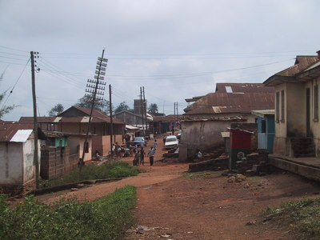
A Section of the West part of Akropong
Project Proposal – Provision of Clean Water and Public Toilet and Sanitation system for Akropong in Ghana, Africa
Needs Assessment:
The town of Akropong has a population of about 50,000 people and is rich in culture and tradition. The town sits on a steep ridge in the Eastern Region of Ghana, about 34 miles from Ghana’s capital, Accra. The town’s major problem is the lack of portable clean water supply and support from the government has for the most part been lacking or given a very low priority.
Through collaborative efforts of a local Accra West Rotary Club, water was provided to the Eastern part of the town that helped ease some of the water burden. However the west part of the town still lacks adequate supply of water and this risk coupled with a high prevalence of water borne diseases makes for an urgent supply of clean water.
Coupled with this problem is the basic lack of a public toilet system. The whole town of 50,000 inhabitants is served by two dilapidated free fall toilet system with its attendant insanitary environment and with the potential to contaminate food sources and further enhancing the potential for water borne diseases.
Proposed Project:
Given the foregoing, the need for provision of clean portable accessible water and toilet system is paramount and acute. The concept of the project has been discussed and approved by the traditional authorities in the town and a piece of land has been designated for the project. The proposed project seeks to sink a mechanized bore hole with hydro fracturing technology, pump the water to overhead storage and distribute it by gravity to the surrounding West part of the town.
With the provision of this water, the project also seeks to take advantage by building a public toilet/restroom system to improve sanitation. The community will provide labor in the form of digging required trenches for distribution pipes. They will also provide labor and materials for any concrete structures.

This project will therefore have a dual function of providing clean water as well as a public toilet facility thereby enhancing the quality of life and decreasing the water borne disease burden from contamination from poorly disposed public fecal matter.

Cost Projection:
Item Description | Unit Cost (GHC) | Quantity | Cost (GHC)
Mechanized Borehole – sunk to an average depth of 120 meters with hydro fracturing capability | 7500 | 1 | 7500
Concrete platform raised to 15 feet to support Storage tanks | 1,000 | 1 | 1,000
Storage Tanks  (Rambo 450 - 1000gals ) | 815 | 2 | 1630
Piping and distribution | 400 | 1 | 400
Water closet systems | 100 | 10 | 1,000
Construction of toilet block | 1 | 10,000 | 10,000
Total cost of construction |  | 1 | 22,530
Contingency (10% of cost) | 2530 | 1 | 2,530
Total Estimated Cost of the Project |  |  | 25,0600
*All monies are quoted in Ghana Monetary Denomination (New Ghana Cedi)
Exchange Rate (as of 10/5/10) 1 USD = 1.45 GHC
Total Cost in USD = $ 17,282.00

Construction:
The BENGEE Borehole and Water Distribution Company Ghana LTD has been tapped for the construction of the project. Bengee has considerable experience and expertise in the borehole industry in Ghana having executed several borehole projects at competitive cost in the country both in the private and public arena. They have particularly successfully executed similar projects in the same geographic area at the Okuapeman Secondary School as well as the Mampong School for the Deaf, Akropong School for the Blind, all in the same vicinity.

Projected Timeline:
Period Activity
October to December 2010 Sourcing for Funding
Beginning of Feb. 2011 Initiation of the Project
End of April 2011 Completion of the Project
May 15th 2011 Inspection of the Project
June 2011 Commission of the Project

