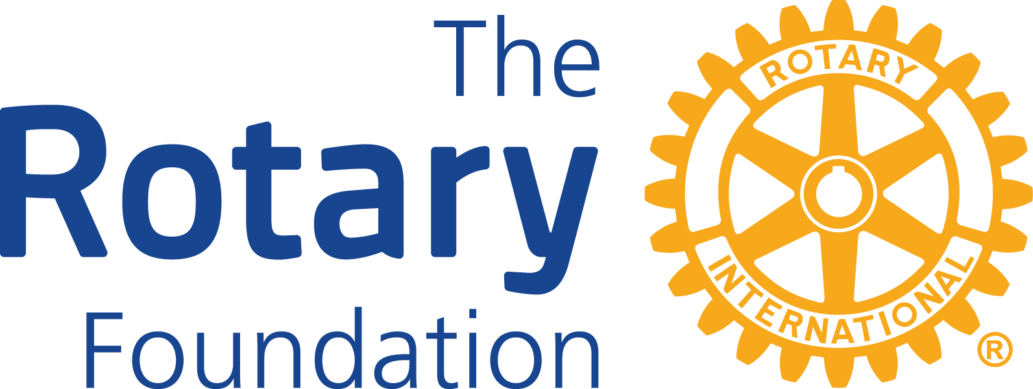
DISTRICT 7890 DISTRICT GRANT APPLICATION FORM
ROTARY/GRANT - YEAR 2023-24

PROJECT TITLE/NAME
(Max 7 words)
ROTARY CLUB NAME

Areas of Focus | Select (x) Area(s) applicable
- Peace and conflict prevention/resolution
- Disease prevention and treatment
- Water and Sanitation
- Maternal and child health
- Basic education and literacy
- Economic and community development
- Protecting the Environment
- Briefly describe the project, its location and objectives. Describe how the project will benefit the community and/or improve the lives of the less fortunate.

- Has your club conducted a Community Assessment? If not, how did you determine this project will meet community needs?

- Describe the non-financial participation by your club members in this project.

- Describe how the general public will know this is a Rotary project.

5. Cooperating organizations. If the project involves a joint cooperating organization(s),
provide the name(s) of the organization(s) and attach a letter from the organization(s).

The letter specifically should state the responsibilities of the cooperating organization and
how Rotarians will interact with that organization in completion of the project.

Note: By signing the application, the Rotarian sponsors endorse the organization as
reputable, responsible, and acting within the laws of the community.

Name of cooperating organization(s):

PROJECT BUDGET
Project Funding (Budget) |  | Income Amount
District Grant* (funds requested)
Club Funds** (committed)
Other Funds (please specify)
Total Income $
Project Purchases and Expenses |  | Expenditures
Total Project Costs $
Note: *Maximum request for a local Community or International Project is $2,500.

**Your club must contribute at least 50% of the amount requested from the District.

DO NOT start your project or purchase items until approval e-mail is received.

Proposed Project Start date:

Estimated Completion date:

Additional Remarks (if necessary, add further information below or on a separate sheet)

Project/Club contacts. List two Rotarians who will provide oversight and
management of the project funds.

Primary Contact: | Secondary Contact:
Contact Numbers (Home/Mobile): | Contact Numbers (Home/Mobile):
Email Address: | Email Address:

Authorization: The Rotary club involved in this project is responsible to District 7890 for the conduct of the project and for final reports. The signatures on the application confirm that the sponsors understand and accept the responsibility and affirm that all the information in this application is true and accurate to their knowledge.

Club President for 2023-2024 - I hereby affirm that the club has agreed to undertake this project as an activity of the club.

Name: | Signature:
Date: | Club President 2023-2024
District Grants Committee Approval by: | Signature:
Date: | District Grants Committee Chair

Email completed application with Club President’s signature by July 1, 2023 to:

Eileen Rau, PDG, District Grants Chair
Rotary District 7890 Grants Committee
ebrau@comcast.net

Additional Information:
Successful clubs will be advised in writing by the Grants Chair and a copy of the Final Report will be attached so Clubs understand what is required at the end of the project. The project must be completed, the final report submitted and approved by the Grants Committee before any grant funds can be reimbursed to the Club.

