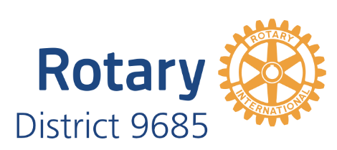

PO 215, St Ives, NSW 2075
1 December 2025

Dear Professional Association,

Rotary is a global network of professionals, community leaders and passionate people, some 1.2 million people globally who collaborate to create meaningful, lasting change. We bring together people from diverse backgrounds to expand their networks, develop leadership skills, and work on impactful service projects—locally and internationally.

For professional associations, Rotary offers a platform to strengthen community engagement, elevate member development, and connect with a worldwide network of like-minded leaders committed to making a difference.

Please find attached a profile of our District 9685 and an impact statement for the 2024-2025 year achieved by the same District.

Do you think your Association and Rotary could benefit from each other and make the world a better place? I believe there are many opportunities to explore. We will contact you next week to hopefully set a time to meet over coffee.

Kind regards

