HOW TO APPLY

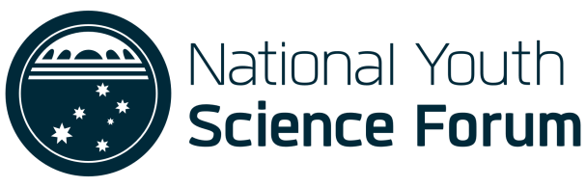

NATIONAL YOUTH SCIENCE FORUM

HOW TO APPLY

HOW TO APPLY

For More information about how to apply, click HERE

THERE ARE FIVE STEPS TO APPLYING

FOR THE NYSF YEAR 12 PROGRAM:

