ITALY AUSTRALIA
Host Club: Milano Cordusio International Club: Macquarie Park
Host District: 2041 International District: 9685
Global Grant 1527912
William Chan | Politecnico di Milano
6 July 2015

To the Rotarians of Milano Cordusio
G’day and Ciao! My name is William Chan and I am 25 years old. I am humbled to receive the Rotary Foundation Global Grant to complete my postgraduate studies in Milan and thank you all for your most generous hospitality in hosting me.
I was born in Hong Kong but moved to Australia at the age of three. Initially, my family moved to Melbourne and then to Brisbane, where I spent most of my childhood. I decided to challenge myself at the end of high school to relocate to Sydney to study at Australia’s most competitive architecture school, the University of Sydney. I also have an identical twin brother (Yes, we do look alike!) and he also attended the same university, recently graduating from a combined media and law degree.
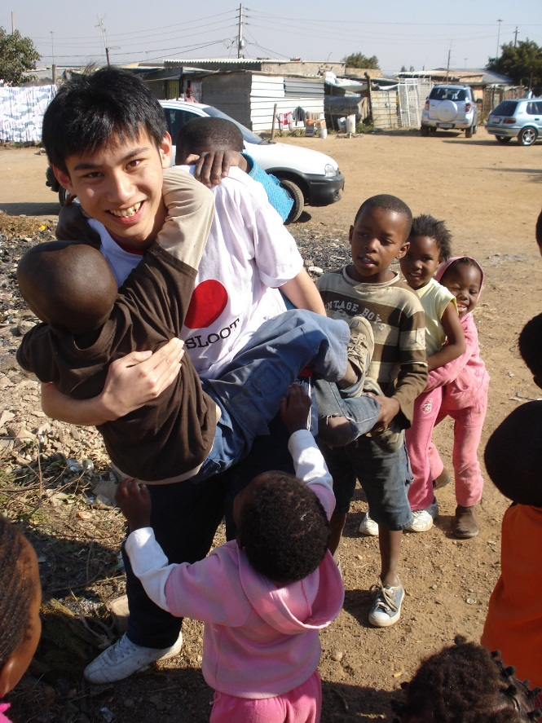 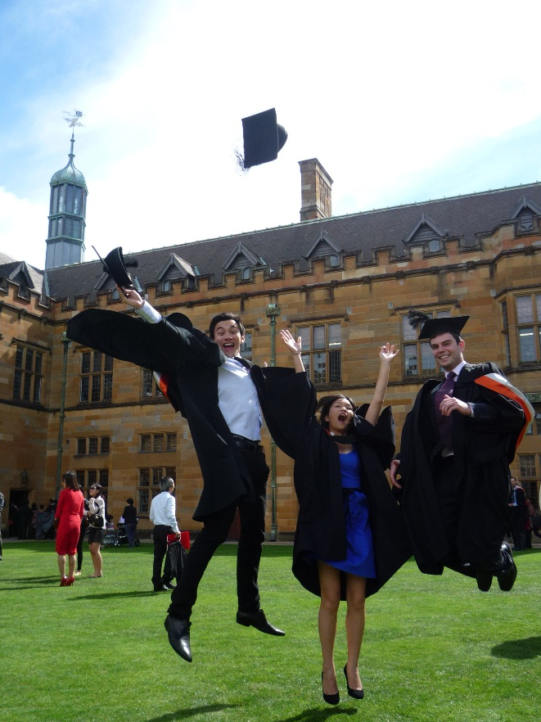
Working in Diepsloot, South Africa with Global Studio Graduation day with classmates at the University of Sydney
I studied the Bachelor of Design in Architecture for four years and have worked at two Sydney architecture firms over the past three years. During my second year of my undergraduate degree, I had the opportunity to work in the slums of South Africa to collaborate on water and sanitation design projects with the local community. Since then, I have been passionate about how I can use my design skills to positively impact and change the lives of the urban poor in this field. I have worked in India, Latin America and back to South Africa on similar projects since then.
As I want to further develop my skills and knowledge in this area, I have decided to study the professional postgraduate program, the Laurea Magistrale in Architecture at the Politecnico di Milano (Leonardo da Vinci campus). I will begin my two-year degree on 5 October 2015 and will be living at the Galileo Galilei Residence in the heart of the city. I have chosen this university because of its strong global reputation in engineering and architecture, the opportunities available for multidisciplinary projects in water and sanitation, and its research focus on solving challenges in the developing world.
Milan is renowned for its design and technological innovations and I can’t wait to move there. I decided to study in Italy because I wanted a cultural experience in addition to an academic one – I am keen to learn Italian, make new Italian friends, immerse myself in the culture and also try all types of Italian food, which I love! I have not visited Milan before but have been to Venice, Rome and Naples in 2012. I lived in Venice for five weeks, building an exhibition for the Venice Architecture Biennale and represented Australia at the UN World Urban Forum in Naples. Experiencing the wonders of Italy opened my horizons and made me realise how much more I could learn by studying and living there (one such opportunity will definitely be the 2015 World Expo in Milan).
I have also been passionate in using my talents to help others and find it very rewarding to volunteer with humanitarian organisations. I have been involved with Rotary initiatives since the age of 12, where in primary school I participated in different community activities as part of a local Rotary Club youth program. Understanding the values of Rotary, I continued my involvement by joining my high school’s Interact Club, eventually becoming the president to lead fundraising projects. More recently at university, I participated in my district’s Rotary Youth Leadership Award.
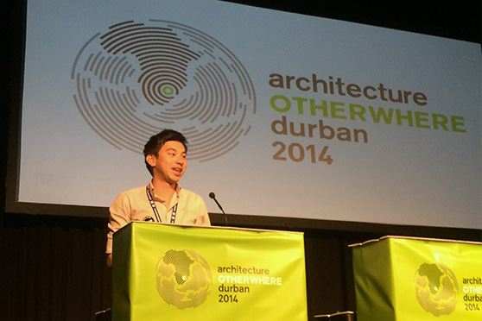 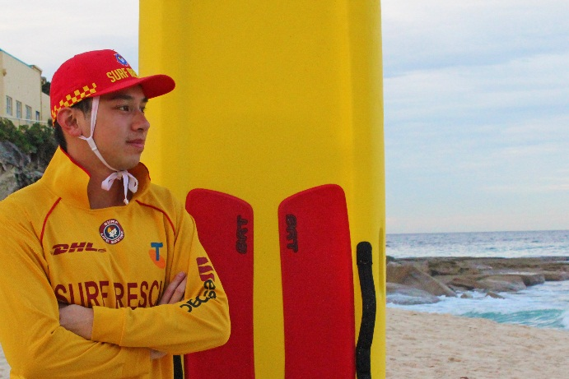 Presenting at the 2014 International Union of Architects Volunteering as a surf lifesaver at Tamarama Beach, Sydney Congress in South Africa
My other hobbies include graphic design, public speaking and keeping fit by playing soccer, rock climbing and snowboarding (though I am not very good). Particularly, I am actively involved in surf lifesaving – I have been awarded both Bronze and Silver Medallions, volunteer on patrol to keep beaches safe and facilitate youth development programs in surf rescue. Above all, I want to use this opportunity to push outside my comfort zone in learning new things.
I know that the next two years will be an immense and profound experience that I will cherish for the rest of my life. I am excited for what I will learn and how I can apply my skillset to benefit the world’s most vulnerable. Thank you very much for sharing this journey with me and I look forward to meeting you all soon.
Yours in Rotary
William
William Chan
Rotary Global Grant Scholar 2015-2017
wcha1925@uni.sydney.edu.au

