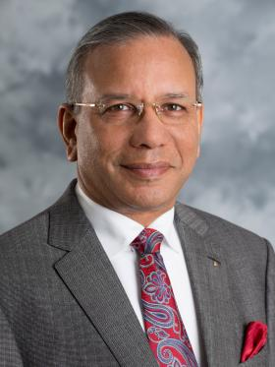 YOU ARE INVITED
I firmly believe that you are not yet a true Rotarian until you have experienced a
ROTARY INTERNATIONAL CONVENTION
This may sound a little provocative, but it’s true – simply ask any Rotarian who has experienced an International Convention. The key word in all of this is “International’.
Whether it was in Melbourne in 1993, Brisbane in 2003 or Sydney in 2014, if you weren’t able to experience one of these Conventions or indeed any other International Convention, then you cannot appreciate what it is that I am talking about.
NOW IS YOUR CHANCE
“CONNECT WITH KOREA – TOUCH THE WORLD”
May 29th to June 1st, 2016

We, as Rotarians, are travelers – trying to spend our kids’ inheritance . This year, why not enjoy the excitement of an Asian trip and plan it around the International Convention in Seoul, Korea. Enjoy the diversity of the country – the culture, the architecture, the people. Come see for yourself – spend four days out of your life to meet with other Rotarians from over 200 countries and geographical regions.
Hear World leaders speak - attend informative workshops – enjoy the fantastic world class entertainment that Rotary International will provide. In addition, be part of the fabulous shows and events that are being organised by the host city.
Come join us
BOOK YOUR TRIP TO SEOUL, KOREA TODAY

