You are invited to the RAWCS Eastern Region meetings to be held on the weekend of 14th and 15th May 2016

ROTARY AUSTRALIA WORLD COMMUNITY SERVICE LTD: EASTERN REGION.
NOTICE OF THE GENERAL MEETING ETC,
TO BE HELD ON 14th AND 15th MAY 2016 AT DIGGERS @THE ENTRANCE, 315 THE ENTRANCE RD, THE ENTRANCE NSW 2261

From: Ted Lewis OAM, Secretary, 18 Karoola Road, Lambton, NSW 2299 –
Tel: 4957 1095; E-mail: lewisted@ozemail.com.au

SATURDAY 14th May Activities:-

1.Training and Information Session 2.00pm to 5.00pm:

Venue:- Diggers @The Entrance

A Training and Information Session for new and existing District RAWCS representatives and anybody who wishes to learn about RAWCS. Session will be presented by District 9685

2. Dinner Meeting: 6.00pm for pre-dinner, seated at 6.45 pm for 7.00pm start.

Venue:- Diggers @The Entrance.

The dinner cost will be $40 per person, with partners and friends of course, very welcome.
The Pink Umbrella Grant Awards will be announced towards the conclusion of the Dinner. The Project Manager or a representative of each of the winning Projects must be in attendance at the meeting for the Project to be eligible for the Award.
Note:- Afternoon Tea on Saturday and Morning Tea on Sunday will be supplied.
ACCOMMODATION
There is plenty of accommodation in this area. Check the Internet!
In this areaT
The Club is only about
249588499hPhone 0249588499one 0249588499

Some Helpful (?) Travel Directions
*Whether you are travelling from the North or South on the M1 Freeway, take the Tuggerah Interchange to WyongRd.
* Follow the B74 Road through Tumbi Umbi and Killarney Vale to the Roundabout here.
* Turn left and you will be on The Entrance Rd.

SUNDAY 15th May Activities:-

Please Mail to : PP Ted Lewis OAM, 18 Karoola Road Lambton 2299;

or Email details to lewisted@ozemail.com.au , before 6th May 2016
- I regret that I am unable to attend the General Meeting at The Entrance
Yes, I will be attending the following activities at the Meetings at The Entrance
- Saturday afternoon sessions
Saturday evening. Number attending Dinner ...............
Sunday RAWCS General Meeting

NAME (BLOCK LETTERS): ............................................………......... DISTRICT: ............................

Venue :- Diggers @The Entrance

9.00am – The General Meeting of RAWCS Eastern Region

The Agenda for the General Meeting, together with associated Business Papers will be emailed before 25th April

ATTENDANCE DETAILS
You can now register your intention to attend the Meetings and Dinner on line at
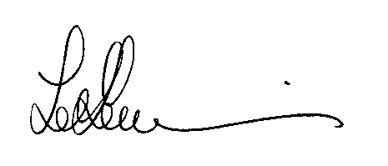http://goo.gl/forms/RyDaNaWciw or by completing the form below and sending it to me at the address shown below no later than Friday 6th May.
Yours in Rotary,

PP Ted Lewis OAM, Secretary

“Very Good Map!”

Should help you find your way!!!

Diggers @the Entrance here

