HEAR YE, HEAR YE, HEAR YE
Have you booked your trip to
exciting and wondrous Korea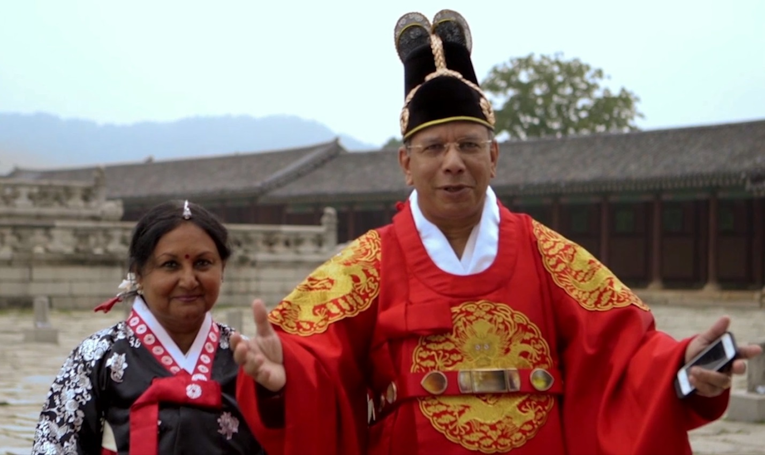
We promise you the biggest and best
ROTARY INTERNATIONAL CONVENTION EVER
May 29th to June 1st
Registration forms available in your R.D.U or
Online at rotary.org international convention
SEE YOU THERE!!

