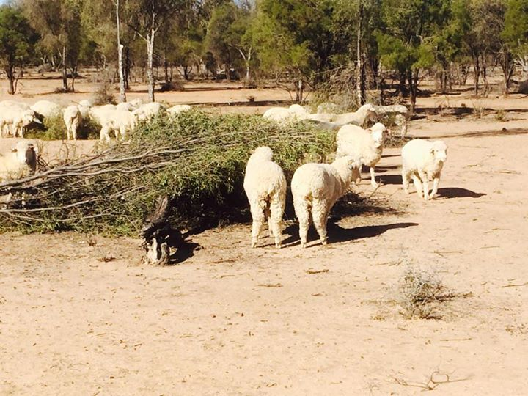
Lightning Ridge Rotary Club
We need your Help!
The Rotary Club of Lightning Ridge would like to help about 50 families in the Lightning Ridge area who are struggling on the land due to the current 10 year drought. Although we had some small falls of rain recently it will take years for these families to get back on their feet. They need help now to pay the bills and put food on the table. Sometimes all they need is some time away, so perhaps a few days holiday away could help save someone's' sanity.
Over the past 12 months we have been involved in multiple hay drops, we have handed out bags of Dog Food, and we have handed out "Pamper Packs" to the wives who have been grateful for the thought and the products. We have had numerous requests from clubs as to how they can help and we think this is it.
We are now asking every club in District 9650 (and beyond) to dig deep and make a donation to our Drought Relief Fund. Our aim is to assist each family with a gift of cash to ease their financial situation.
Please forward cheques made out to Rotary Club of Lightning Ridge - Drought Relief Fund OR consider a direct deposit to our Drought Relief account (details below).
Bank: Westpac
Branch: Lightning Ridge
Account Name: Rotary Club of Lightning Ridge - Drought Relief Fund
BSB: 032561
Acct No: 209839
Postal Address: PO Box 1029, Lightning Ridge, NSW, 2834.

We would be grateful if you would forward this email to any Rotary Club outside District 9650 you may have contact with.

Yours in Rotary
Neroli Bevan
Secretary
Rotary Club of Lightning Ridge
0438 528975
nbevan01@gmail.com

